1. **INTRODUCTION**

The objectives of this project are to design & develop an automated order management and a secure computerized inventory system for J&J Kitchen Catering Company. It is a challenge for the company to handle orders and perform inventory checks without the use of an automated system. In a manual process, allocating excessive time for these activities affects the efficiency of their service; there is also a risk of making a mistake when performing their inventory check. With these reasons, the proponents aim is to create a system that will enhance the efficiency of their services by saving time and by making sure mistakes will be at a lowered chance.

1. **HISTORICAL BACKGROUND**

J&J's Kitchen Catering Company, a daughter company of RRA Food Services, was established last June 2016. RRA Food Services is a private company which was established in the year 2000; they offer food services for the employees of big establishments such as Meralco and SM. On the other hand, J&J's Kitchen Catering Co, located at Caloocan City, is a company that handles both catering and food services.

The J&J's Kitchen catering team is designed to serve the finest food they can offer to those who are planning events such as Weddings, Birthday Parties, Meetings, Corporate Events, Christening, Friends and Family Reunions and other similar events. With a wide variety of food bundles and other services to choose from and their simple call then book system, J&J's Kitchen Catering Company will continue to serve their quality food and services where ever in the country it may be.

1. **STATEMENT OF THE PROBLEM**
2. **GENERAL PROBLEM**

It is a challenge for the company to handle orders and perform inventories without the use of an automated system. In manual process, allocating time for these activities affects the efficiency of their services. There is also a risk of errors in performing their inventories.

1. **SPECIFIC PROBLEM**

*Order Management System.* The company is currently taking order through phone calls and personal visit. The customer orders are encoded in an excel file and being transferred through a specific file location. The problem with this is that customer orders might have some errors because the orders are manually encoded. Thus, one of the goal of this project is to create a software system that will handle customer orders and schedules.

*Inventory System.* The company is conducting inventory procedures using manual process. In the manual process, all the records are being backtrack one by one in the past orders. Each customer order files that being generated in the order management phase are being reviewed and tabulated in a separate excel file. The available product items are also stored in separate excel files. The problem with this is that the data are difficult to backtrack and may lead to miscalculations. There is also a tendency that other data might be overlook because the data are recorded in separate files. Thus, one of the goal of this project is to create an inventory system that will handle data and perform calculations.

*Main System and a Customer Website.* The company is currently using an excel application. The problem with this is that the data are difficult handle. There is also a tendency of miscommunication and miscalculation in the data being process. The company aim to have an own software system that will help them to improve the efficiency of the task that they are doing. The company also aim to have a main software system that will integrate the order management system and the inventory system. The company also aim to have a customer website where in customer can view a full detail of the menu, product offers, event sales, and ordering procedures. Thus, one of the goal is of this project is to create a main software that will integrate both the order management system, inventory system and the customer website.

1. **OBJECTIVES**
2. **GENERAL OBJECTIVES**

To make the compiling and organizing of the data of the company, order management and inventory software system will be developed. In addition, a layout for a usable website shall be provided to the company to promote their product to the public. The Inventory software will provide a table of their products in stock; it will also contain the information about the workers of the company and customer interactions with the company. The website layout shall contain the menu/bundles for customers to look at, background of the company, ways to contact the company, make reservations and send their feedbacks.

1. **SPECIFIC OBJECTIVES**

*Order Management Software System.* The first phase of this system is to create a software system that will handle customer order operations such as accepting orders, modifying orders, and planning catering schedules. A specific form that contains all order information will be created.

*Inventory Software System*. The second phase of this system is to create a software system that will handle inventories of stock and, orders. A list of workers shall also be included, with only the admin/owner being able to edit this. Finally a section where all customer interactions will be made, this is where previous order, current bookings and customer feedbacks are checked.

*Customer Website*. The third phase of this system is to create a customized website that will contain a customer feedback option. The website will also contain the company’s background, menu, product offers, and payment terms. A customer can also create reservations for future orders. Reservations and Customer feedbacks directly go to the inventory system.

1. **REVIEW OF RELATED LITERATURE**

*Related Literature for Inventory System*

Companies are increasingly employing Inventory System. A computer start with an inventory counts in memory. Withdrawals are recorded by the computer as they are made, and the inventory balance is constantly revised. When the recorded point is reached, the computer automatically places an order, when this new order is received, the recorded balance is increased. Retail stores have carried this system quite far, each item has magnetic codes, and as on item is checked out, and it passes over an electronic reader, which then adjusts the computers inventory balance, at the same time the price is fed to cash register tape.

*Related Literature for System Automation*

Systematic reviews, a cornerstone of evidence-based medicine, are not produced quickly enough to support clinical practice. The cost of production, availability of the requisite expertise and timeliness are often quoted as major contributors for the delay. This detailed survey of the state of the art of information systems designed to support or automate individual tasks in the systematic review, and in particular systematic reviews of randomized controlled clinical trials, reveals trends that see the convergence of several parallel research projects.

We surveyed literature describing informatics systems that support or automate the processes of systematic review or each of the tasks of the systematic review. Several projects focus on automating, simplifying and/or streamlining specific tasks of the systematic review. Some tasks are already fully automated while others are still largely manual. In this review, we describe each task and the effect that its automation would have on the entire systematic review process, summarize the existing information system support for each task, and highlight where further research is needed for realizing automation for the task. Integration of the systems that automate systematic review tasks may lead to a revised systematic review workflow. We envisage the optimized workflow will lead to system in which each systematic review is described as a computer program that automatically retrieves relevant trials, appraises them, extracts and synthesizes data, evaluates the risk of bias, performs meta-analysis calculations, and produces a report in real time.

*Related Literature for Website Development*

In the early 1990s, numerous academic libraries adopted the web as a communication tool with users. The literature on academic library websites includes research on both design and navigation. Early studies typically focused on design characteristics, since websites initially merely provided information on the services and collections available in the university's physical library. Beginning in the late 1990s, technological developments coupled with new digitization efforts offered new opportunities for websites with commercial and local databases, electronic journals, e-books, and virtual reference. The availability of new content and services on library websites facilitated research efforts comparing these features among academic library websites. During this period, articles also emerged that considered navigation and usability issues for these pages. The literature on academic library web pages documents efforts by libraries to use web technologies and resources to serve user groups. However, the research also suggests these efforts were hindered by design and navigation issues with academic library web pages. It remains especially important that libraries consider design in the development of their web pages to maximize usage of content.

1. **System Flowchart**

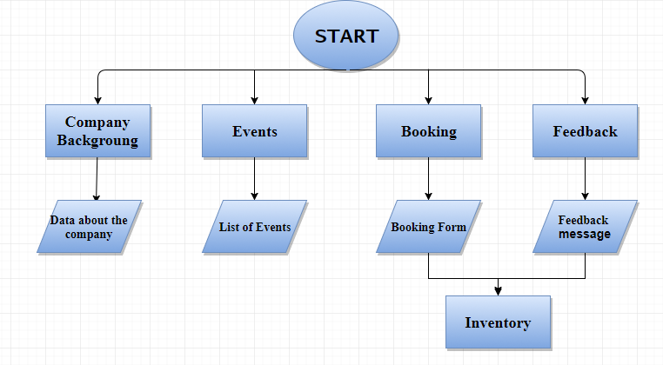

*Fig 5.1 Website*

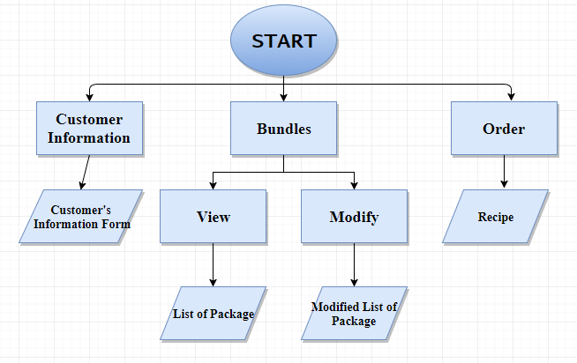

*Fig 5.2 Order Management*

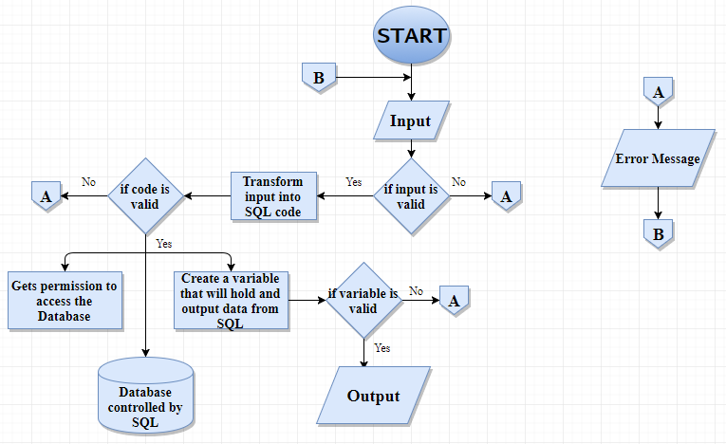 *Fig 5.3 Inventory Software*

1. **Programming Languages**

*Visual Basic (VB)* is a programming environment from Microsoft in which a programmer uses a graphical user interface ([GUI](http://searchwindevelopment.techtarget.com/definition/GUI)) to choose and modify preselected sections of code written in the [BASIC](http://whatis.techtarget.com/definition/BASIC-Beginners-All-purpose-Symbolic-Instruction-Code) programming language.

***MySQL* is a database management system,** where a database is a structured collection of data. It may be used in anything from a simple shopping list to a picture gallery or the vast amounts of information in a corporate network. To add, access, and process data stored in a computer database and you will need a database management system such as MySQL Server. Since computers are very good at handling large amounts of data, database management systems play a central role in computing, storing data, as a standalone utility, or as parts of other applications.

*Hypertext Markup Language (HTML)* is the standard [markup language](https://en.wikipedia.org/wiki/Markup_language) for creating [web pages](https://en.wikipedia.org/wiki/Web_page) and [web applications](https://en.wikipedia.org/wiki/Web_application). With [Cascading Style Sheets](https://en.wikipedia.org/wiki/Cascading_Style_Sheets) (CSS) and [JavaScript](https://en.wikipedia.org/wiki/JavaScript) it forms a triad of cornerstone technologies for the [World Wide Web](https://en.wikipedia.org/wiki/World_Wide_Web). HTML describes the structure of a web page [semantically](https://en.wikipedia.org/wiki/Semantic_Web) and originally included cues for the appearance of the document. [Web browsers](https://en.wikipedia.org/wiki/Web_browser) receive HTML documents from a [web server](https://en.wikipedia.org/wiki/Web_server) or from local storage and render them into multimedia web pages.

*PHP (Hypertext Preprocessor)* is a widely-used open source general-purpose scripting language that is especially suited for web development and can be embedded into HTML.

In this project, the above programming languages will be implemented. Visual Basic will be used in the main system, order management, and inventory part. This programming language will be useful to create beautiful display and graphic designs. On the other hand, MySQL will be used in the handling of data. This programming language will be useful to create data management system that will handle information throughout the system. Lastly, HTML will be used in the customer website part. The software will use VB and CSS as its interface for the convenience of the user and will process the data using SQL. This will create a database composing of the company’s products and can be organized in a multitude of ways, for example, they can be organized as bundles for promo packages or what type of food among other possible categories they can be organized.

1. **DATA DICTIONARY**

|  |  |  |
| --- | --- | --- |
| External Entities | Process | Data Store |
| Customer – the end user of the services.  Manager – the one who manage the overall system  Supplier – delivers the new product items  Kitchen – orders are being processed | Accepting customer order  Scheduling order  Processing customer order  Preparing the products needed  Generate reports  Calculating profit gain/loss  Checking for new deliveries | Order – stores information about the orders. It consists of customer information, order, and schedules.  Inventory – stores information about the inventories of stocks/ available items, orders, sales and profit. |

*Fig 6.1 Data dictionary*

1. **SYSTEM REQUIREMENTS**

The user will require basic knowledge of how to use a computer. For the software itself the user should require basic knowledge of how to use the program of which the instructions will be provided. For hardware, the computer must be of modern standard specifications and runs on at least Windows XP in order to run the software. For the website, a stable internet connection is needed and a server host to bring up the website itself.

The requirements are:

*Software*

* Stable Internet
* Minimum OS: Windows XP

*Hardware*

* Minimum Processor: 100Mhz Pentium Processor or higher
* Minimum Memory: 256MB RAM

1. **SCOPE AND LIMITATIONS**

This project encompass the majority of the internal work within the J&J’s Kitchen Catering Company, this includes an inventory system, an order management system and a website. The limiting factor for the programs is only the user, but the project was made with the intention of being used as easily as possible and error trappings were placed in to prevent bad inputs from getting into the database.

The website contains most info that a customer would want from the company, including its history and the food/bundles that are offered. Here a customer can send booking and feedback to the company. The website itself is limited since the bundles provided can’t be changed easily.

The Inventory contains a list of all available items within the company, including ingredients and tableware. It can also house Menu items and Bundles for the company. All items are editable and a user can add an item if he/she wishes so. It also stores any booked orders and feedbacks coming in from the website. Lastly it has a section for the company’s worker list to easily check on the members of the company. This system is password protected but is currently limited to 2 users, one for the admin and one for the encoders.

Lastly an order management or front desk software is provided that makes it easy to generate recipes whenever a customer comes into order. Choosing what the customer wants is just a click away. It is limited because it is a separate system from the inventory thus interaction with it and the database not available.

1. **RECOMMENDATION**

Based on the project that was made, it is recommended to further the study on what else within a company that can be automated in order to improve a company’s time efficiency even further. It is also recommended to discover more efficient code languages when creating a system like this, especially languages that can interact with the “internet of things” which is the current trend within system creation.

As for this project itself, it is recommended to use only one main programming language in order to easily combine each program into a singular system. Also to gather as much data from the customer that will be using the system in order to customize the system as much to their liking.

1. **CONCLUSION**

By means of shifting from manual to automated system there are many improvements in order management, it can be notice that it is much faster and more organize when automated rather than using a manual system. As for the inventory software, it is much easier to organize and keep track of inventory using the system. Lastly it is much easier for the customer to contact the company since it has a website where they can view the information about the company and a section to make a booking and give feedback.

It can therefore be concluded that by shifting from manual system to an automated system, it helps on making the process of handling order and performing inventory time efficient with little to no risk as tested by the company.

1. **APPENDICES**
2. 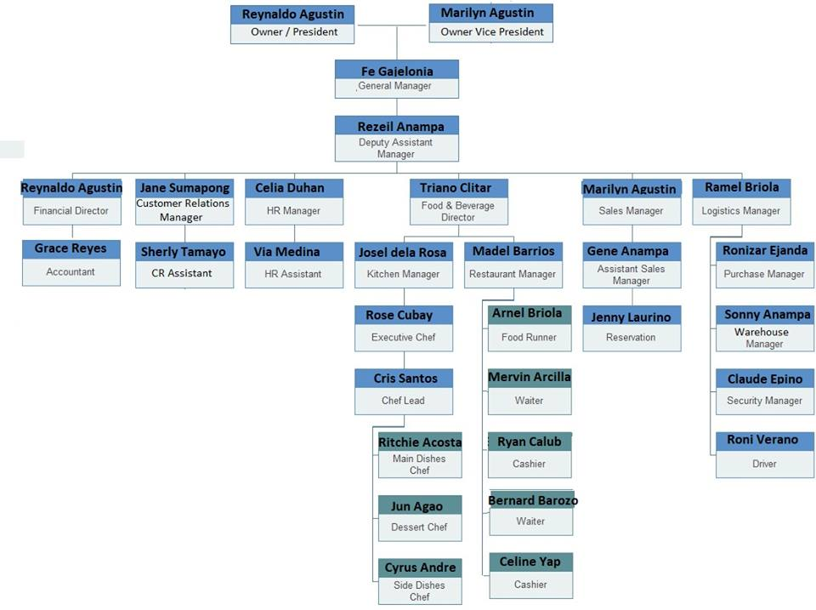**ORGANIZATIONAL CHART**

*Fig 11-A.1 Organizational chart*

1. **DOCUMENTS INVOLVE**

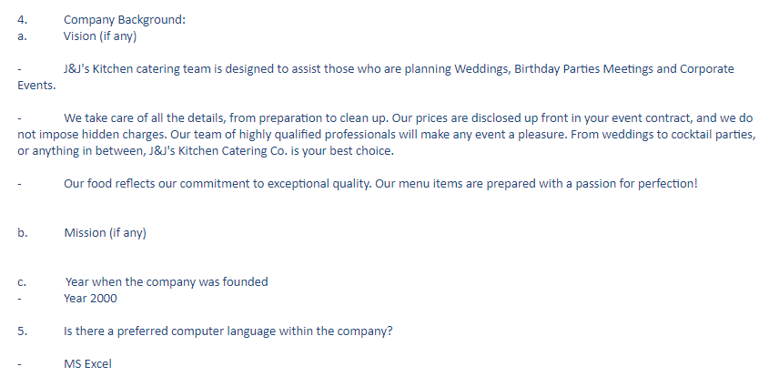

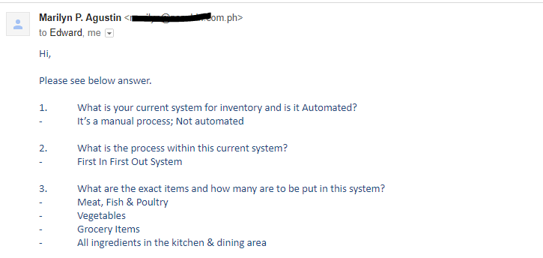

*Fig 11-B.1 Client’s provided information*

1. **OLD SYSTEM**

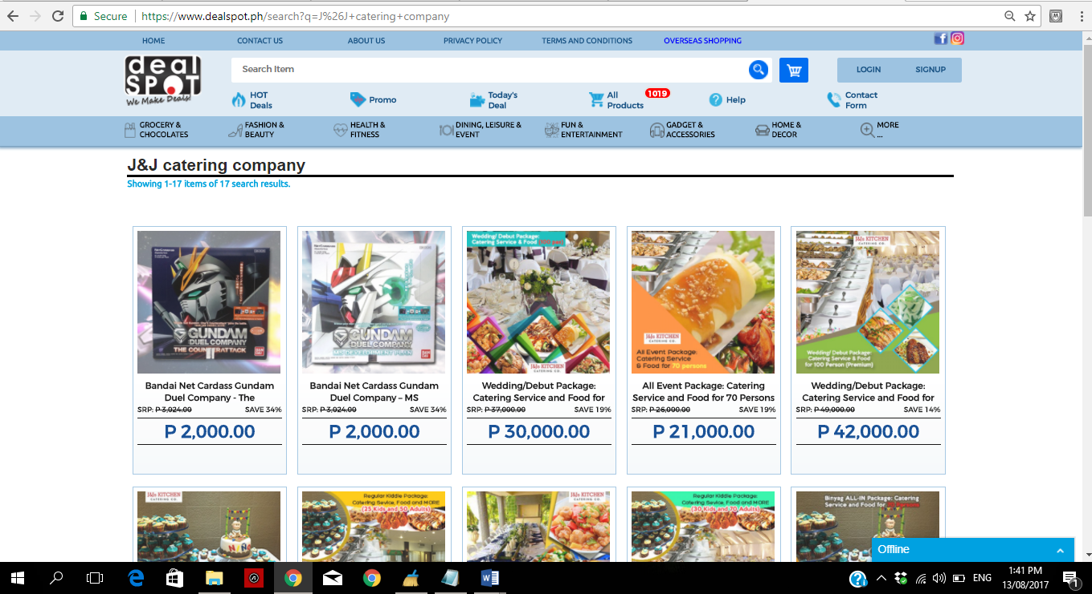

*Fig 11-C.1 Dealspot Philippines*

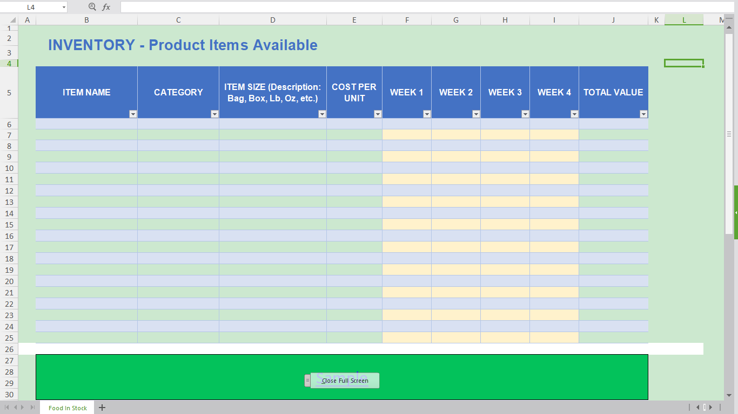

*Fig 11-C.2 Storing data using Excel*

1. **NEW SYSTEM**



*Fig 11-D.1 Home*

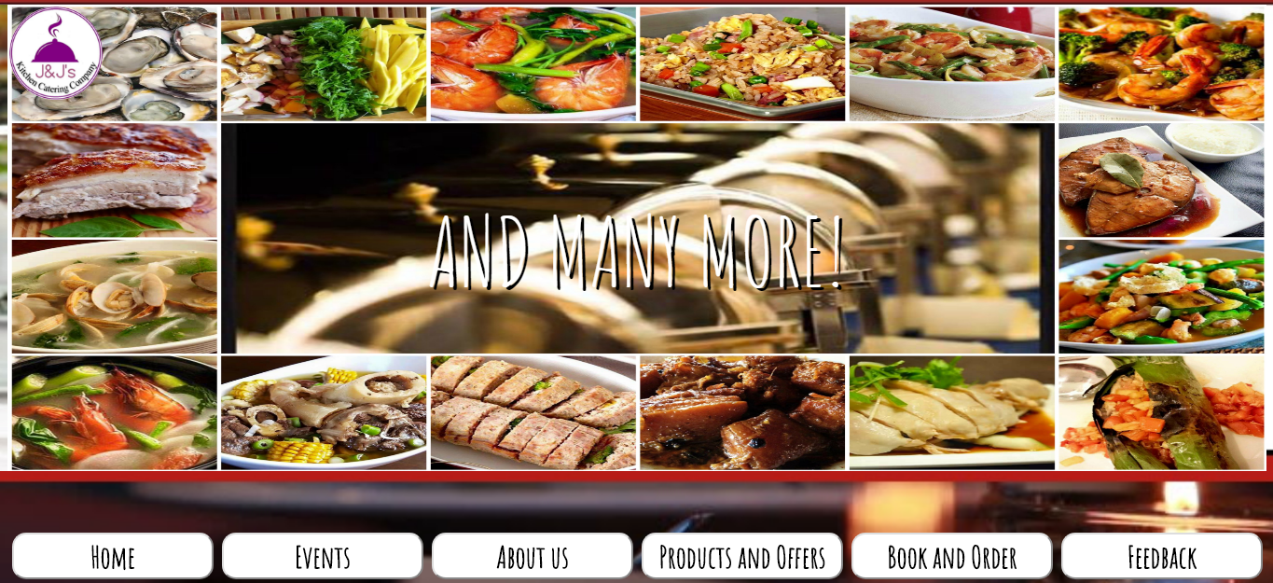

*Fig 11-D.2 Events*

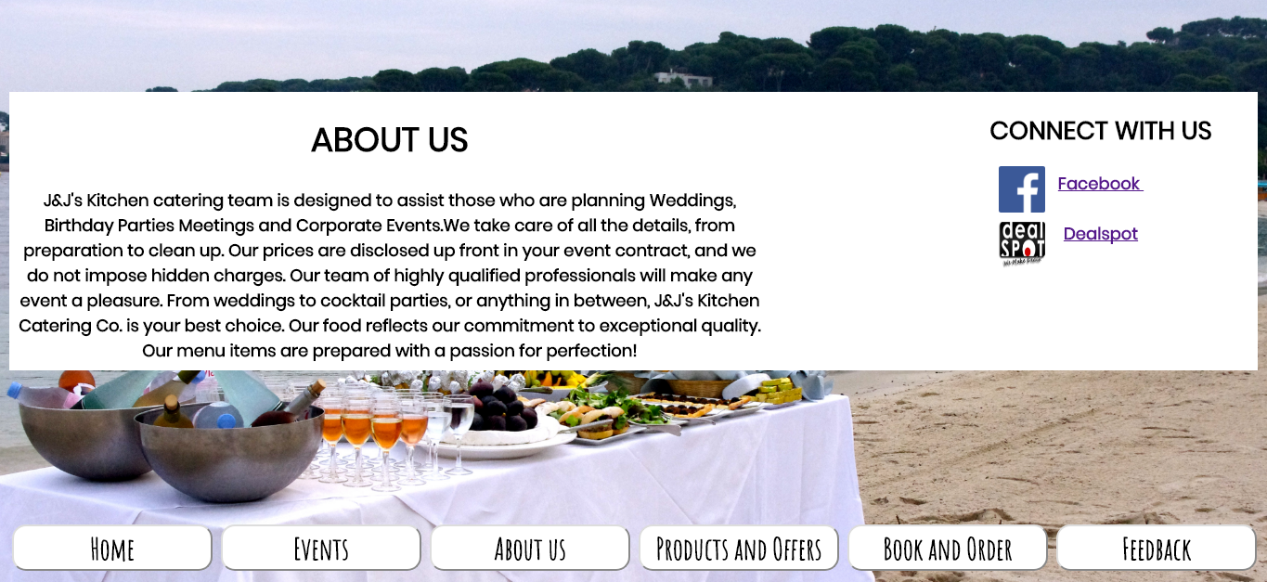

*Fig 11-D.3 About us*

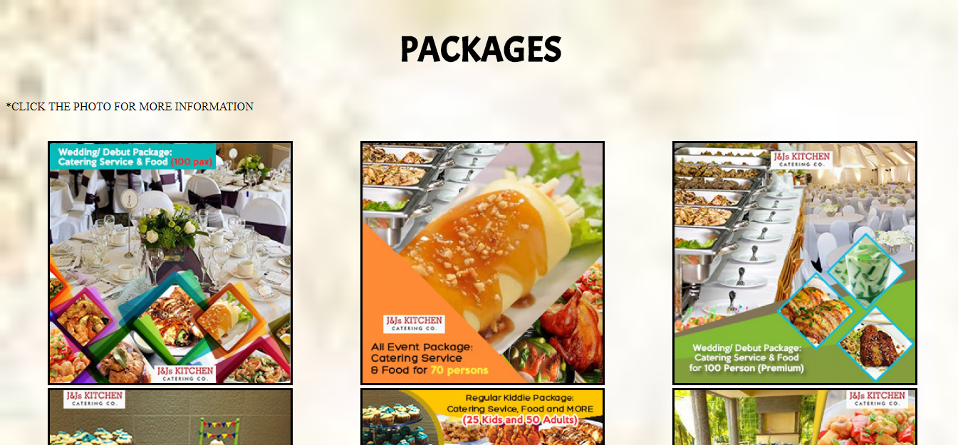

*Fig 11-D.4 Packages (1)*

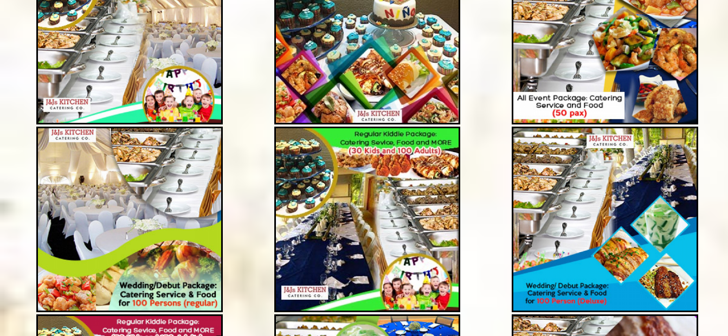

*Fig 11-D.4 Packages (2)*

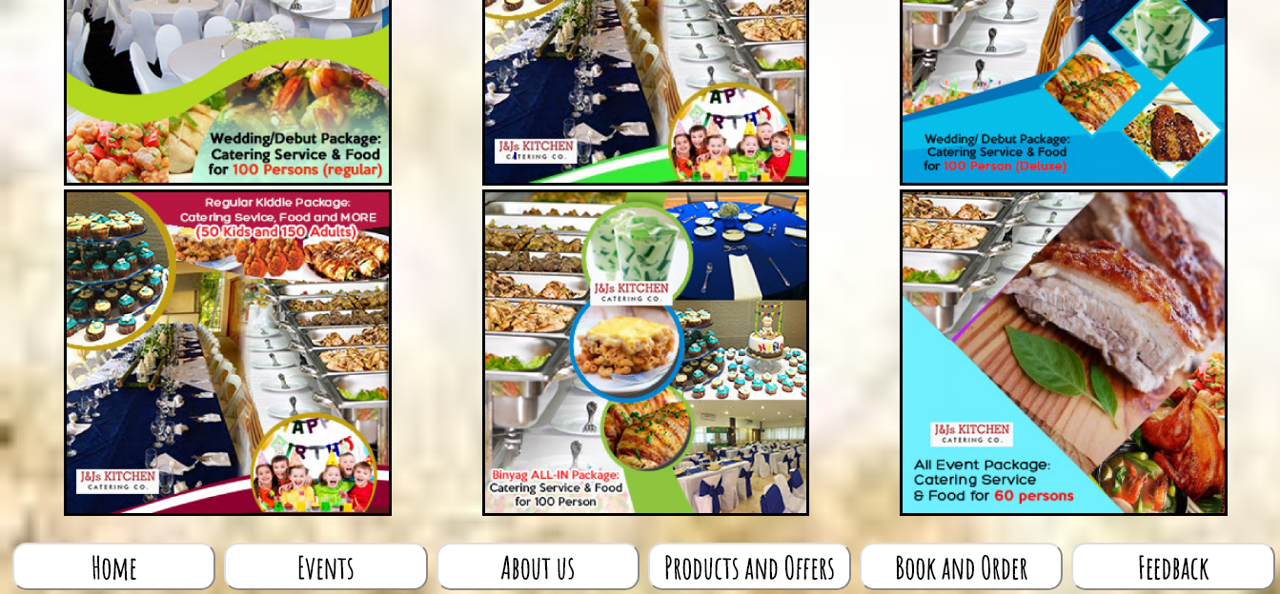

*Fig 11-D.4 Packages (3)*

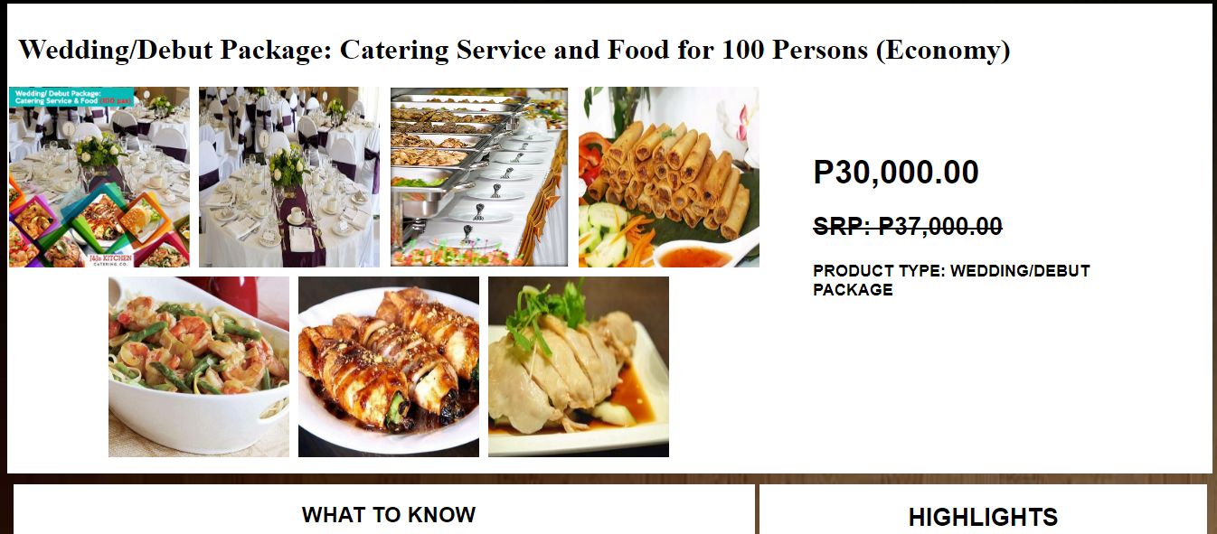

*Fig 11-D.5 Packages (1)*

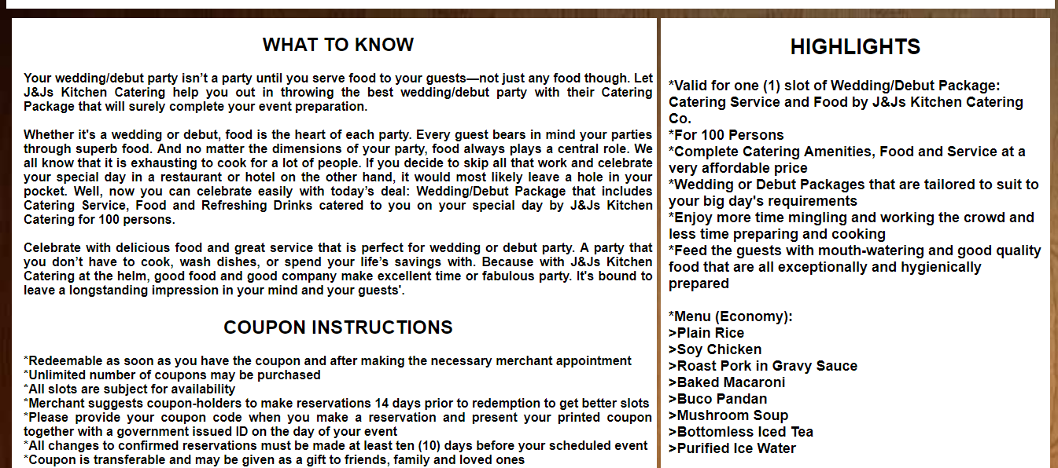

*Fig 11-D.5 Packages (2)*

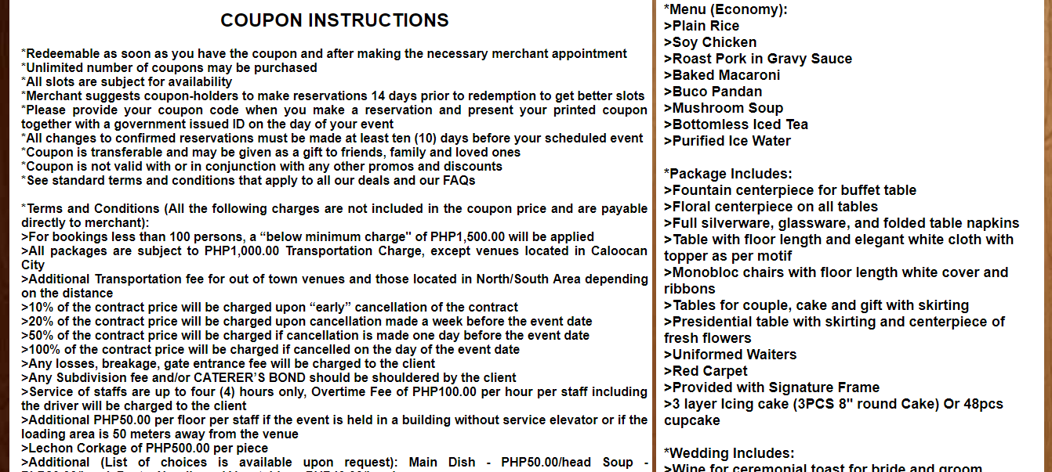

*Fig 11-D.5 Packages (3)*

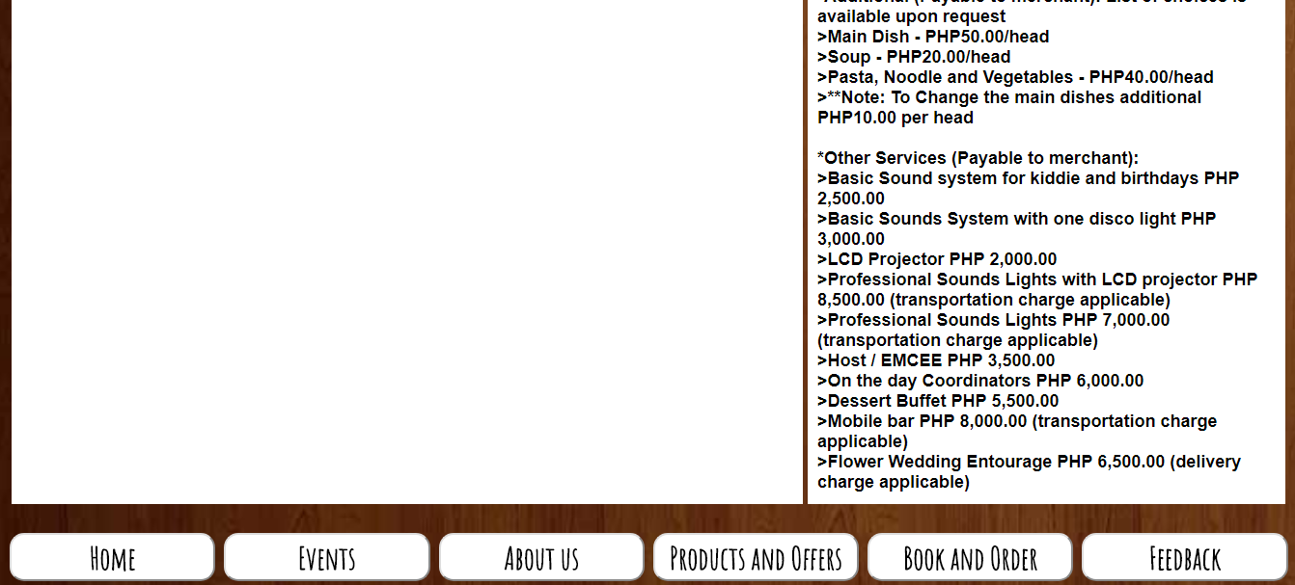

*Fig 11-D.5 Packages (4)*

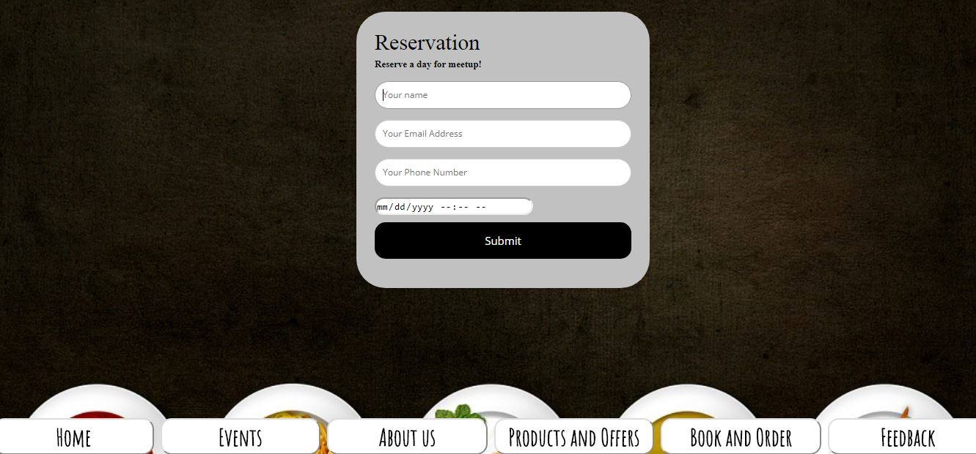

*Fig 11-D.6 Book and Order*

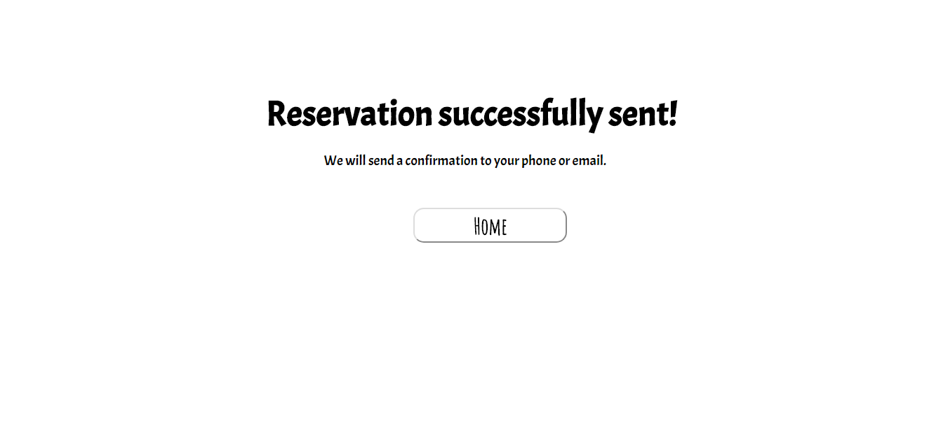

*Fig 11-D.7 Confirmation Message (1)*

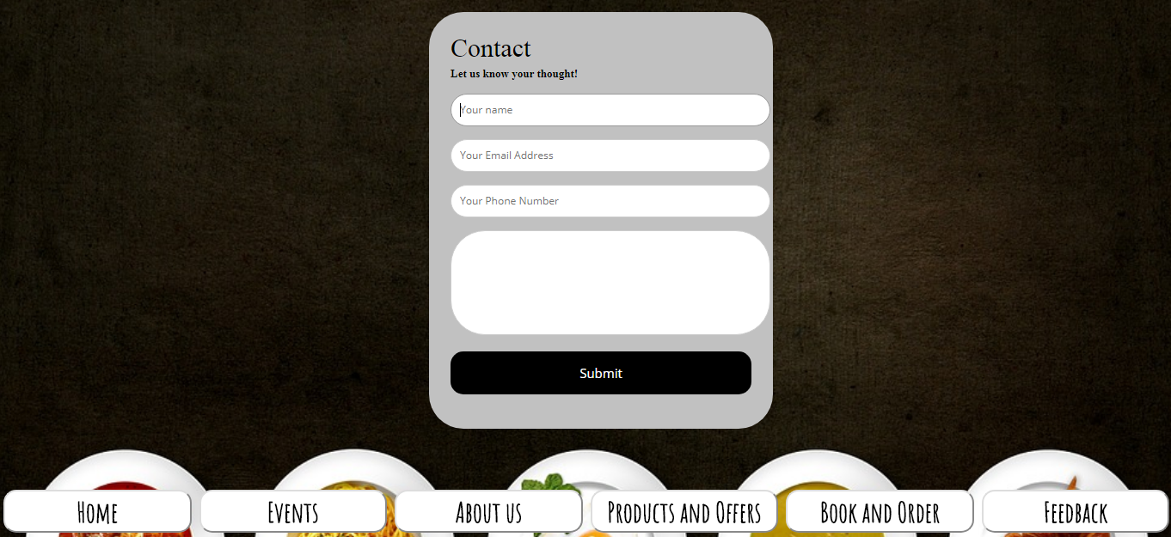

*Fig 11-D.8 Feedback*

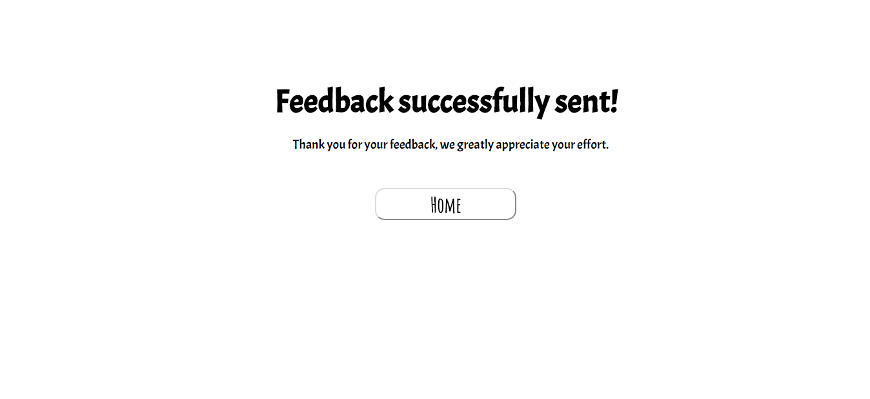 *Fig 11-D.9 Confirmation Message (2)*

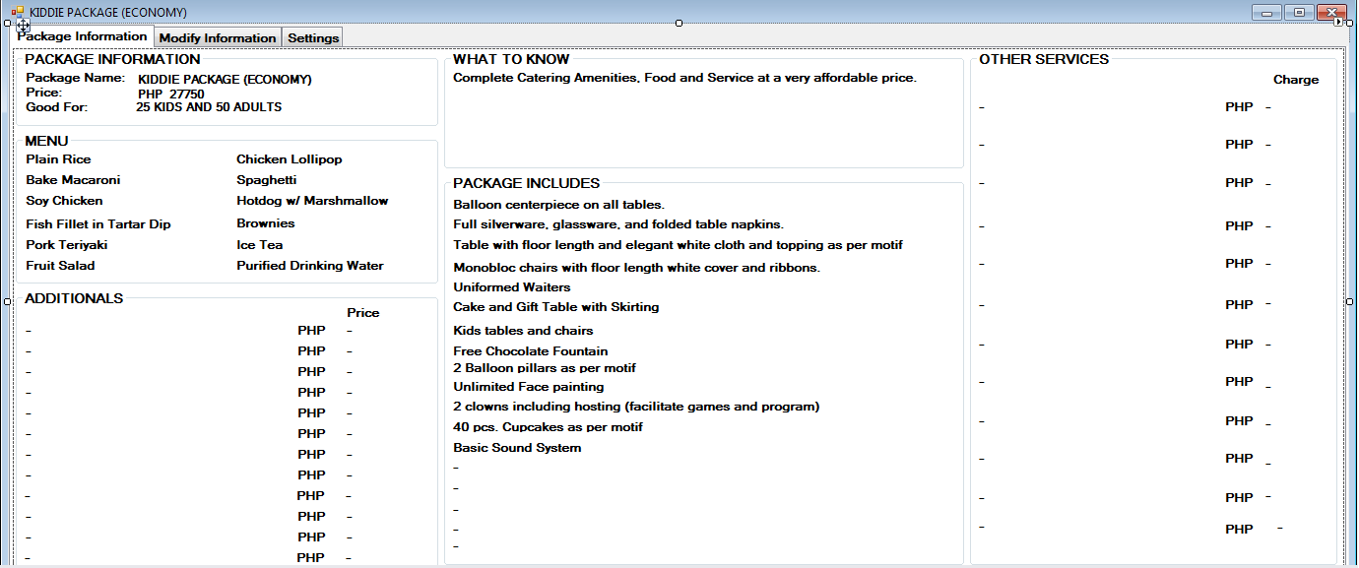

*Fig 11-D.10 Economy Kiddie Package (1)*

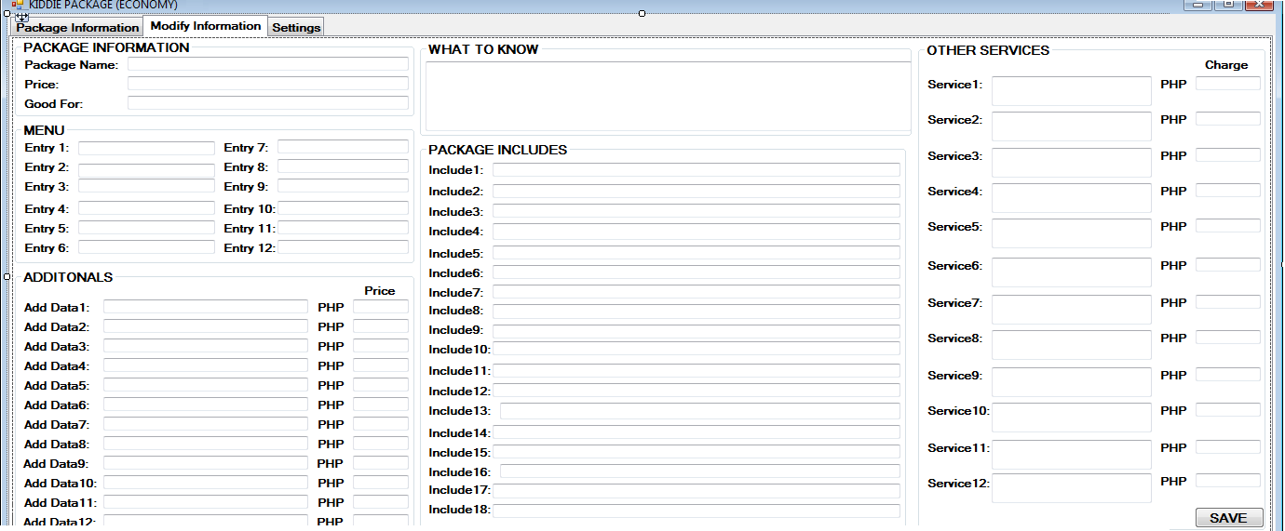

*Fig 11-D.10 Economy Kiddie Package (2)*

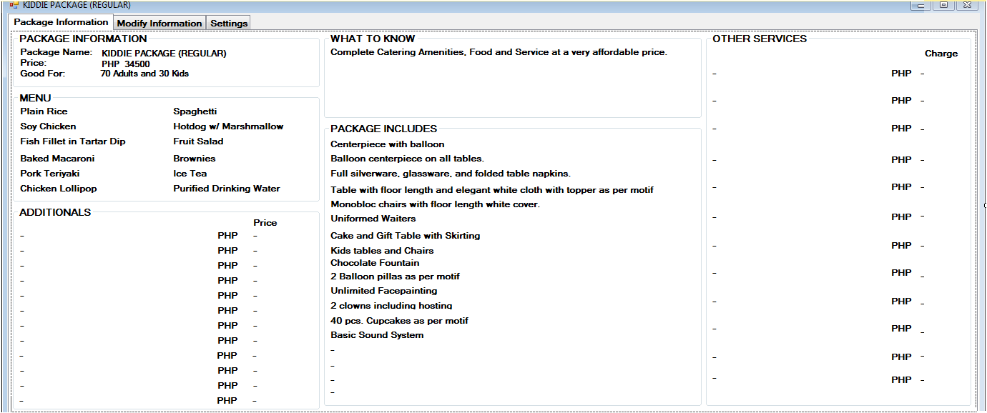

*Fig 11-D.11 Regular Kiddie Package (1)*

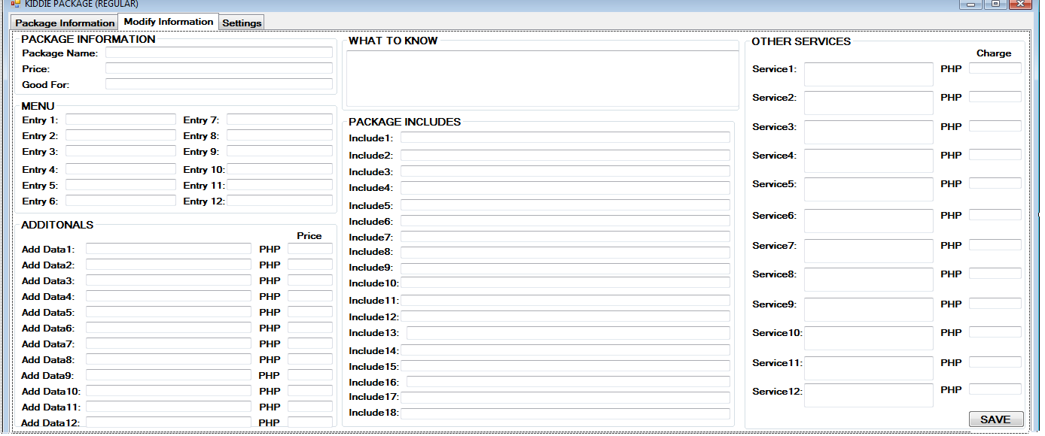

*Fig 11-D.11 Regular Kiddie Package (2)*

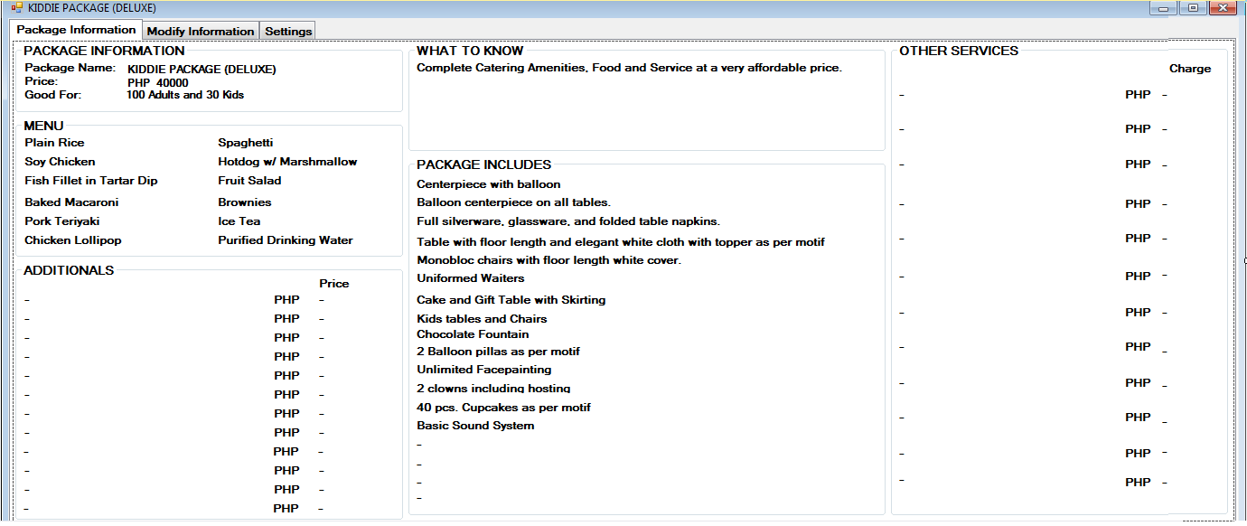

*Fig 11-D.12 Deluxe Kiddie Package (1)*

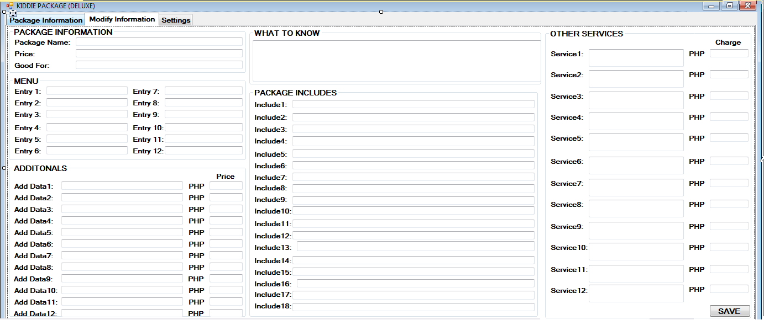

*Fig 11-D.12 Deluxe Kiddie Package (2)*

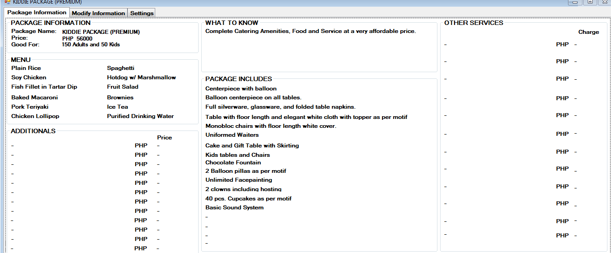

*Fig 11-D.13 Premium Kiddie Package (1)*

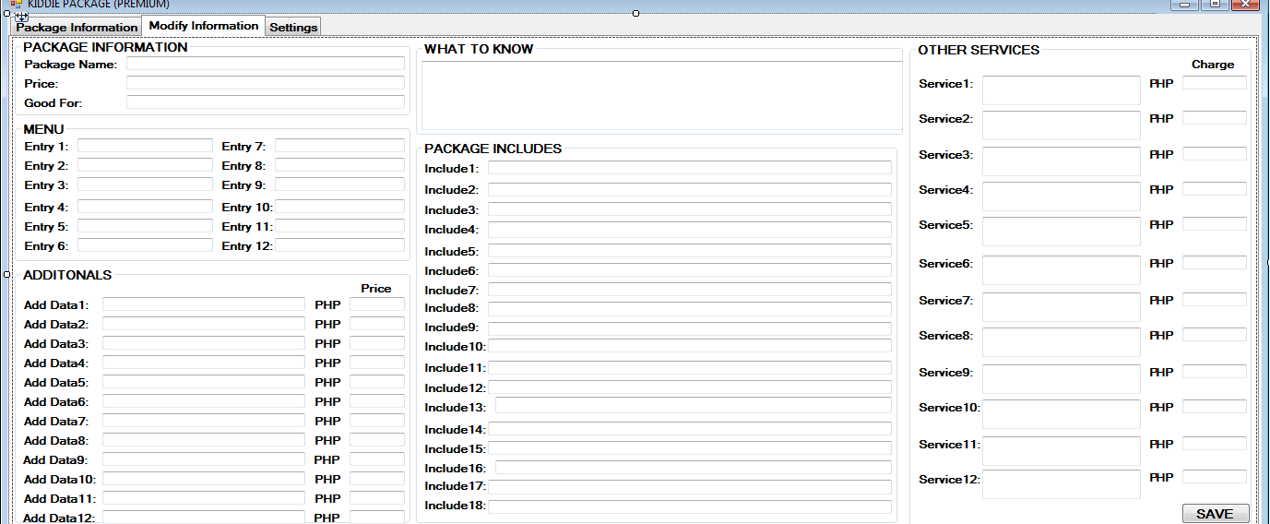

*Fig 11-D.13 Premium Kiddie Package (2)*

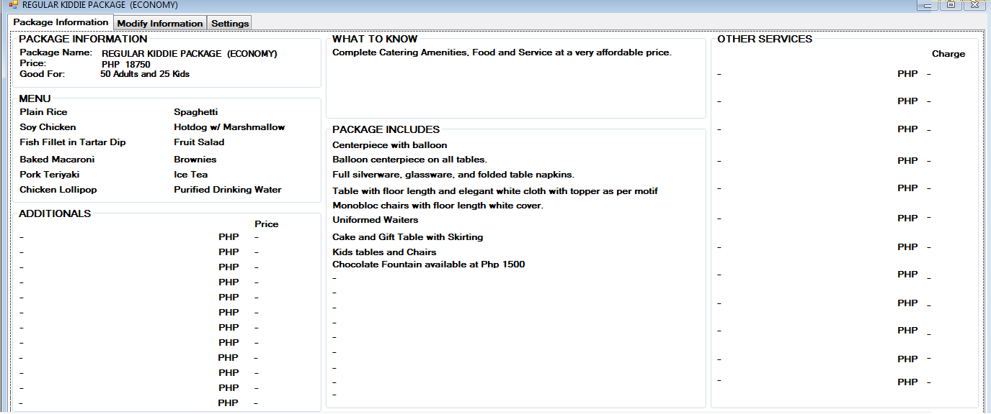

*Fig 11-D.14 Regular-Economy Kiddie Package (1)*

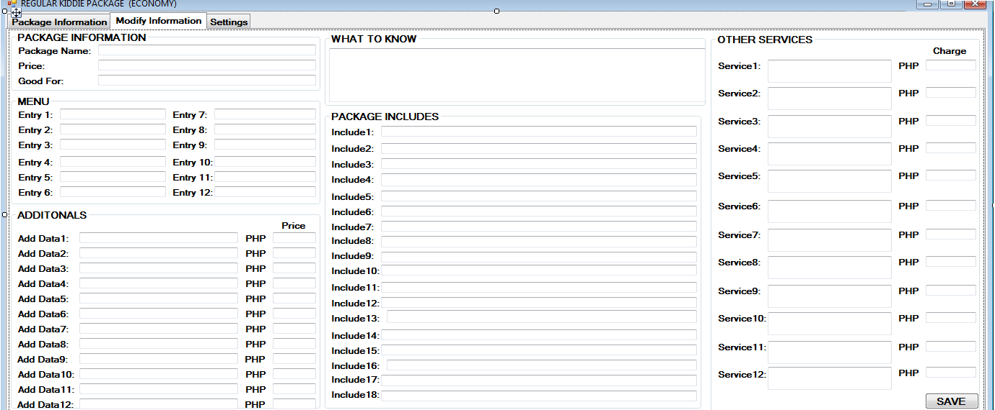

*Fig 11-D.14 Regular-Economy Kiddie Package (2)*

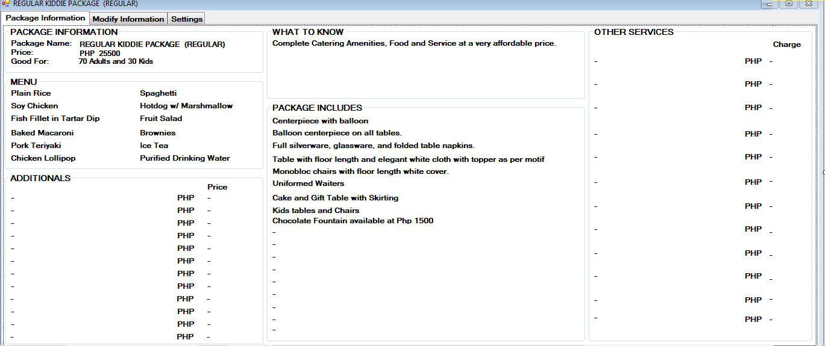

*Fig 11-D.15 Regular-Regular Kiddie Package (1)*

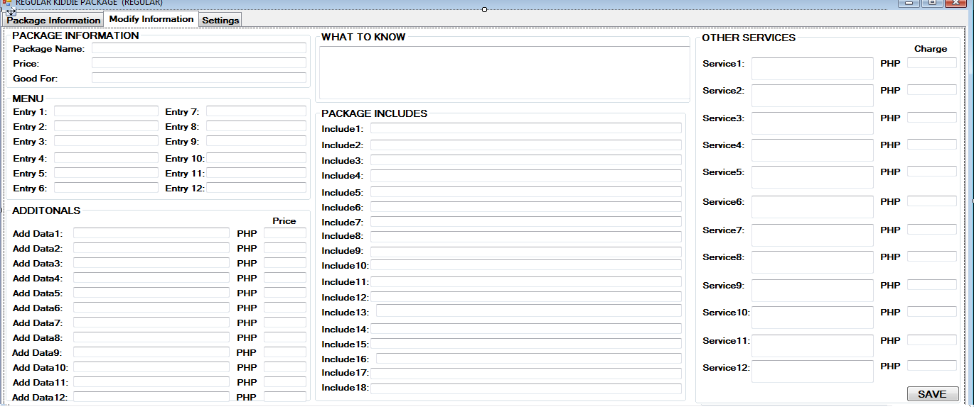

*Fig 11-D.15 Regular-Regular Kiddie Package (2)*

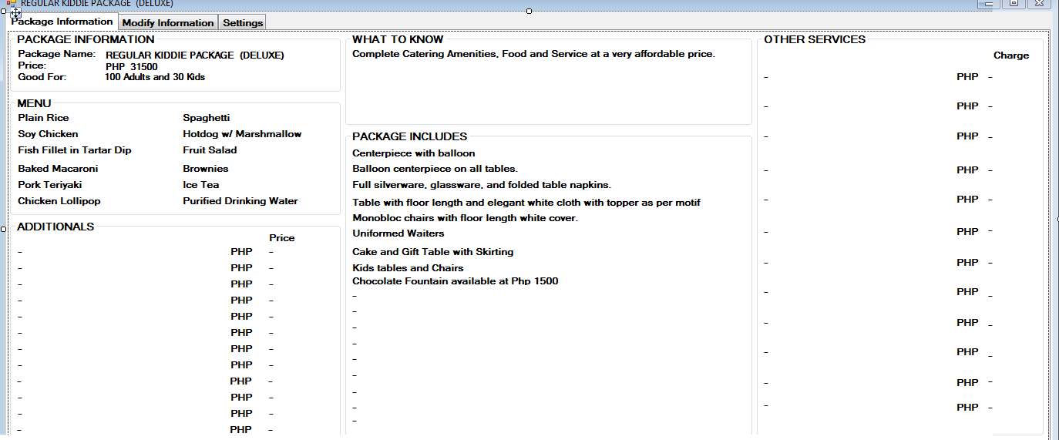

*Fig 11-D.16 Regular-Deluxe Kiddie Package (1)*

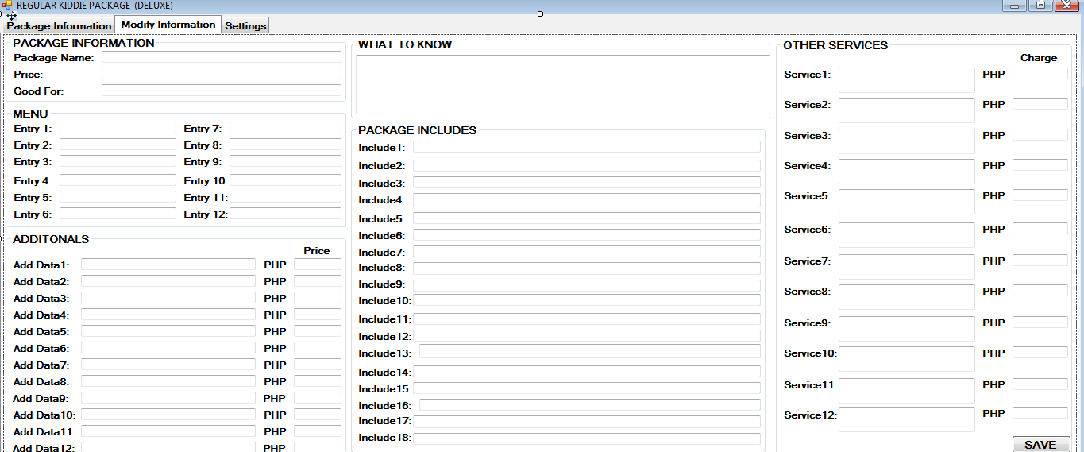

*Fig 11-D.16 Regular-Deluxe Kiddie Package (2)*

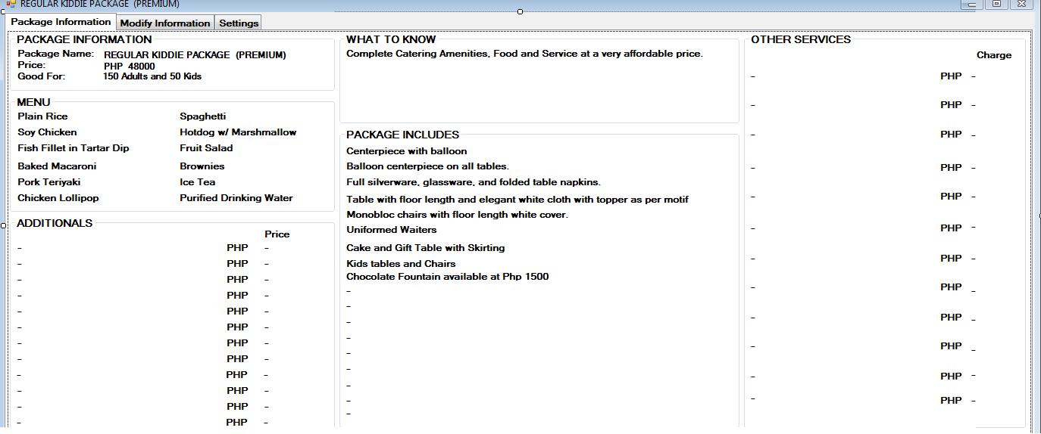

*Fig 11-D.17 Regular-Premium Kiddie Package (1)*

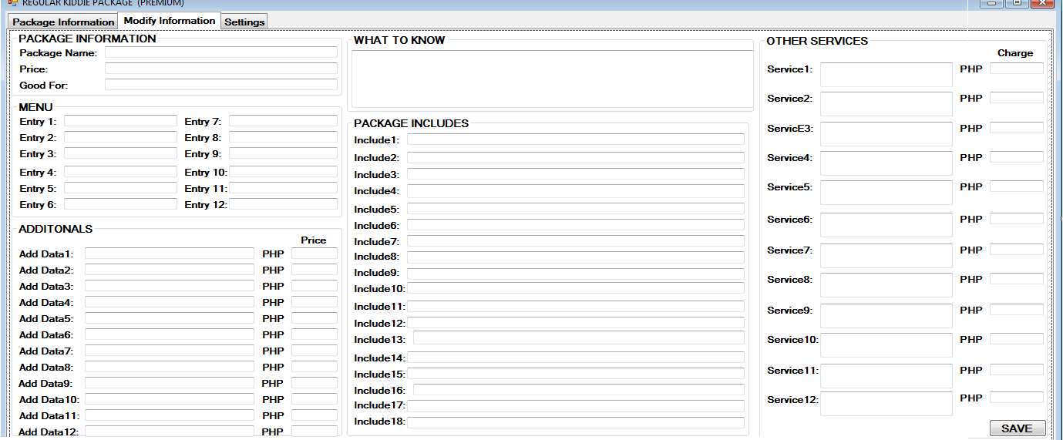

*Fig 11-D.17 Regular-Premium Kiddie Package (2)*

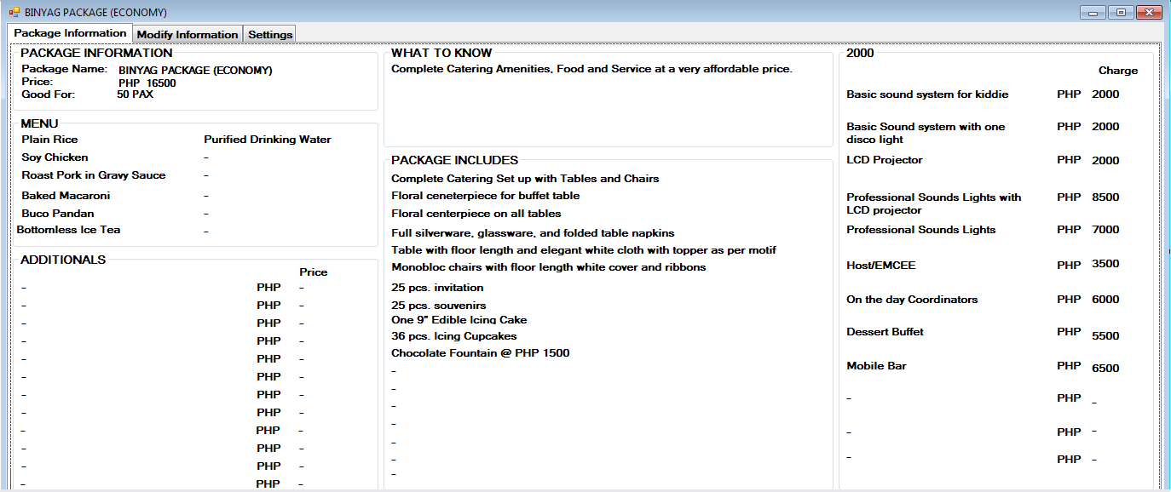

*Fig 11-D.18 Economy Binyag Package (1)*

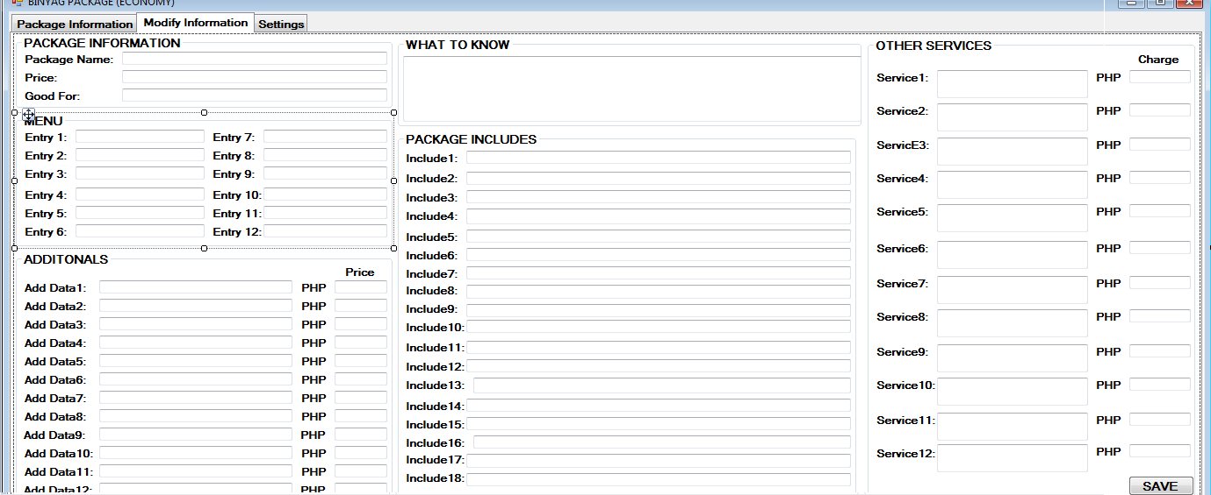

*Fig 11-D.18 Economy Binyag Package (2)*

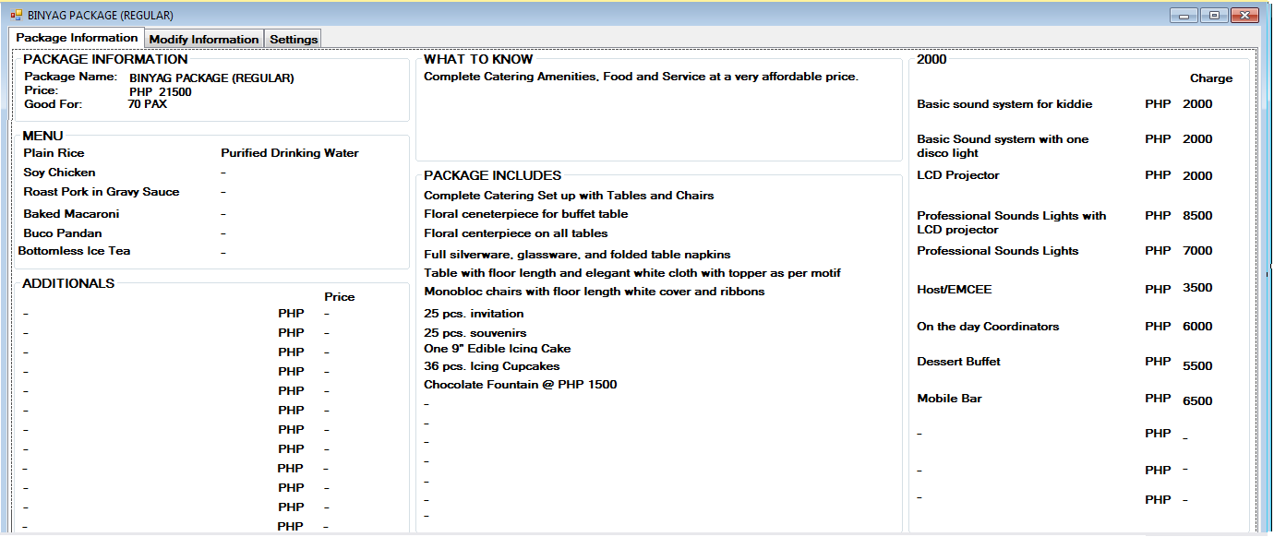

*Fig 11-D.19 Regular Binyag Package (1)*

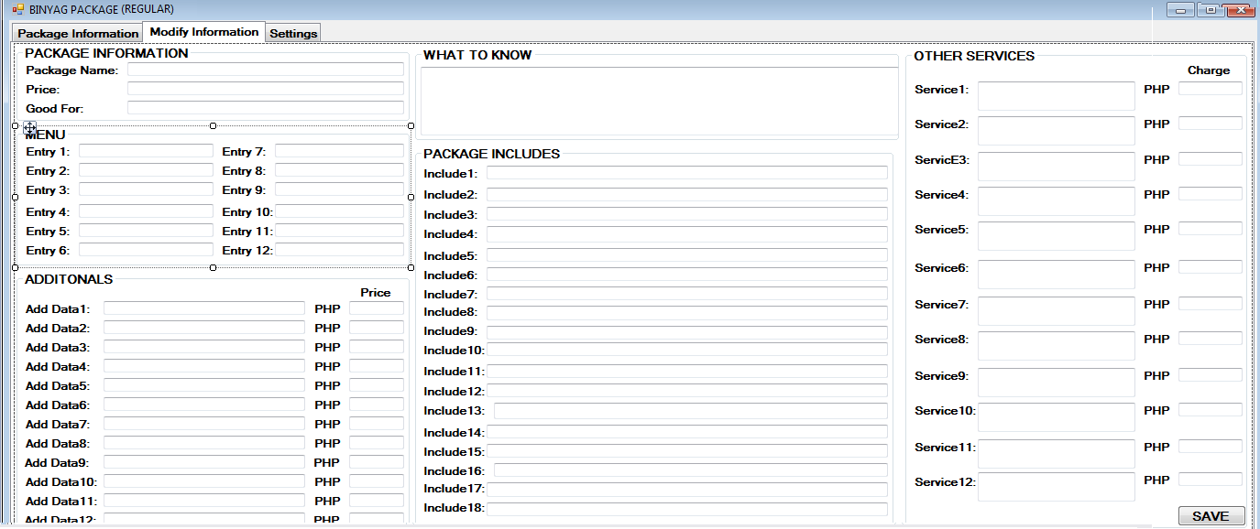

*Fig 11-D.19 Regular Binyag Package (2)*

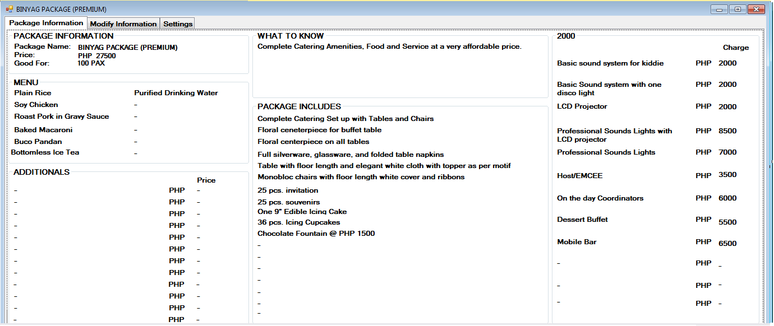

*Fig 11-D.20 Premium Binyag Package (1)*

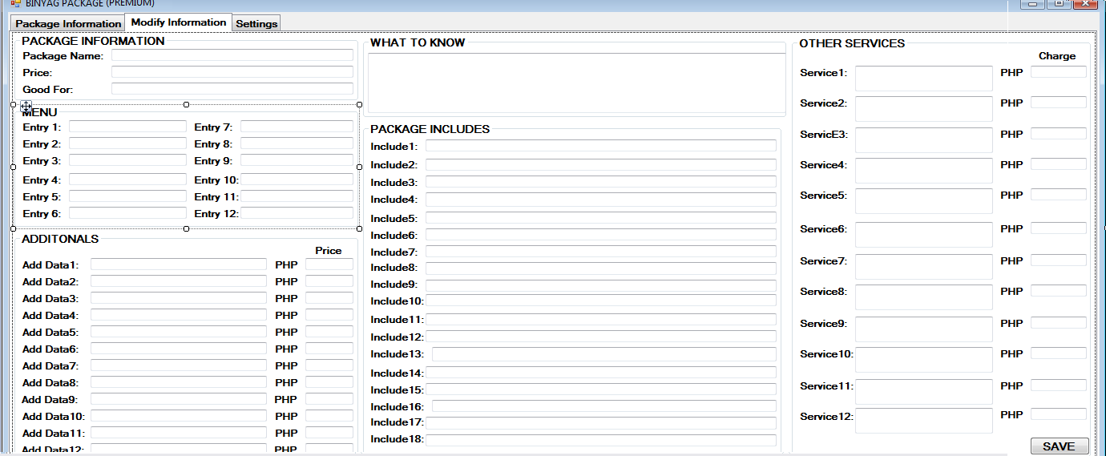

*Fig 11-D.20 Premium Binyag Package (2)*

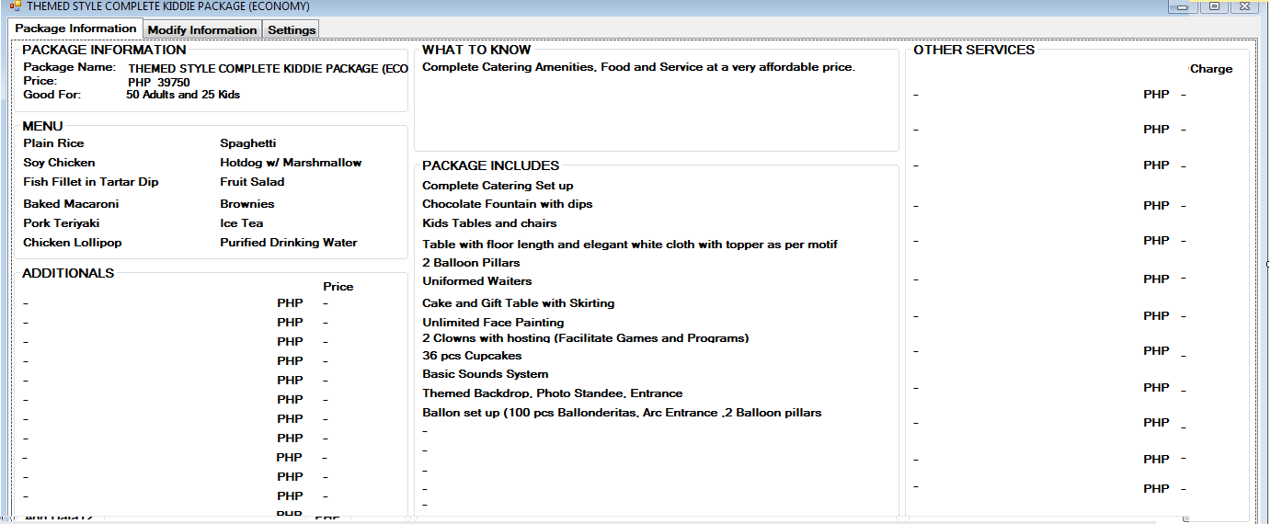

*Fig 11-D.21 Economy Themed style complete package (1)*

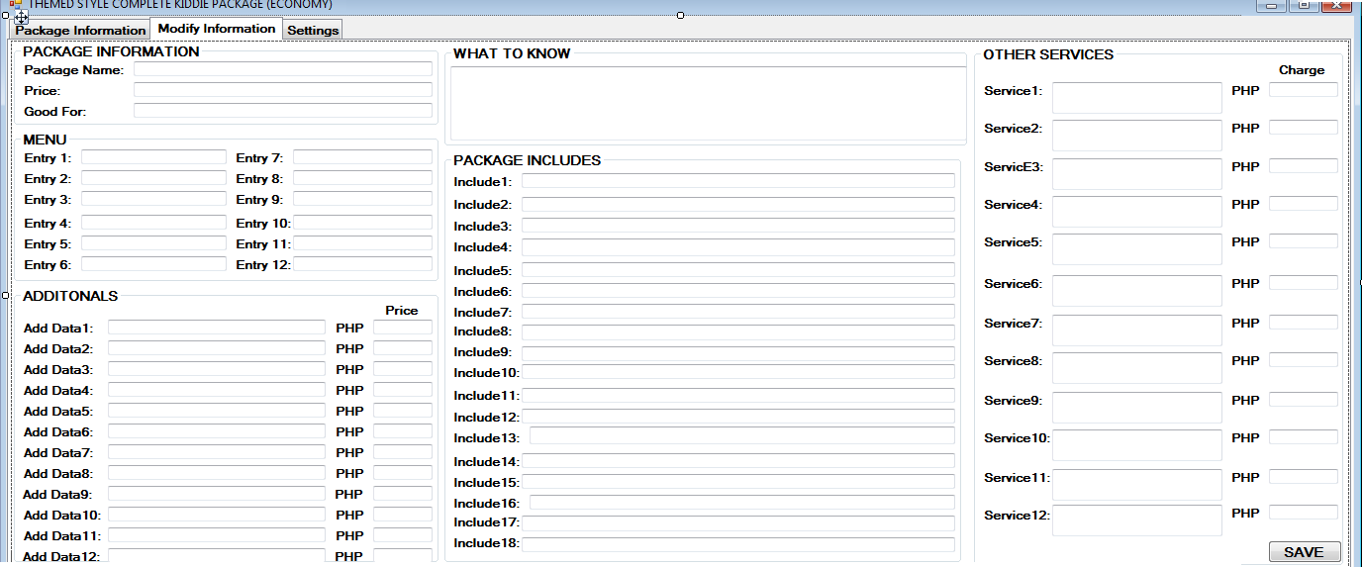

*Fig 11-D.21 Economy Themed style complete package (2)*

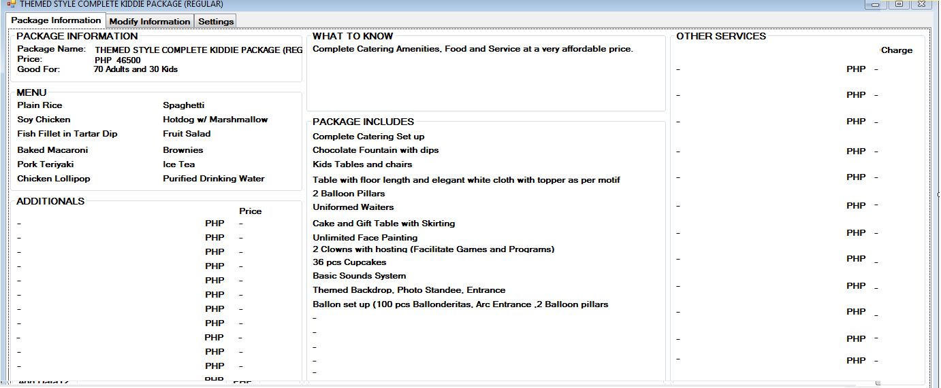

*Fig 11-D.22 Regular Themed style complete package (1)*

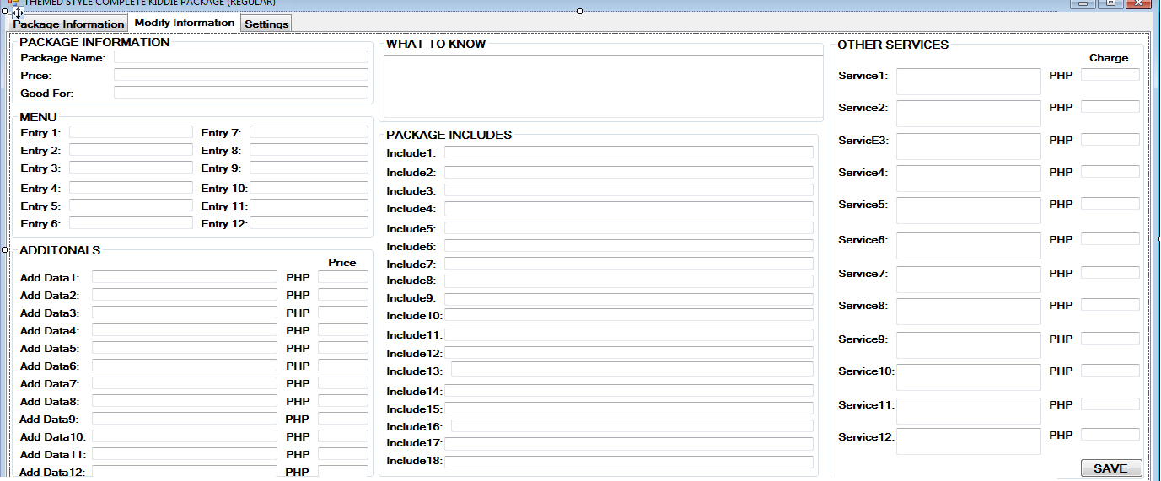

*Fig 11-D.22 Regular Themed style complete package (2)*

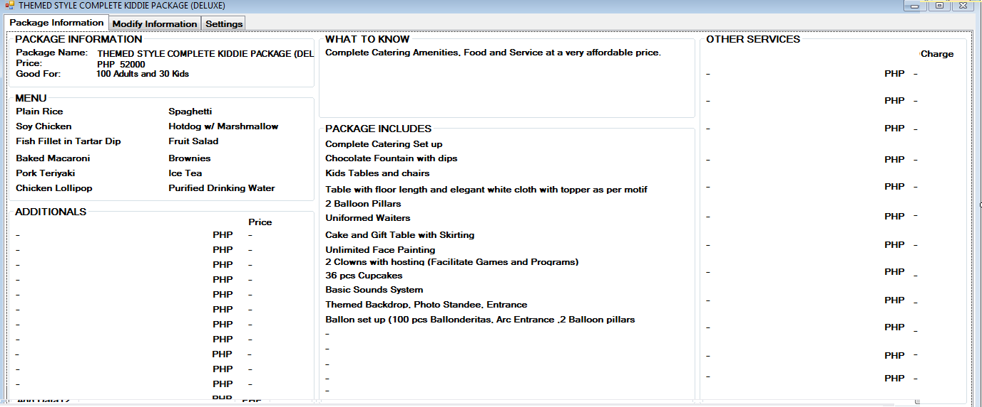

*Fig 11-D.23 Deluxe Themed style complete package (1)*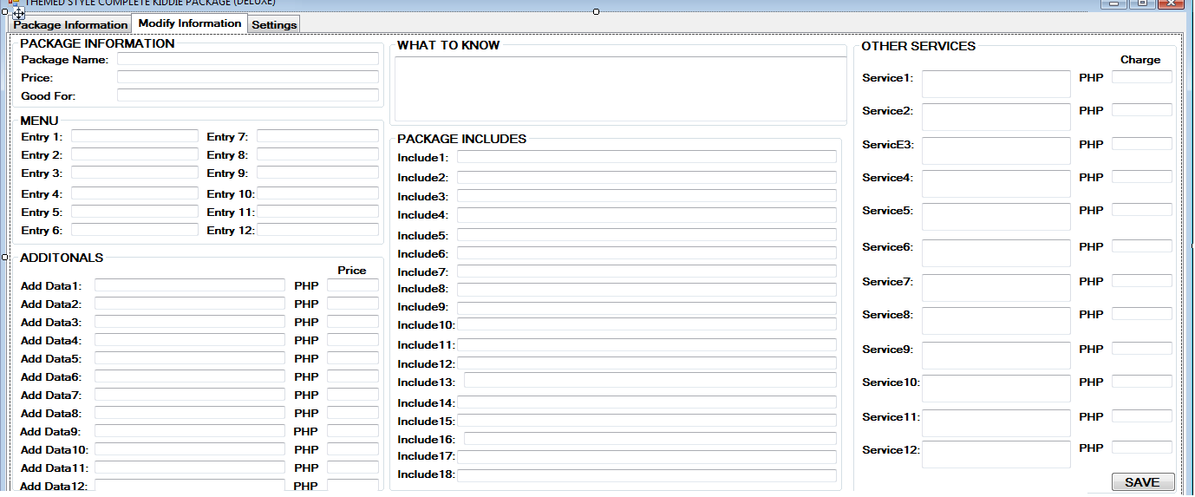

*Fig 11-D.23 Deluxe Themed style complete package (2)*

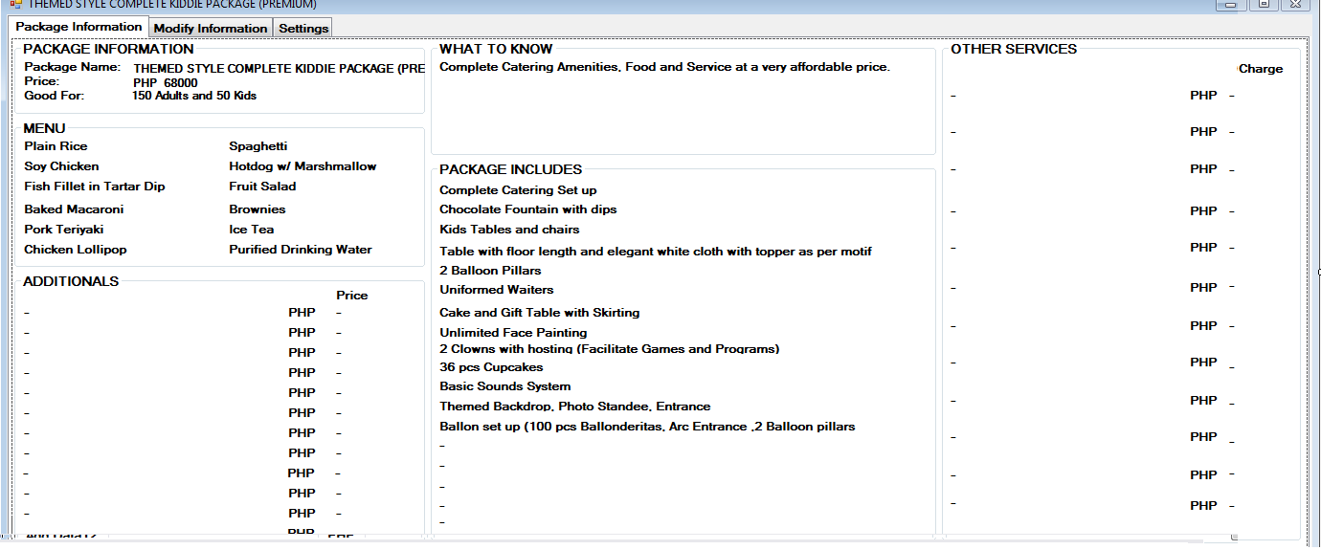

*Fig 11-D.24 Premium Themed style complete package (1)*

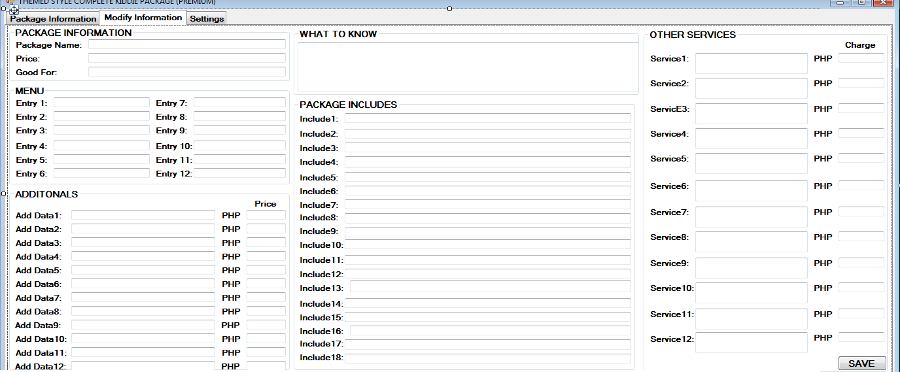

*Fig 11-D.24 Premium Themed style complete package (2)*

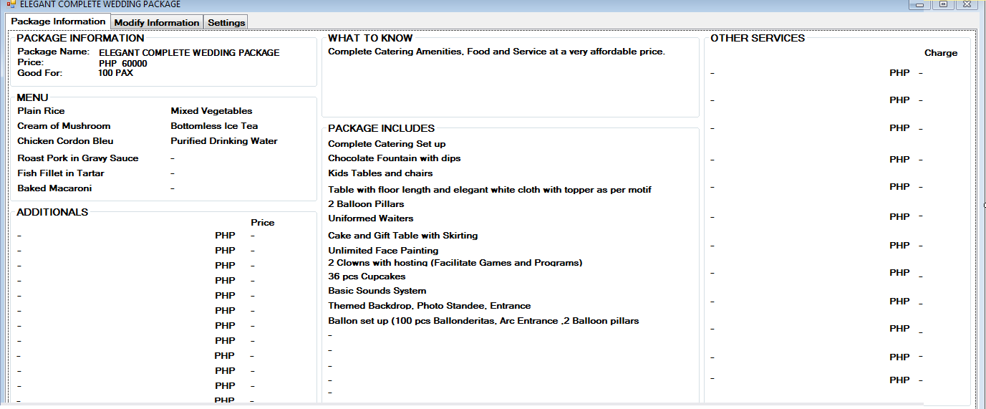

*Fig 11-D.25 Elegant complete Wedding package (1)*

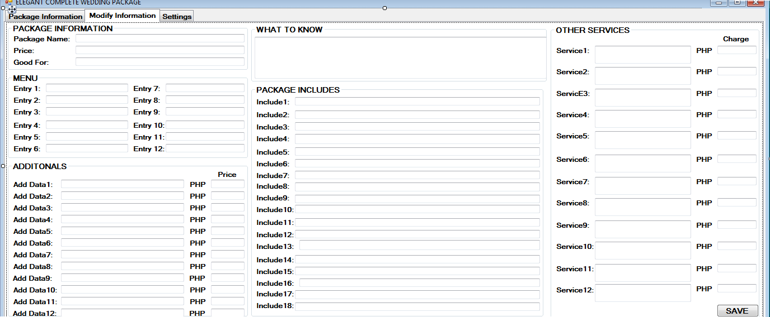

*Fig 11-D.25 Elegant complete Wedding package (2)*

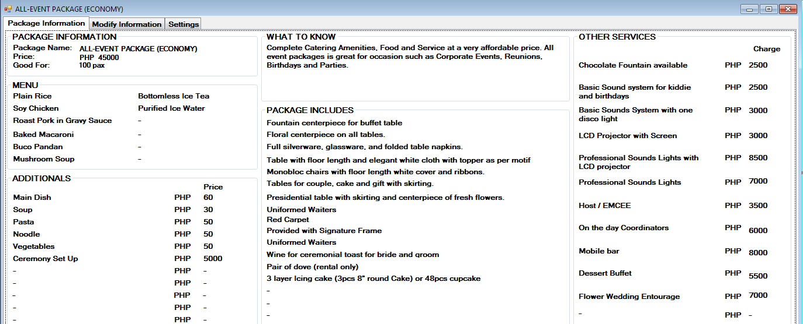

*Fig 11-D.26 Economy All event package (1)*

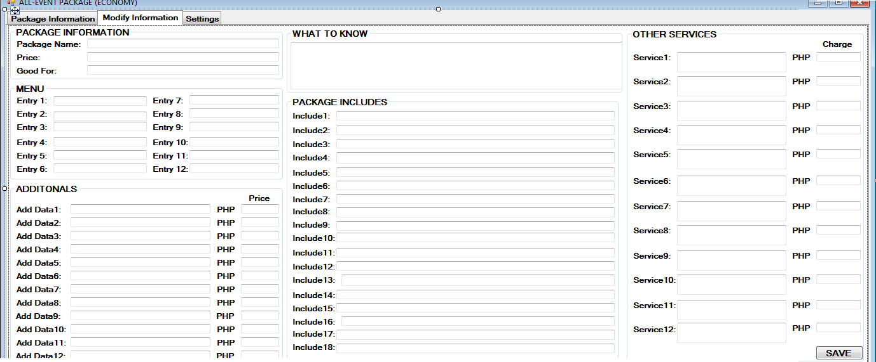

*Fig 11-D.26 Economy All event package (1)*

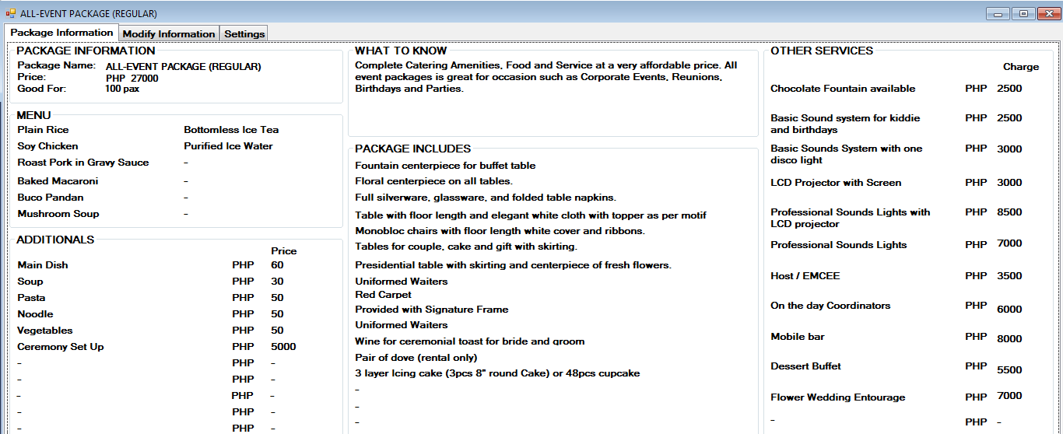

*Fig 11-D.27 Regular All event package (1)*

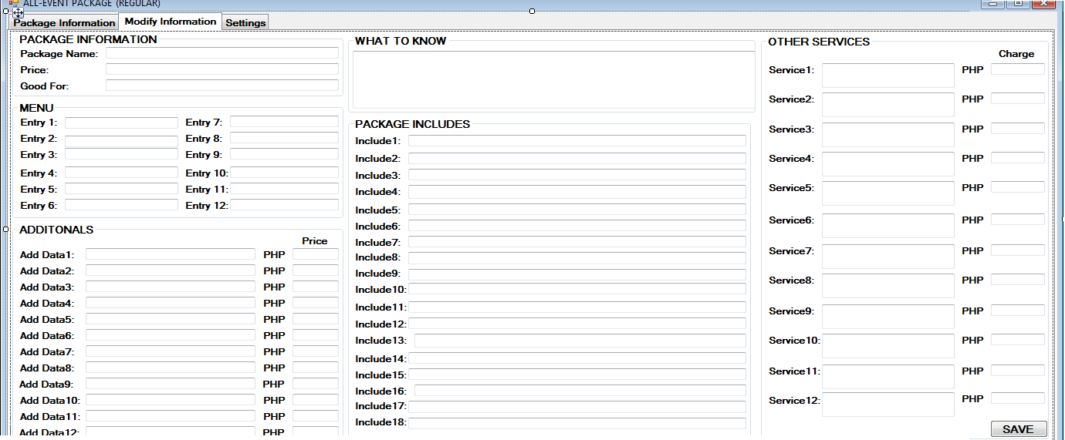

*Fig 11-D.27 Regular All event package (2)*

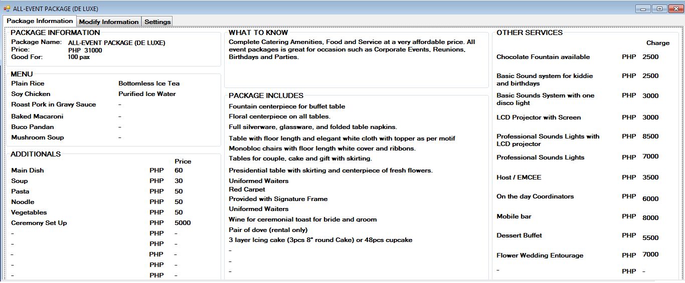

*Fig 11-D.28 Deluxe All event package (1)*

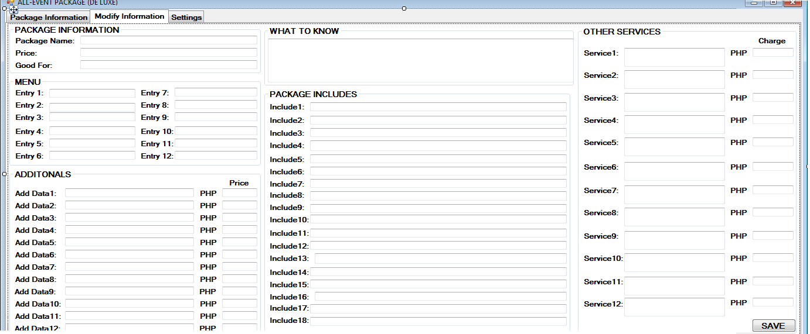

*Fig 11-D.28 Deluxe All event package (2)*

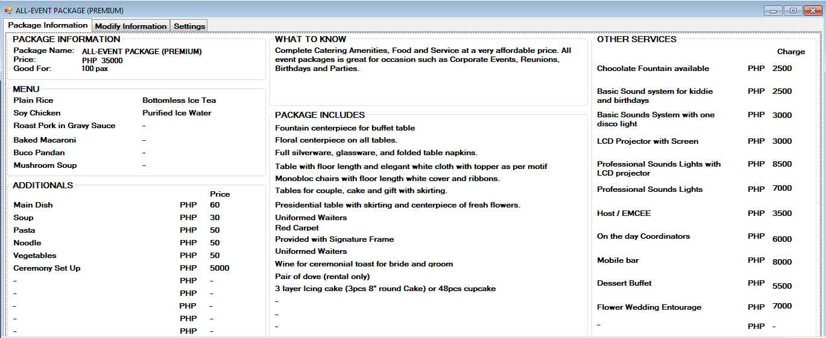

*Fig 11-D.29 Premium All event package (1)*

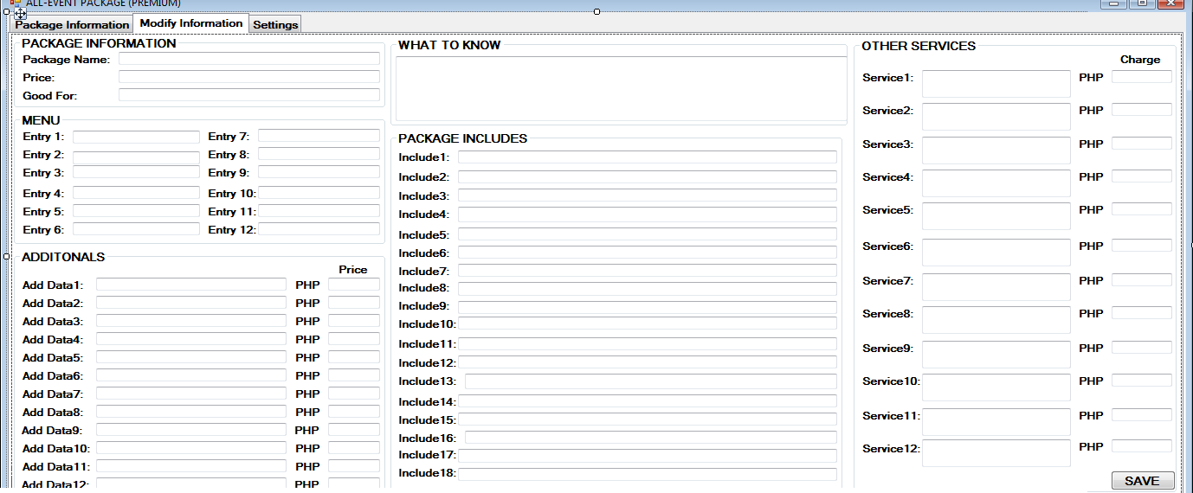

*Fig 11-D.29 Premium All event package (2)*

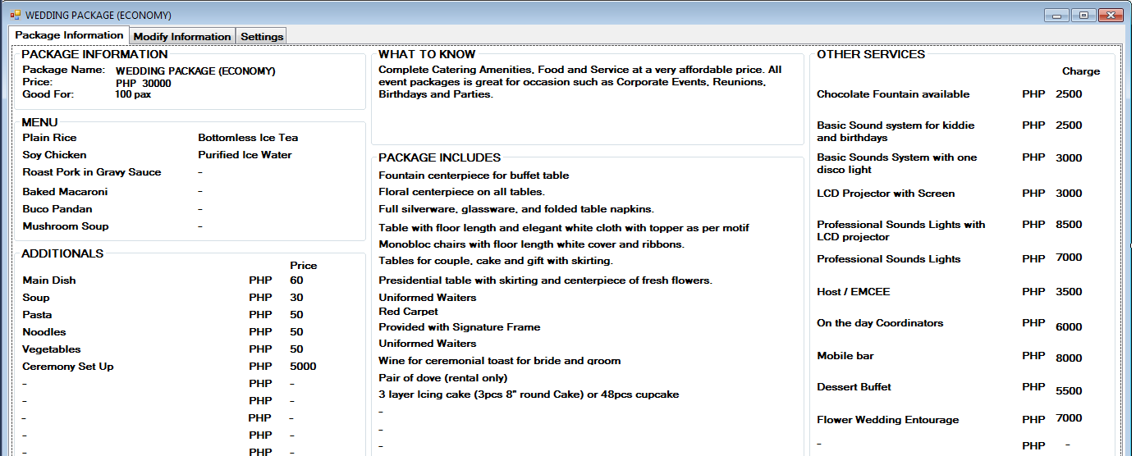

*Fig 11-D.30 Economy Wedding package (1)*

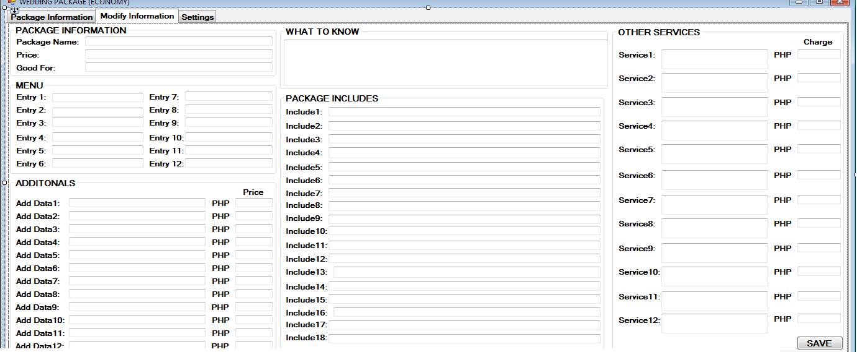

*Fig 11-D.30 Economy Wedding package (2)*

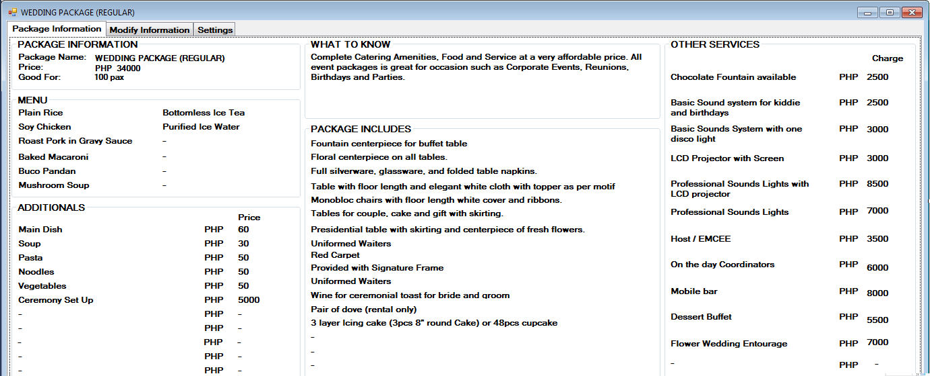

*Fig 11-D.31 Regular Wedding package (1)*

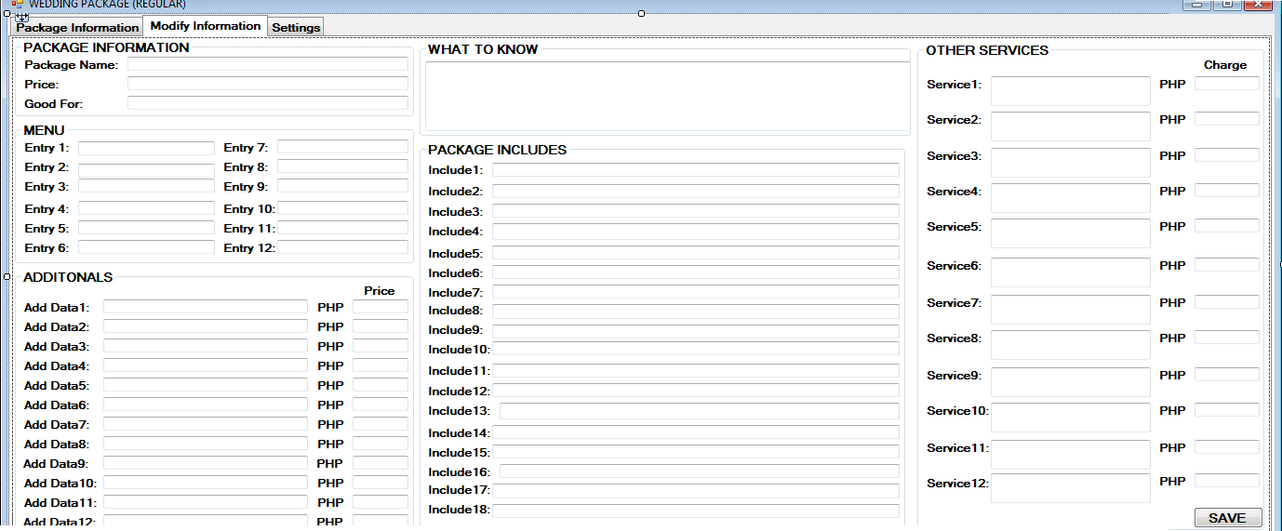

*Fig 11-D.31 Regular Wedding package (2)*

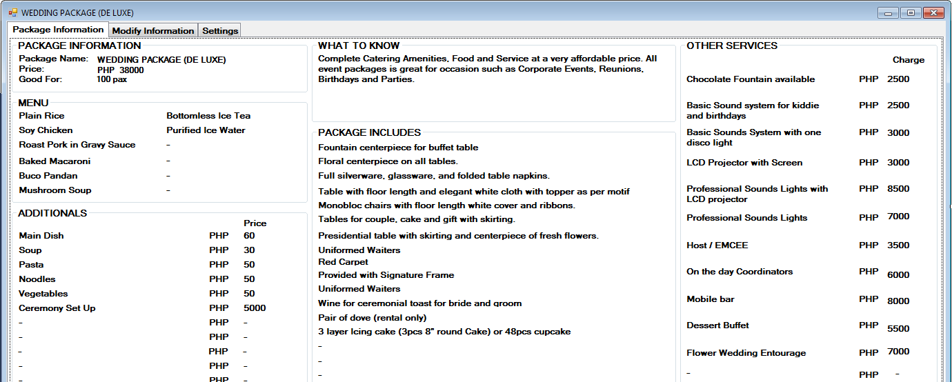

*Fig 11-D.32 Deluxe Wedding package (1)*

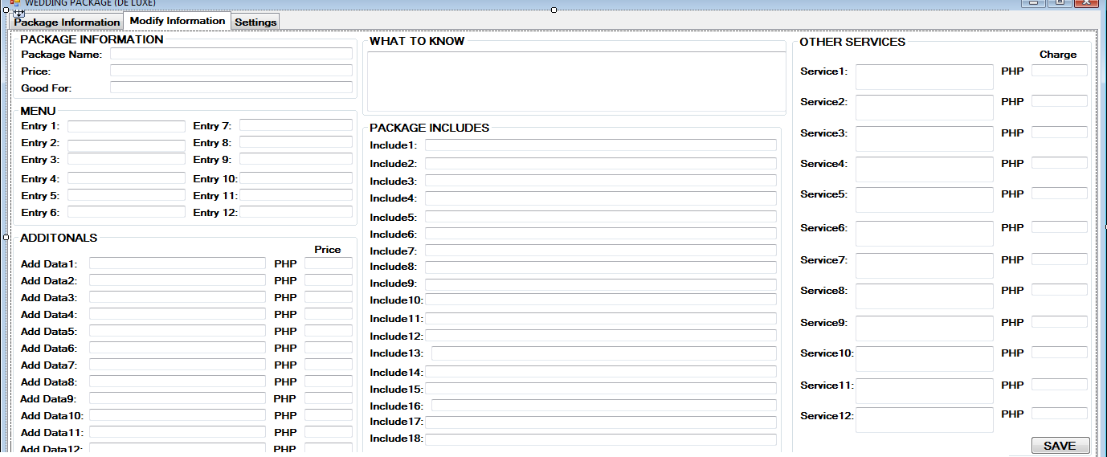

*Fig 11-D.32 Deluxe Wedding package (2)*

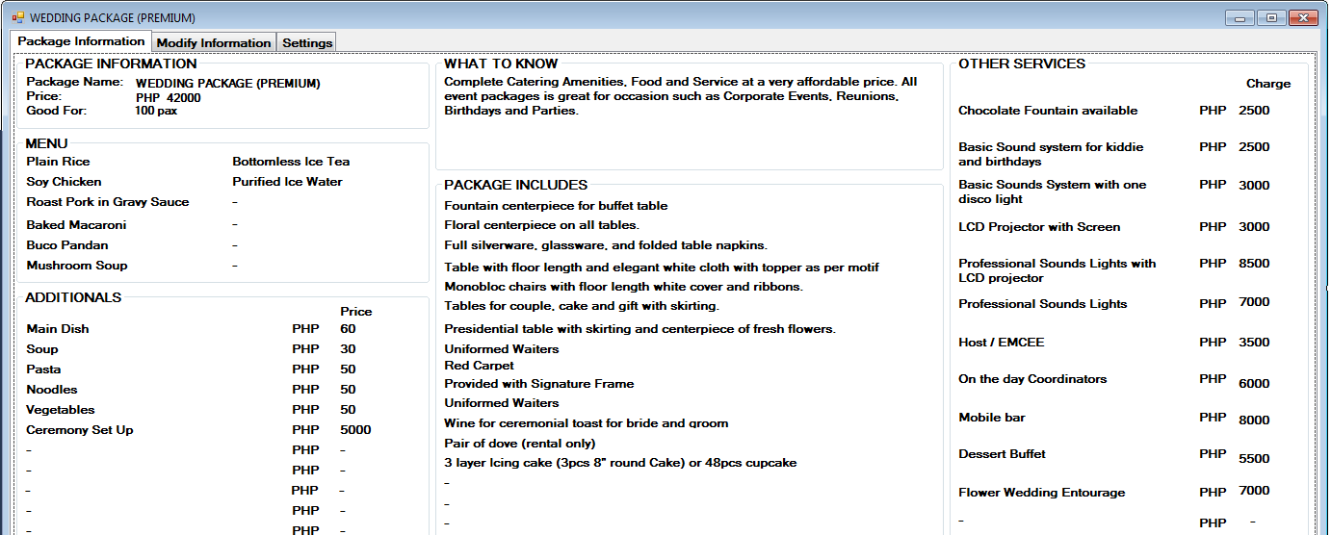

*Fig 11-D.33 Premium Wedding package (1)*

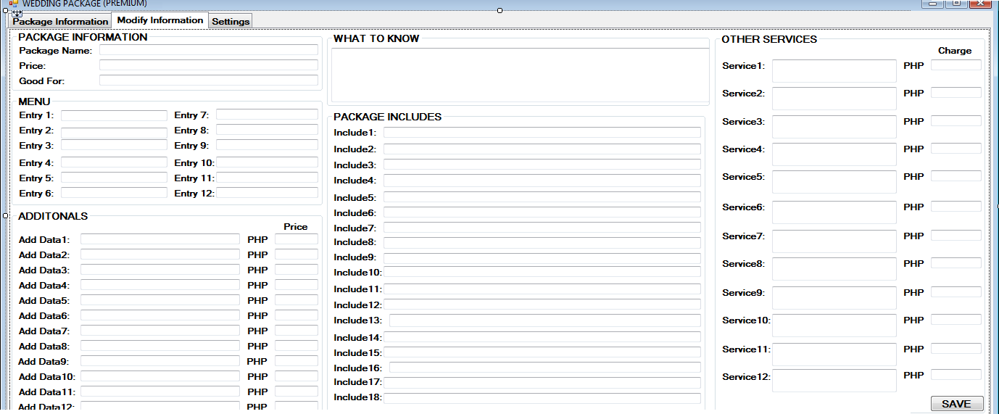

*Fig 11-D.33 Premium Wedding package (2)*

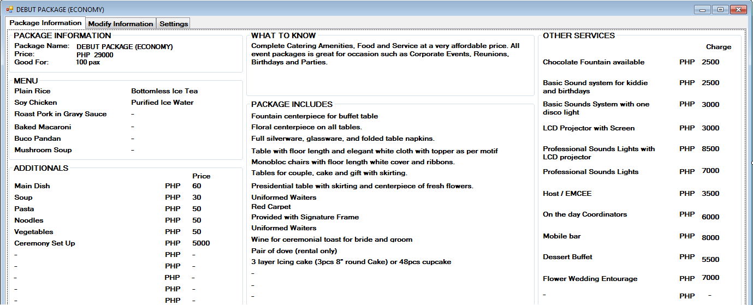

*Fig 11-D.34 Economy Debut package (1)*

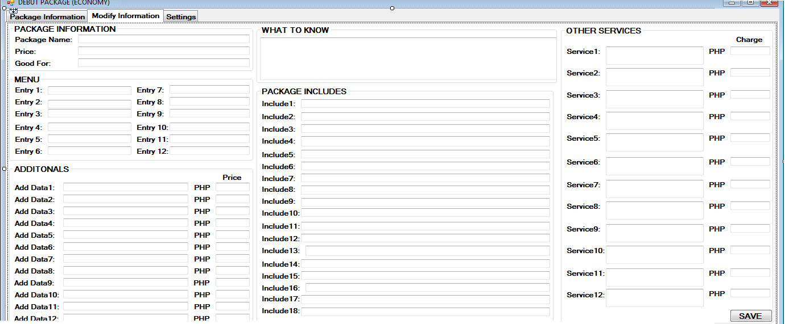

*Fig 11-D.34 Economy Debut package (2)*

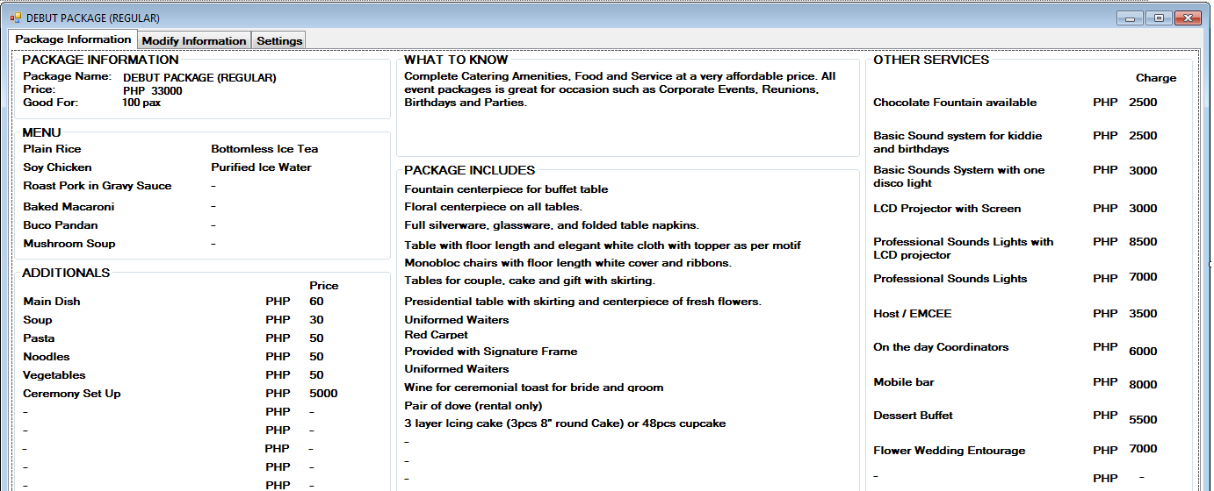

*Fig 11-D.35 Regular Debut package (1)*

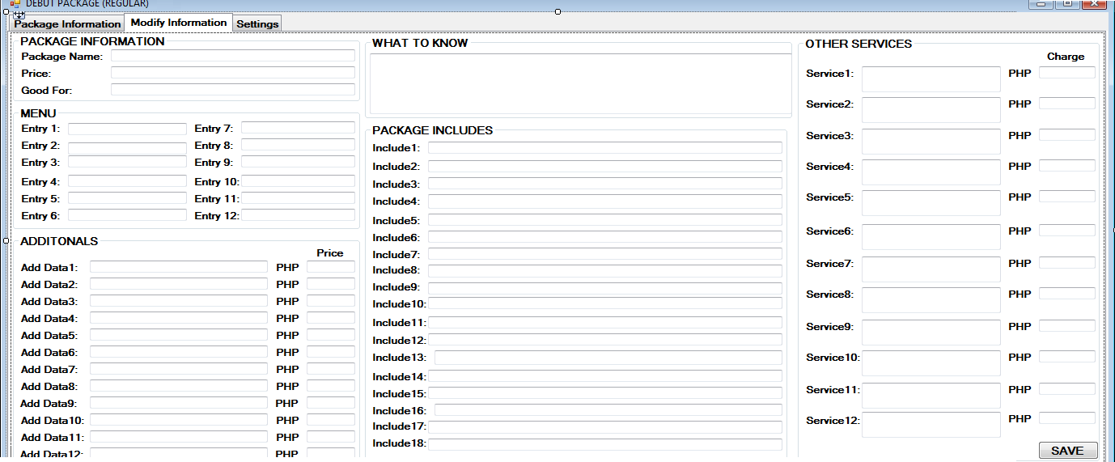

*Fig 11-D.35 Regular Debut package (2)*

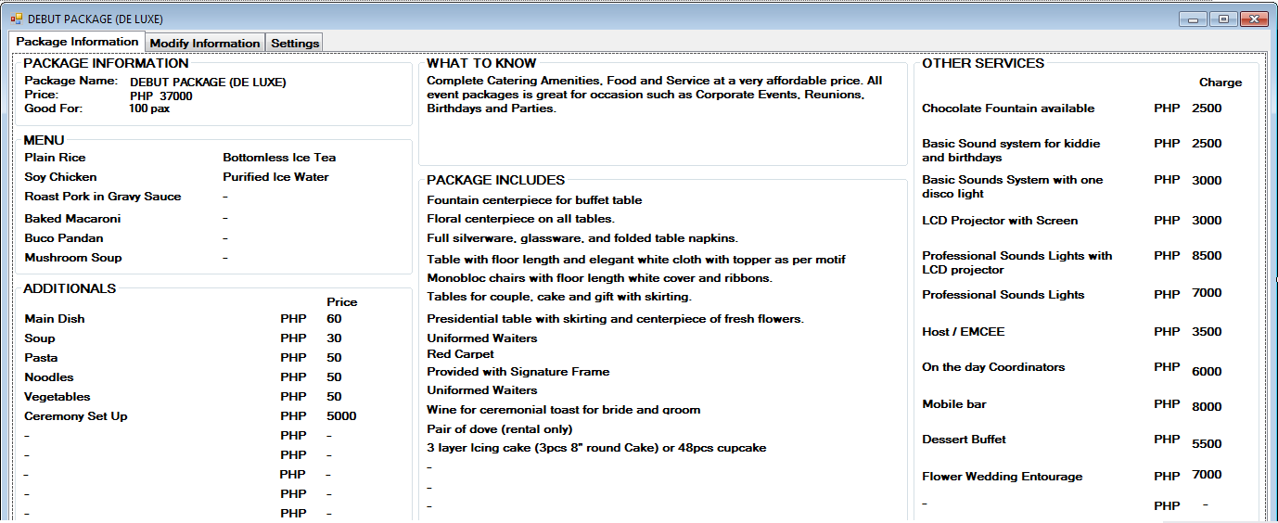

*Fig 11-D.36 Deluxe Debut package (1)*

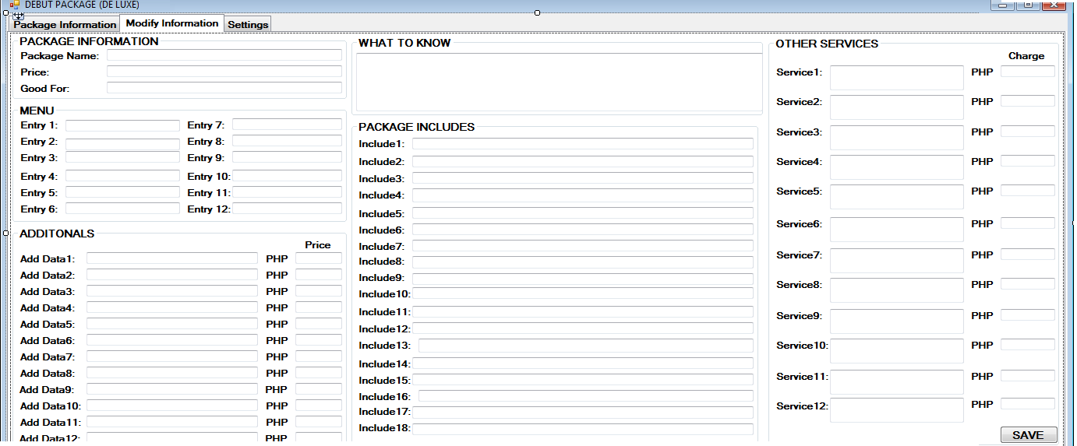

*Fig 11-D.36 Deluxe Debut package (2)*

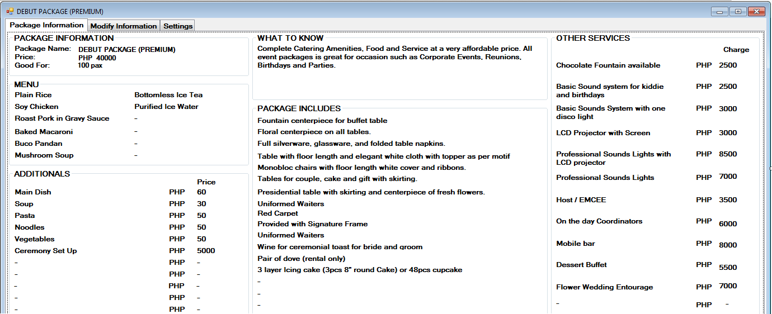

*Fig 11-D.37 Premium Debut package (1)*

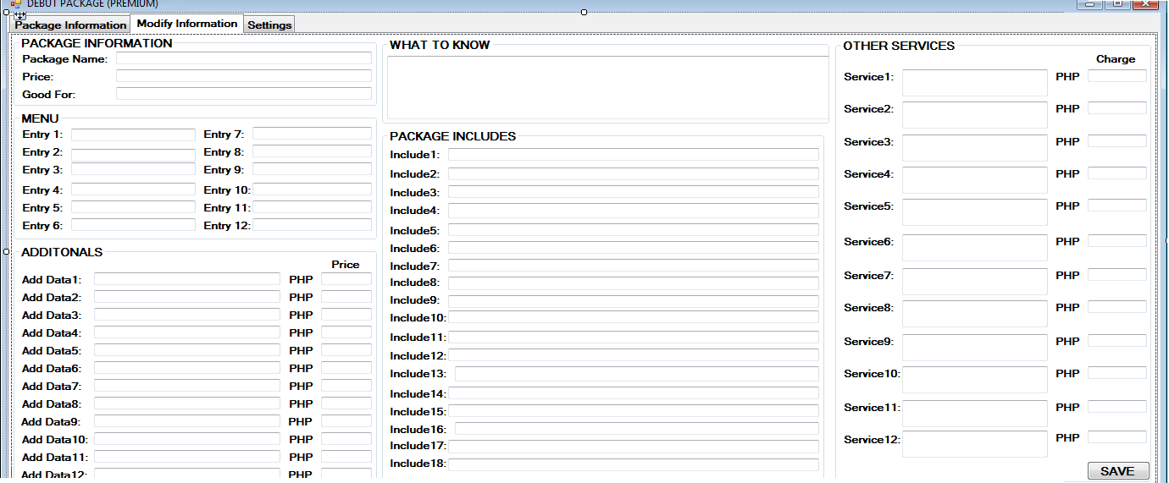

*Fig 11-D.37 Premium Debut package (2)*

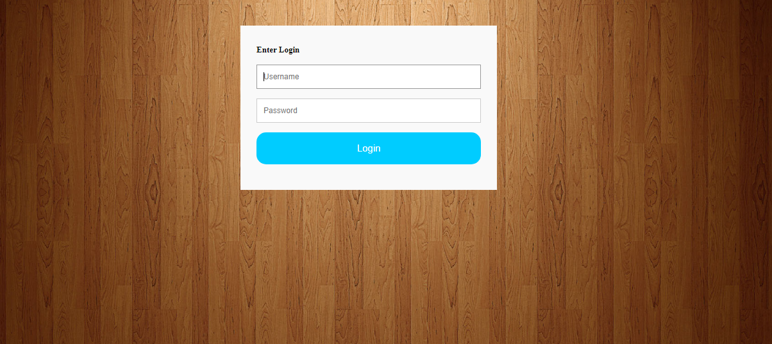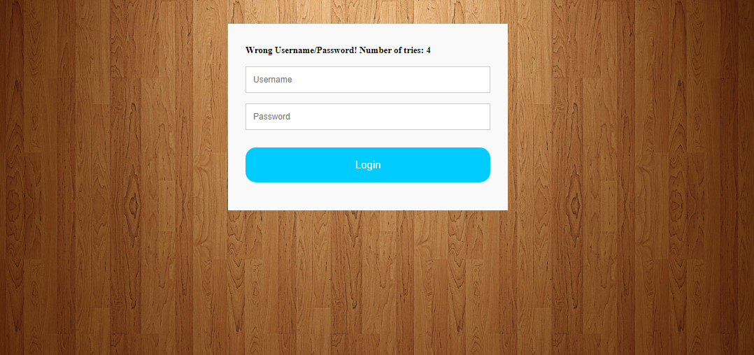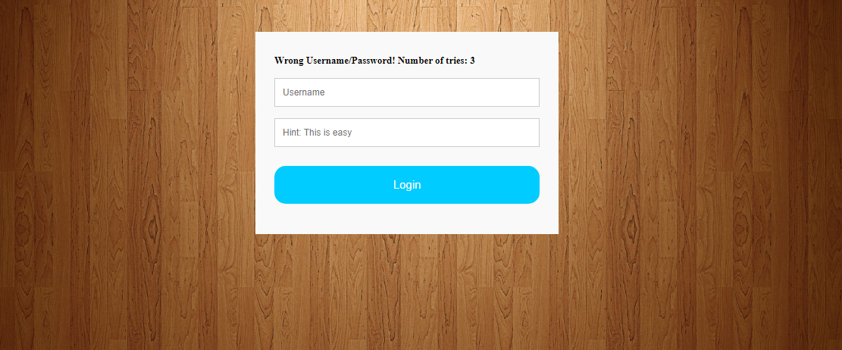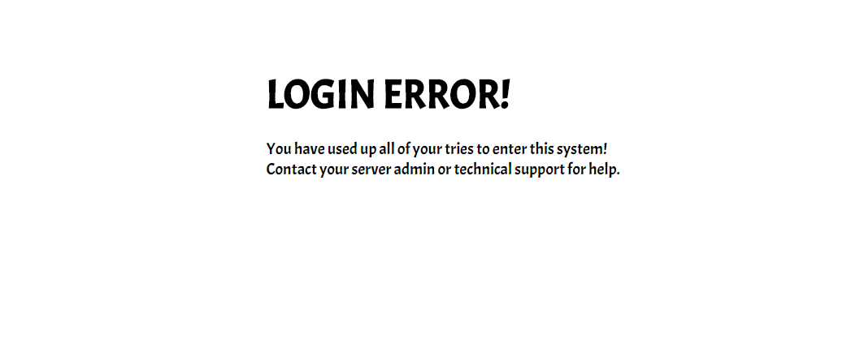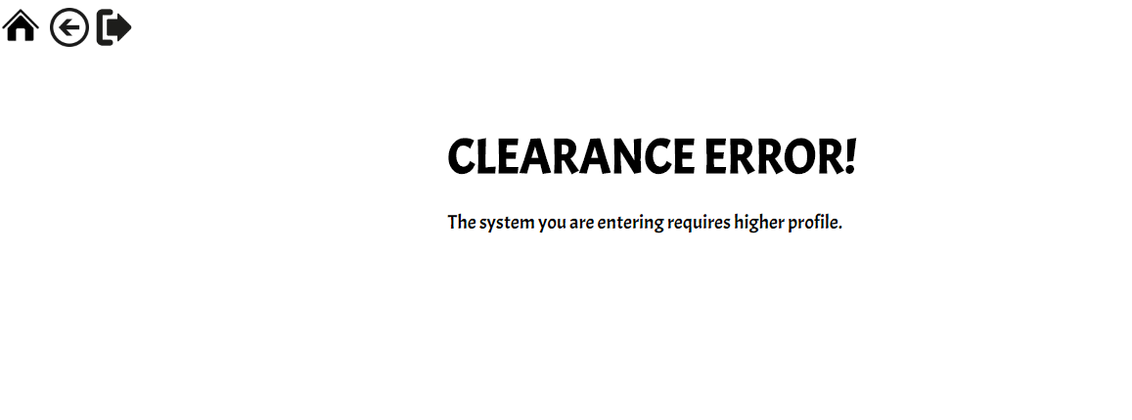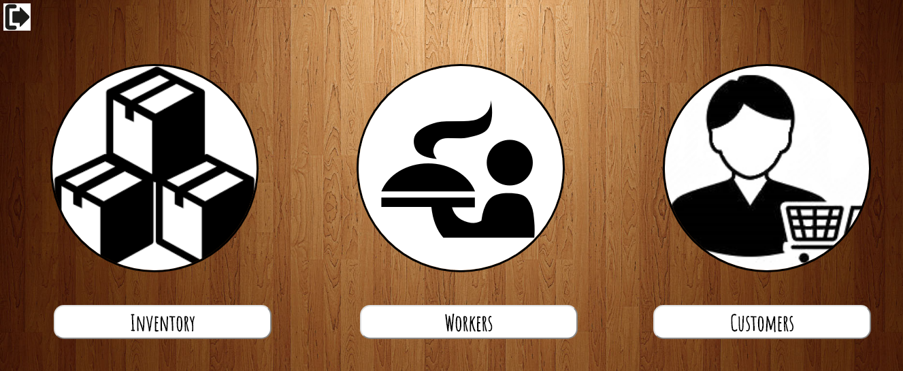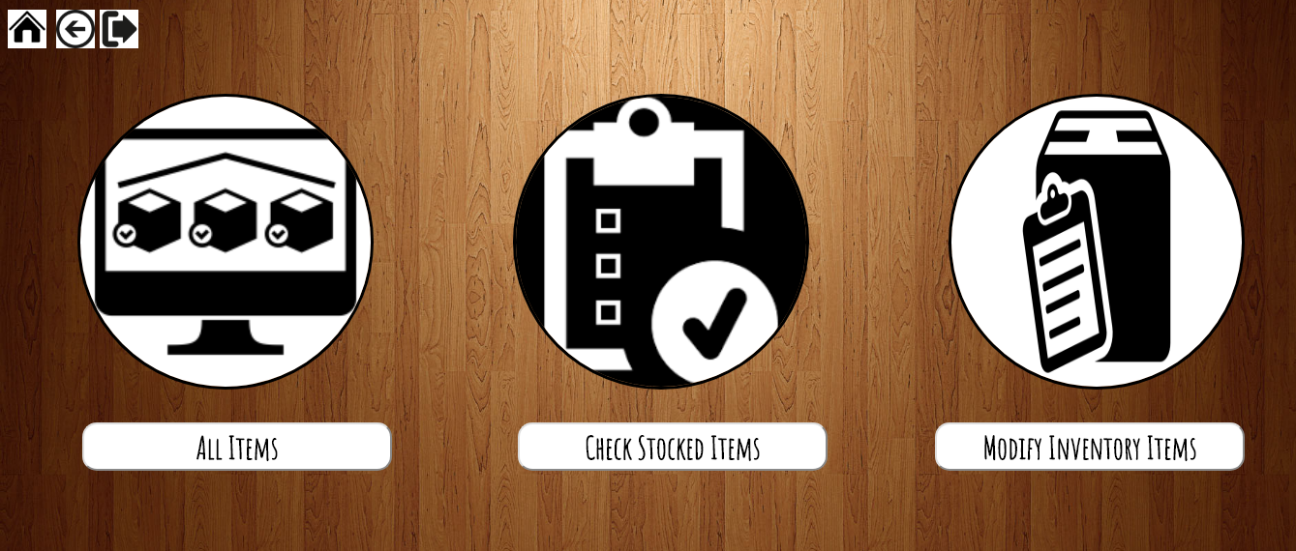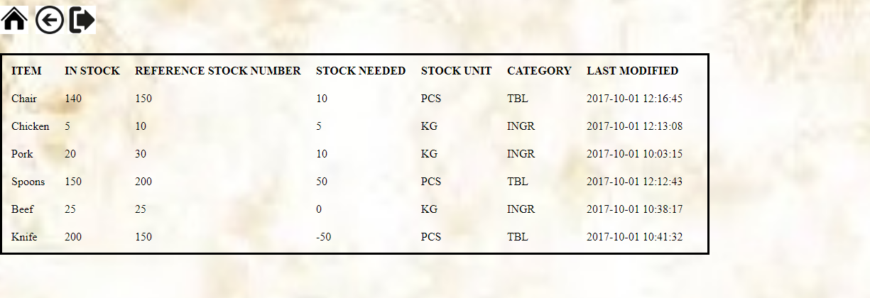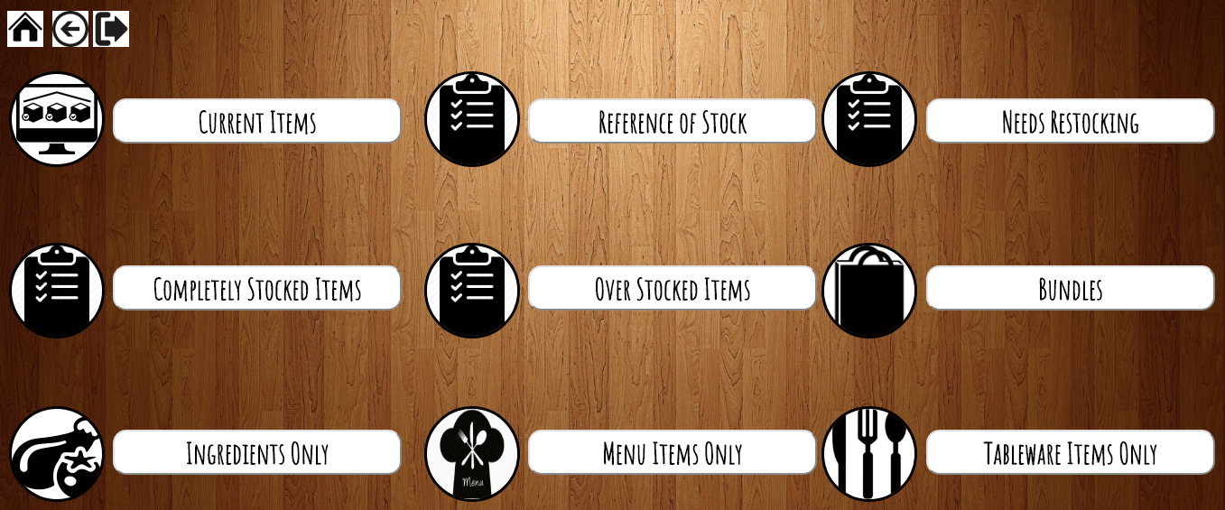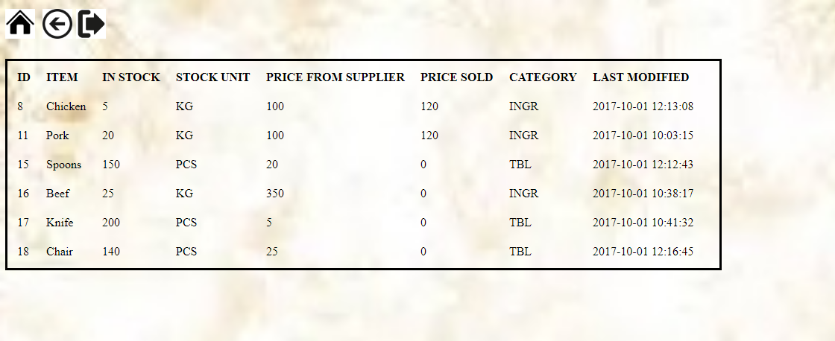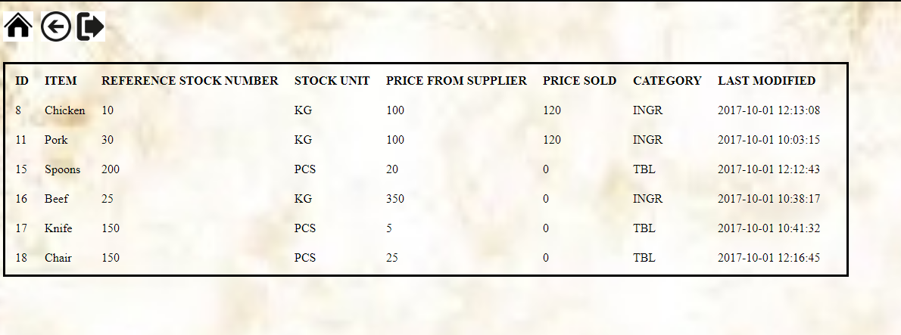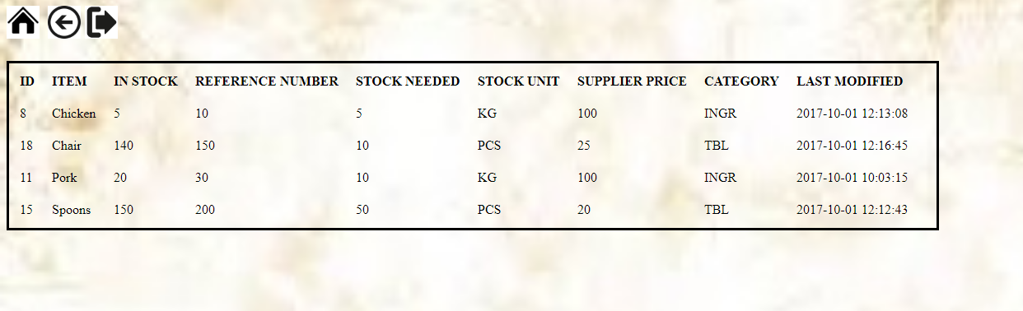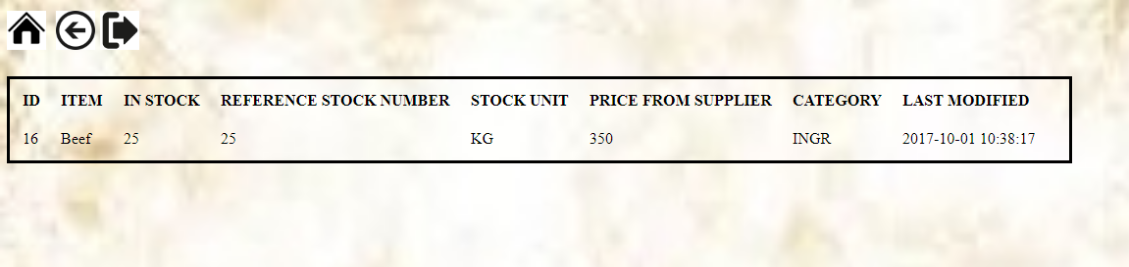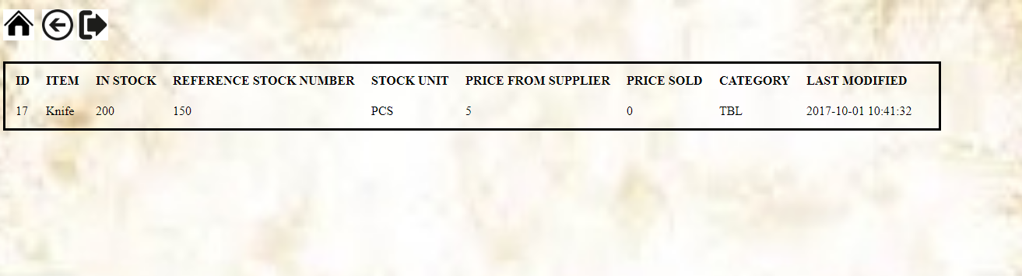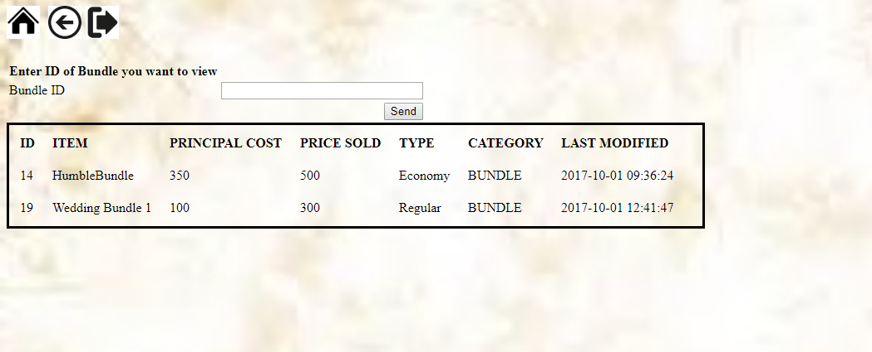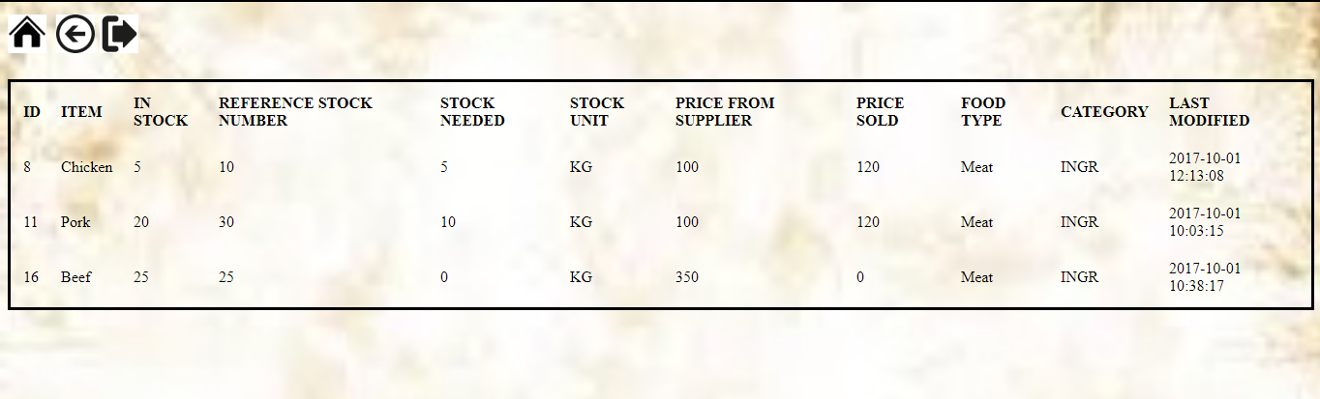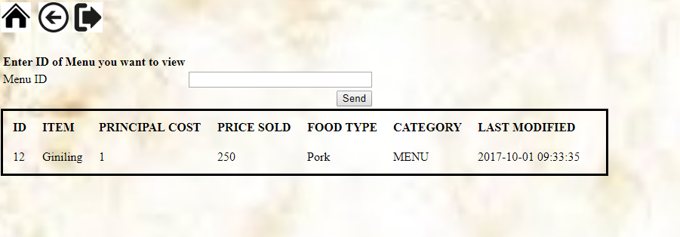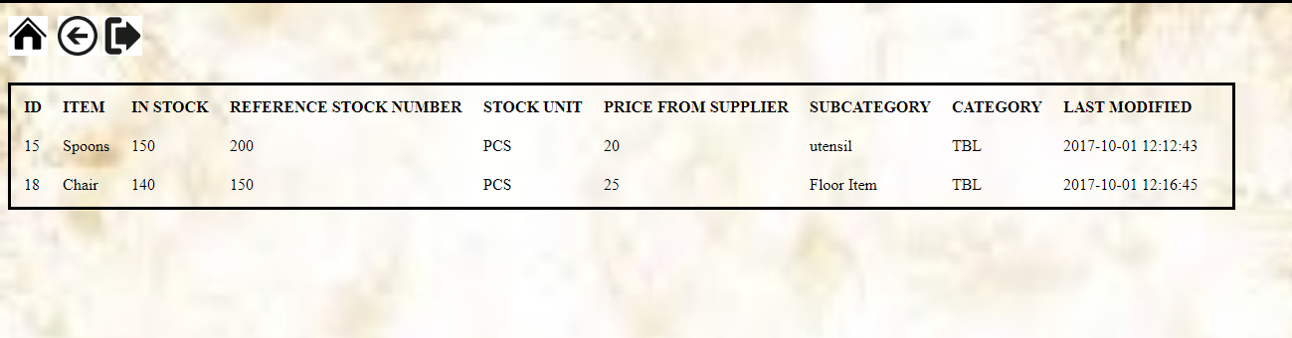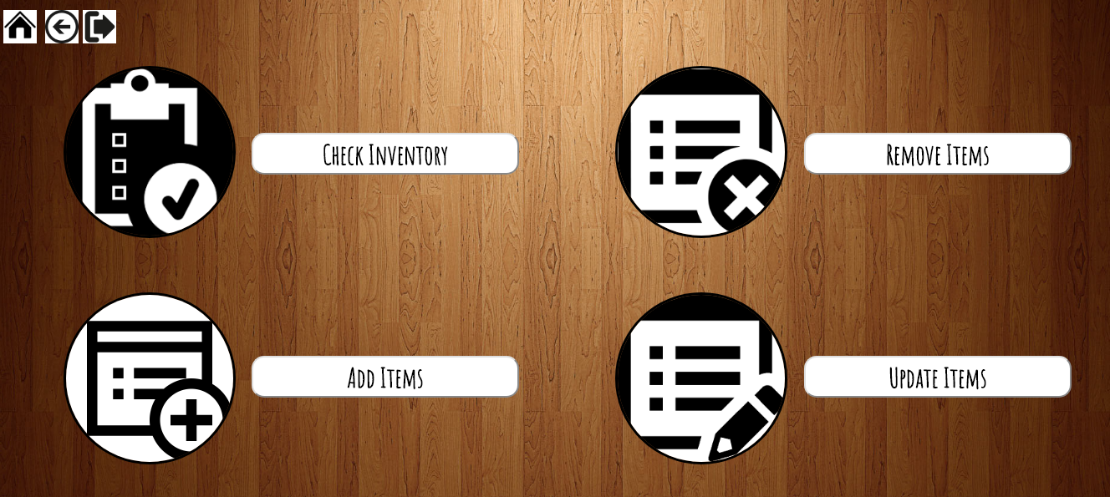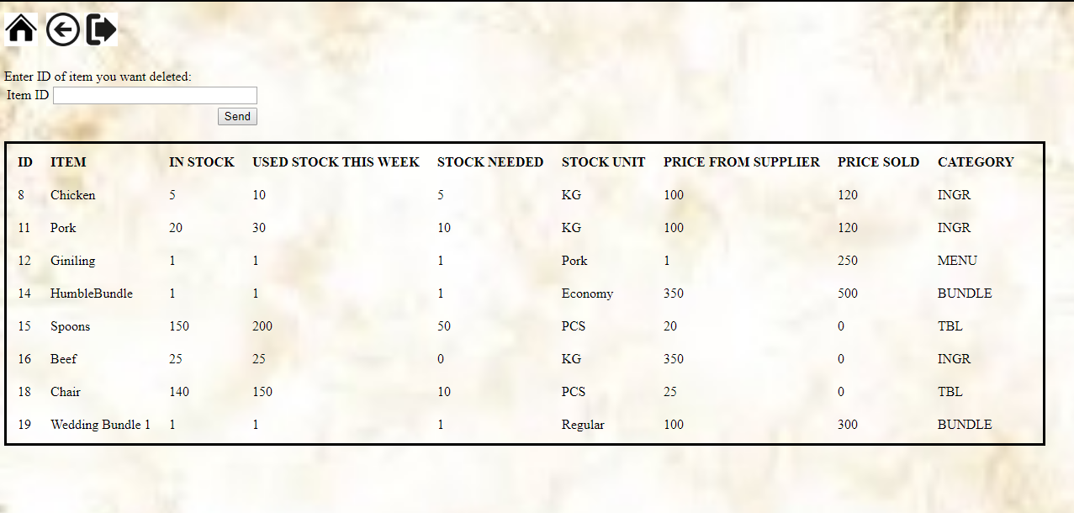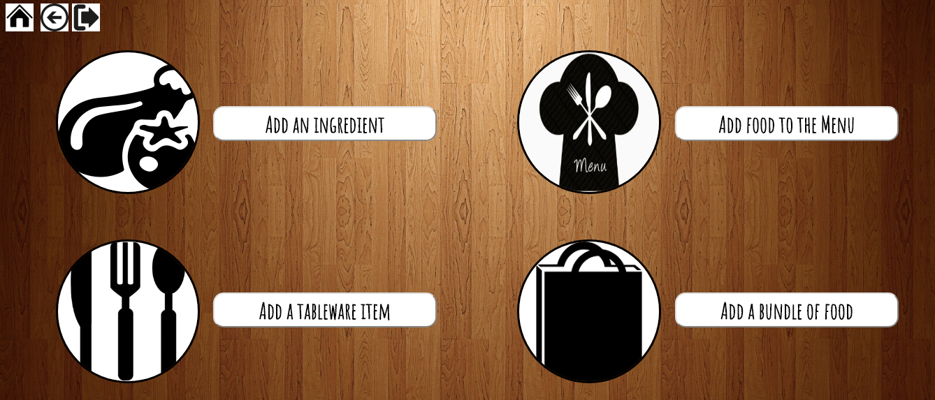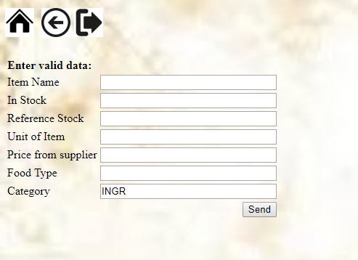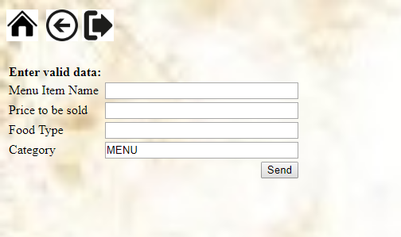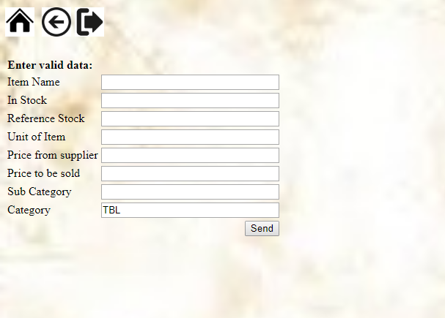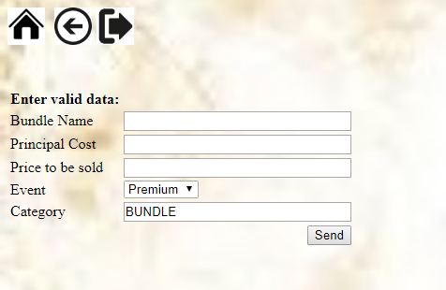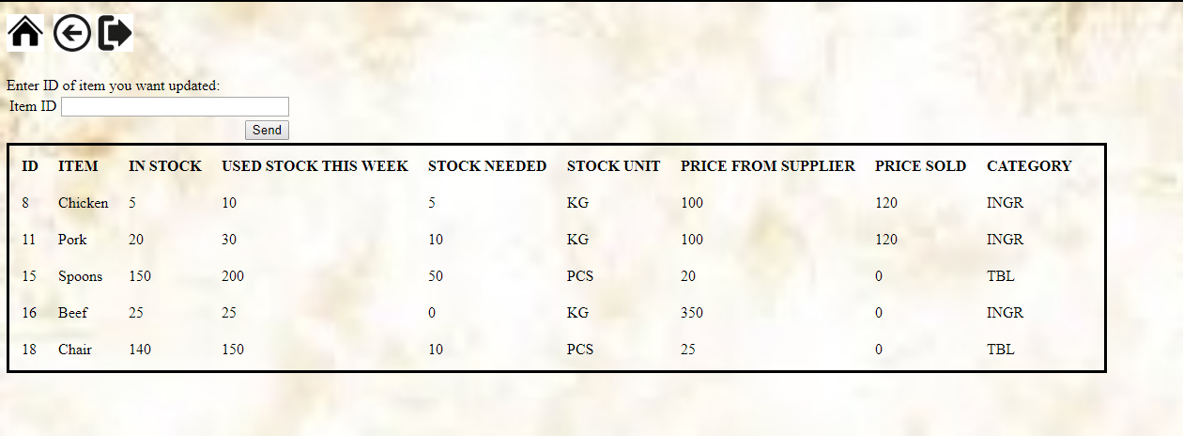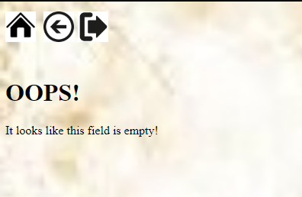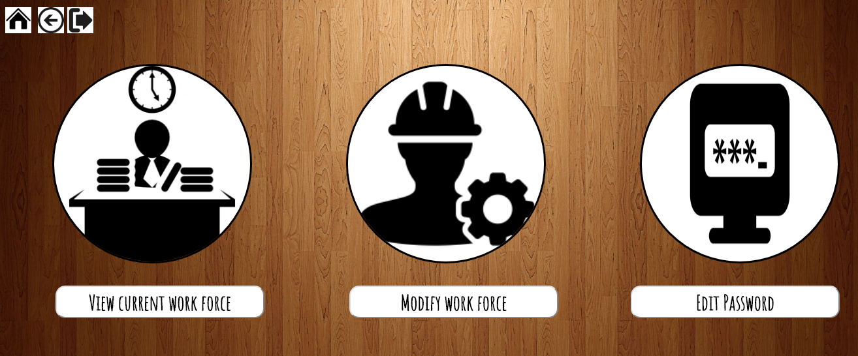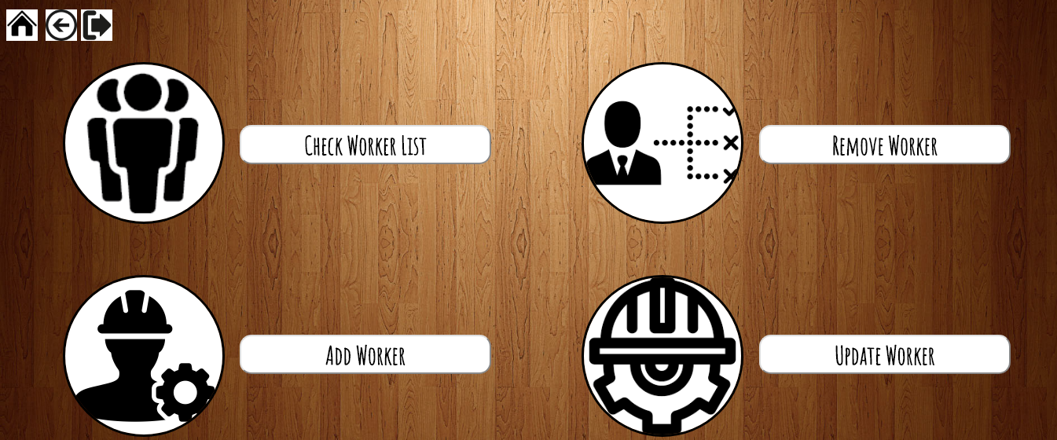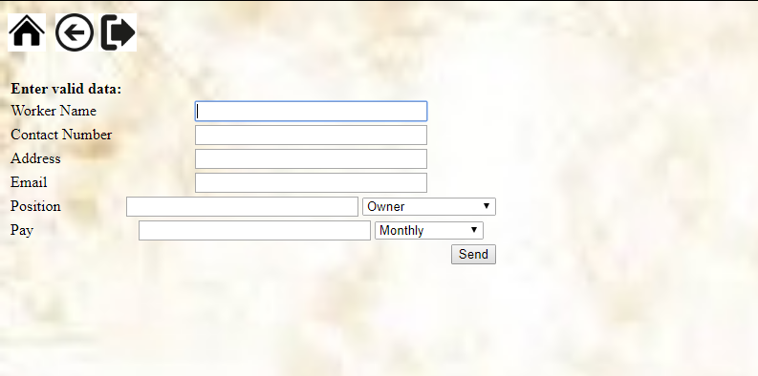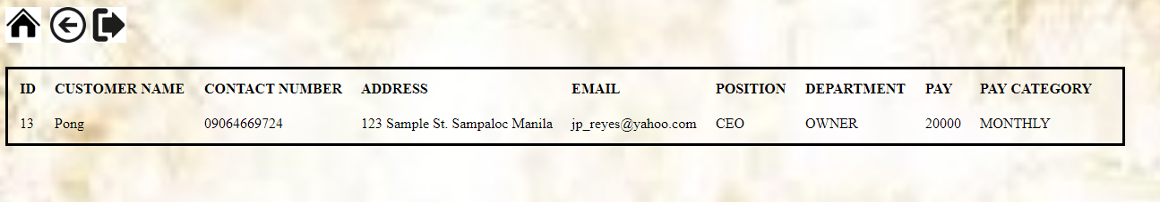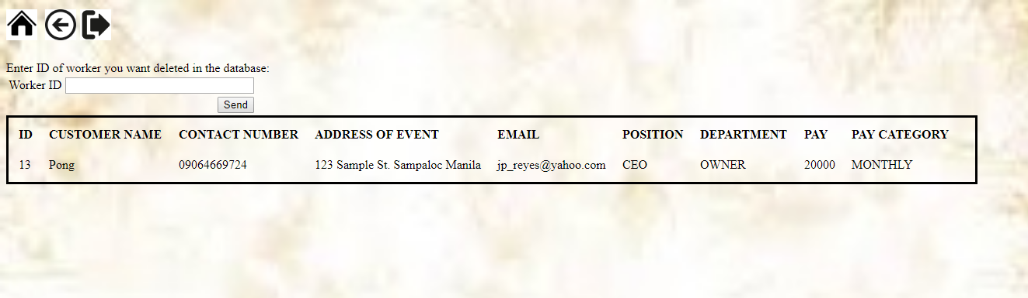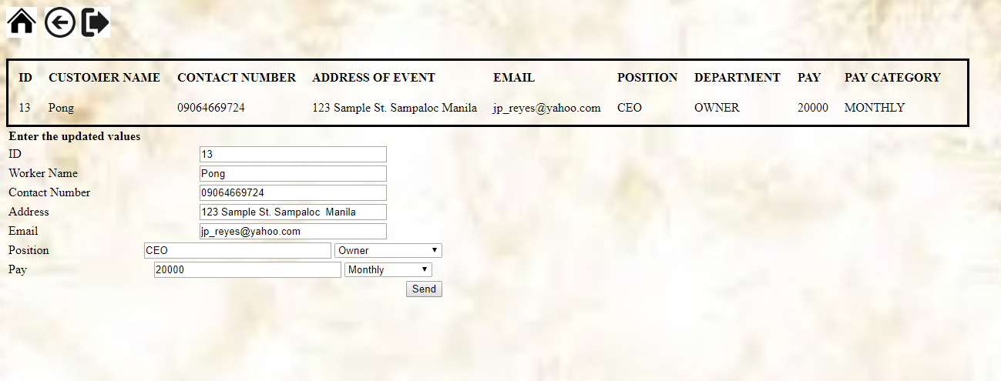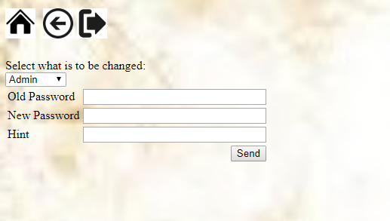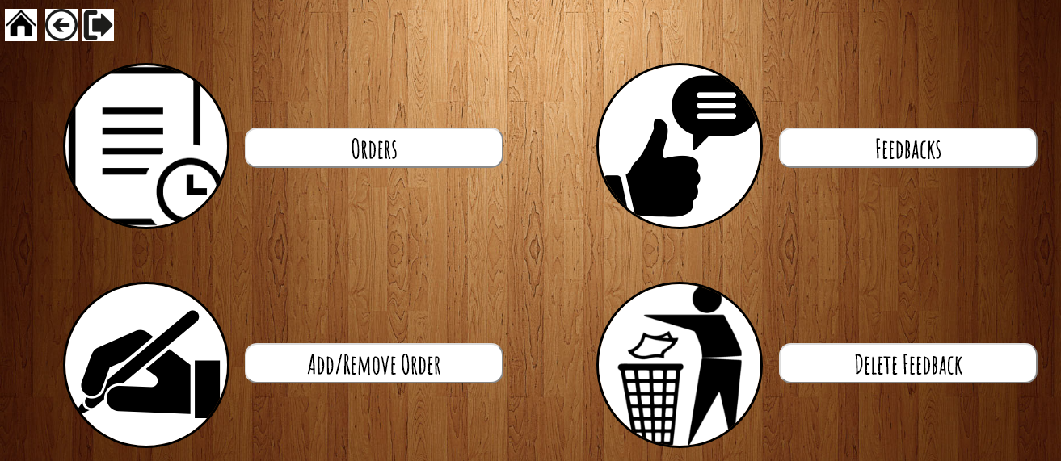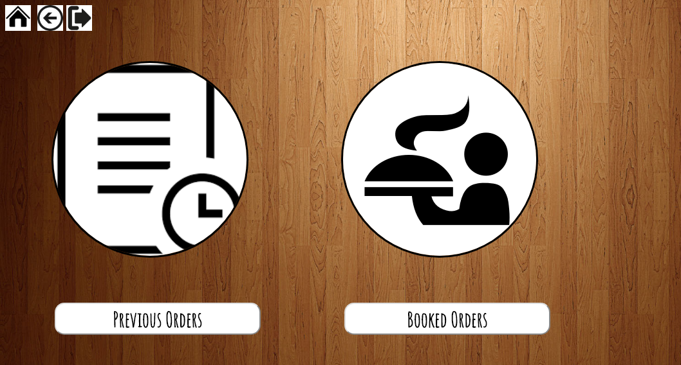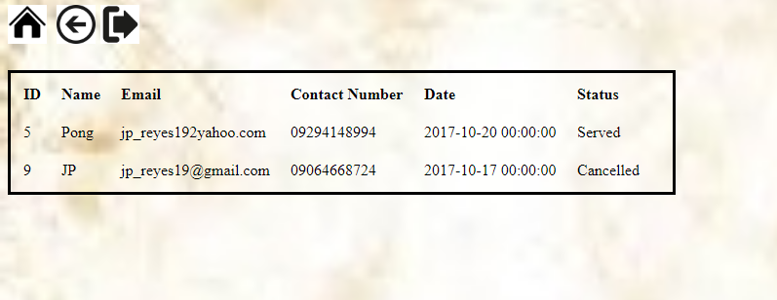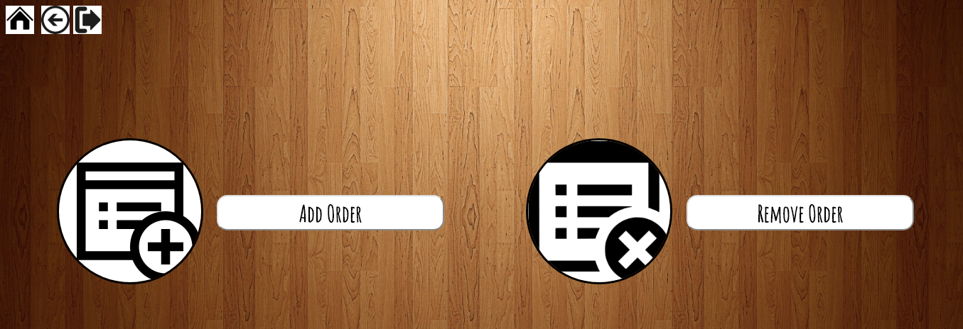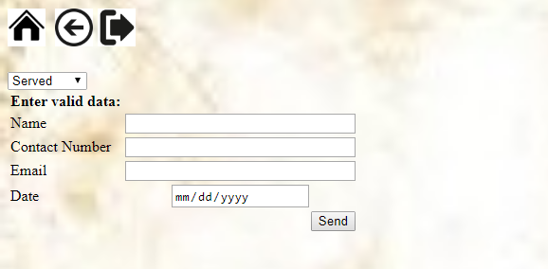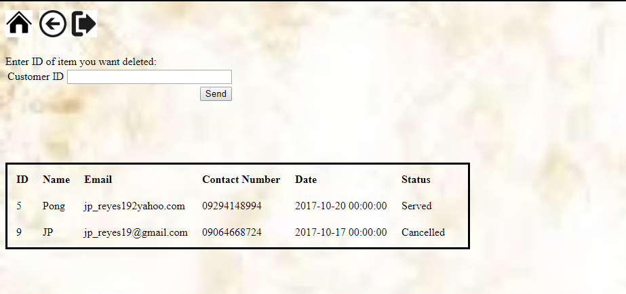

*Fig 11-D.38 Welcome screen*

*Fig 11-D.40 Fail to login*

*Fig 11-D.39 Login screen*

*Fig 11-D.41 Hint appears*

*Fig 11-D.42 Login error*

*Fig 11-D.43 Clearance error*

*Fig 11-D.44 Main screen*

*Fig 11-D.45 Inventory screen*

*Fig 11-D.46 All items*

*Fig 11-D.46 Sort Categories*

*Fig 11-D.47 Current items*

*Fig 11-D.48 Reference*

*Fig 11-D.52 Bundles*

*Fig 11-D.49 Needs restocking*

*Fig 11-D.50 Fully stocked*

*Fig 11-D.51 Over stocked*

*Fig 11-D.53 Ingredients*

*Fig 11-D.54 Menu*

*Fig 11-D.55 Tableware*

*Fig 11-D.56 Modify inventory*

*Fig 11-D.57 Check inventory in modify*

*Fig 11-D.58 Add item*

*Fig 11-D.59 Add ingredient*

*Fig 11-D.60 Add to menu*

*Fig 11-D.61 Add to tableware*

*Fig 11-D.62 Bundle*

*Fig 11-D.64 Empty message*

*Fig 11-D.63 Choose update item*

*Fig 11-D.65 Workers*

*Fig 11-D.66 Modify workers*

*Fig 11-D.67 Add workers*

*Fig 11-D.68 Worker list*

*Fig 11-D.71 Update worker*

*Fig 11-D.69 Update worker list*

*Fig 11-D.70 Change password*

*Fig 11-D.74 Customer*

*Fig 11-D.72 Orders*

*Fig 11-D.73 Order history*

*Fig 11-D.77 Modify order customer history*

*Fig 11-D.75 Add to customer history*

*Fig 11-D.76 Delete order customer history*

1. **CODES**

**Example Codes for Html**

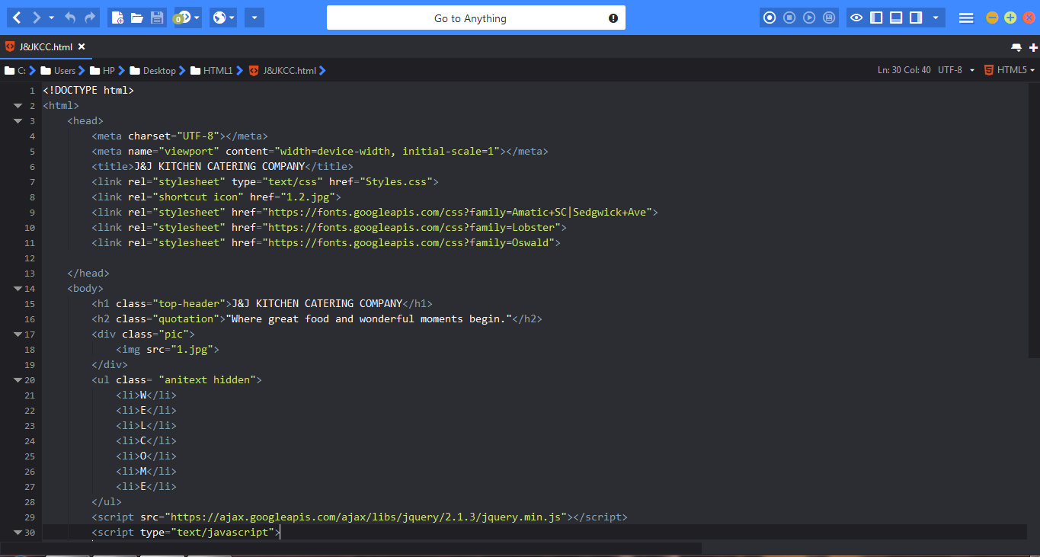

*Fig 11-E.1 Home*

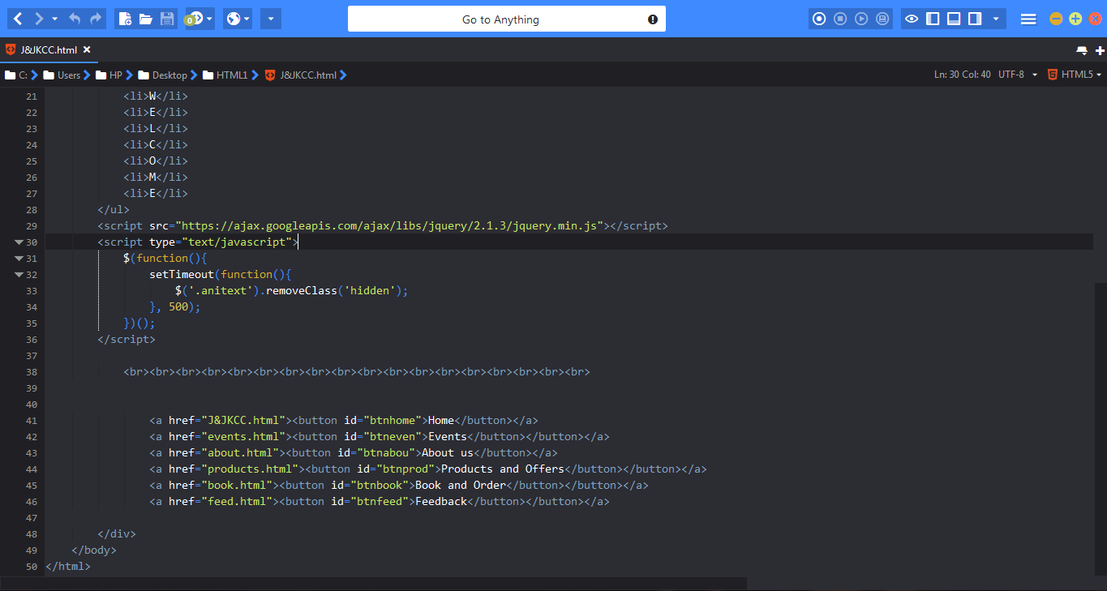

*Fig 11-E.1 Home*

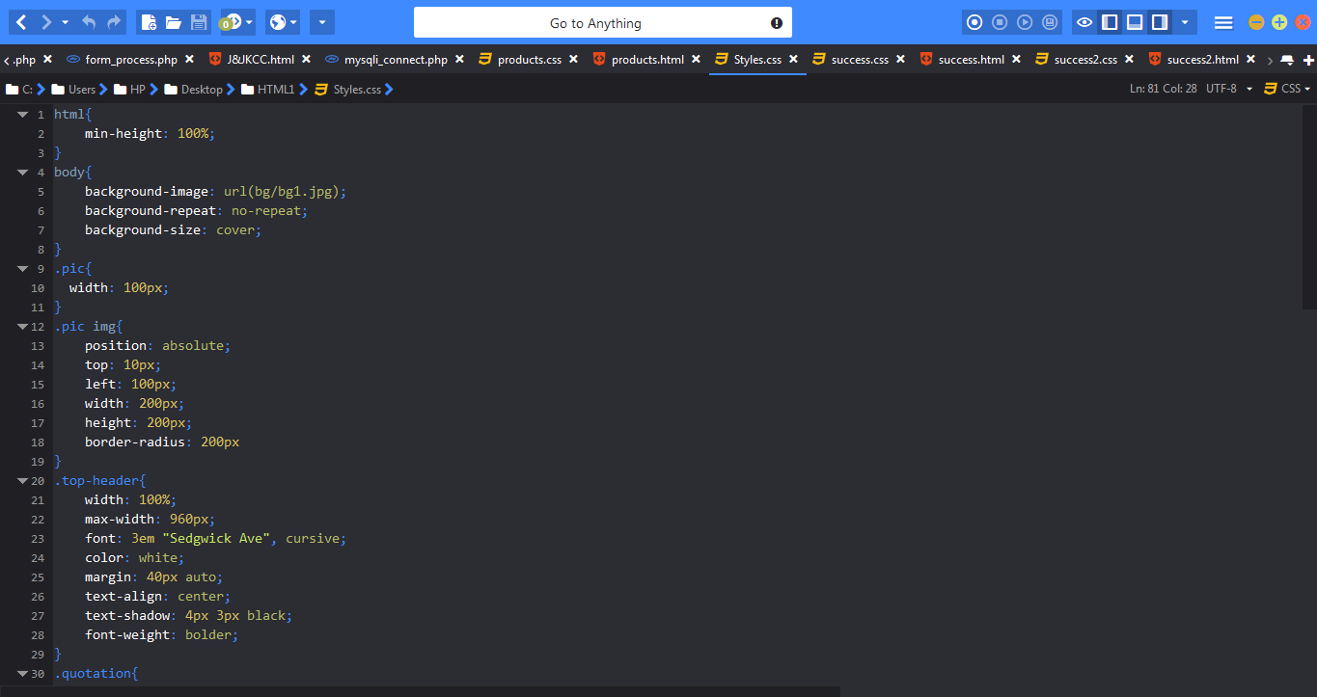

*Fig 11-E.2 Home-Css*

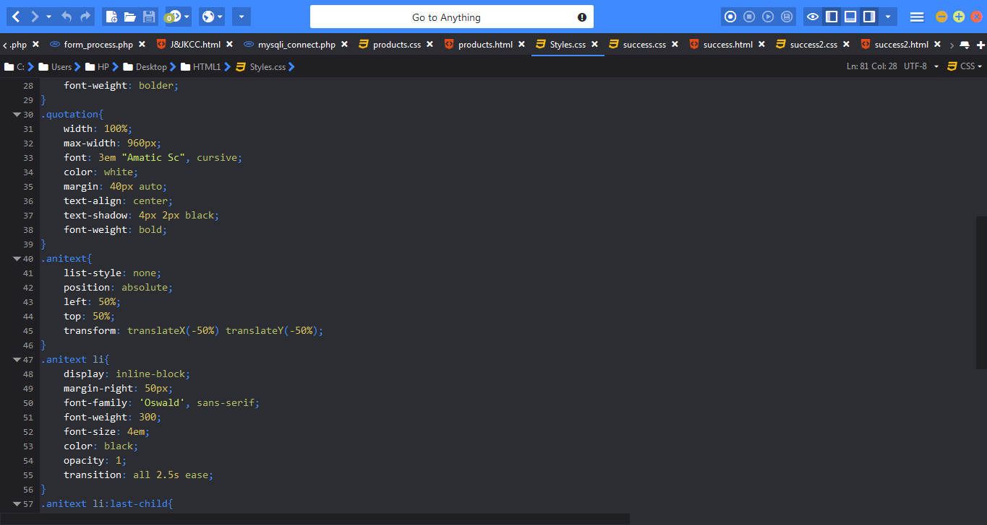

*Fig 11-E.2 Home-Css*

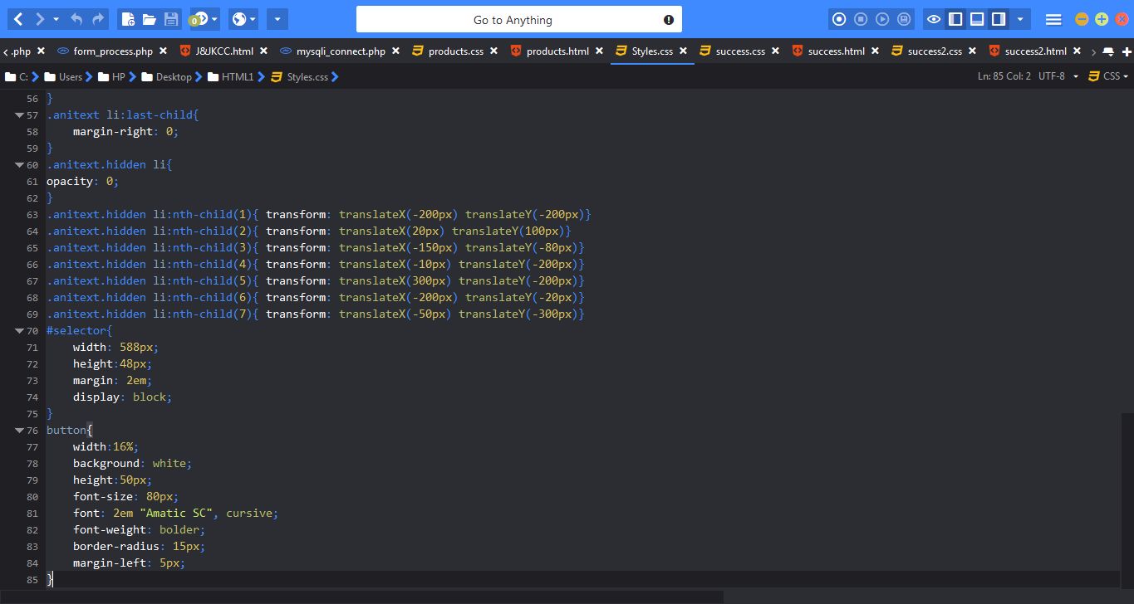

*Fig 11-E.2 Home-Css*

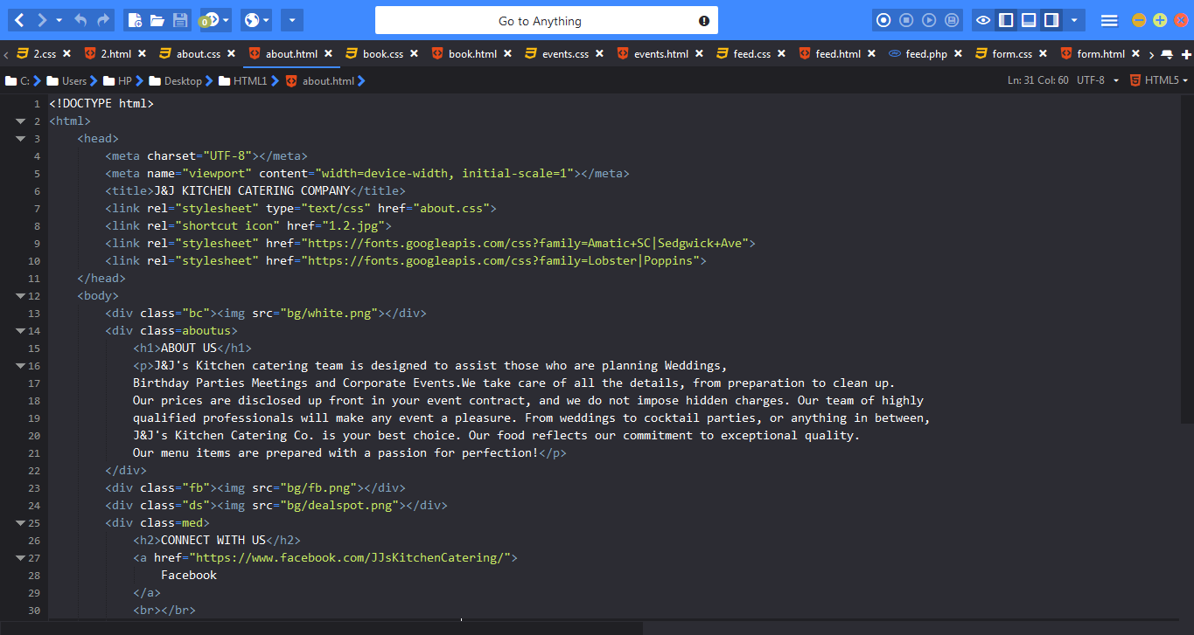

*Fig 11-E.3 About*

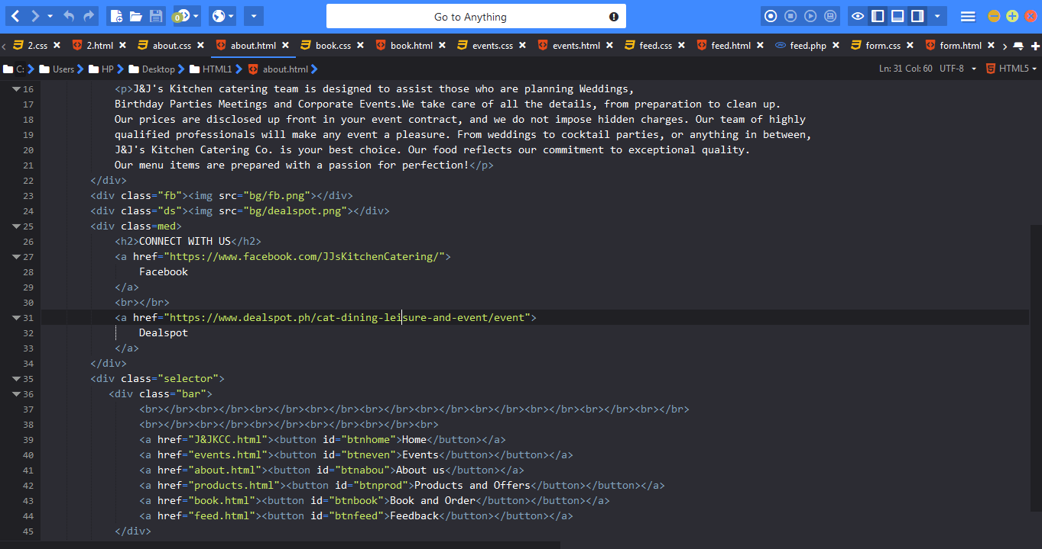

*Fig 11-E.3 About*

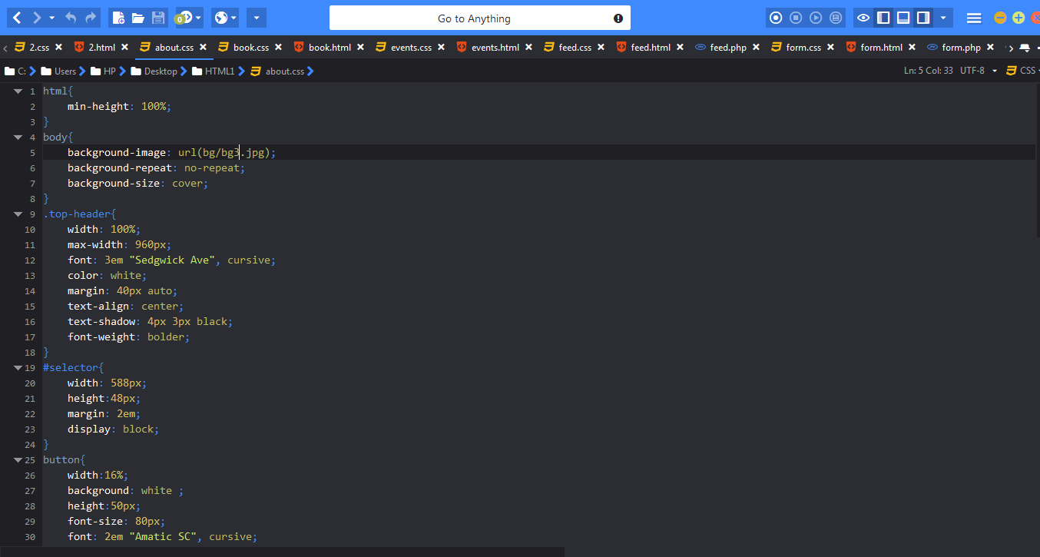

*Fig 11-E.4 About-Css*

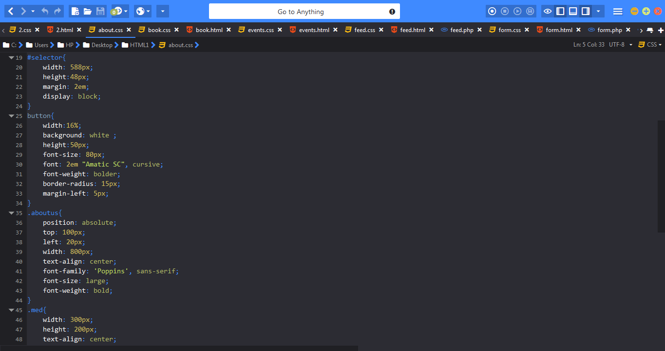

*Fig 11-E.4 About-Css*

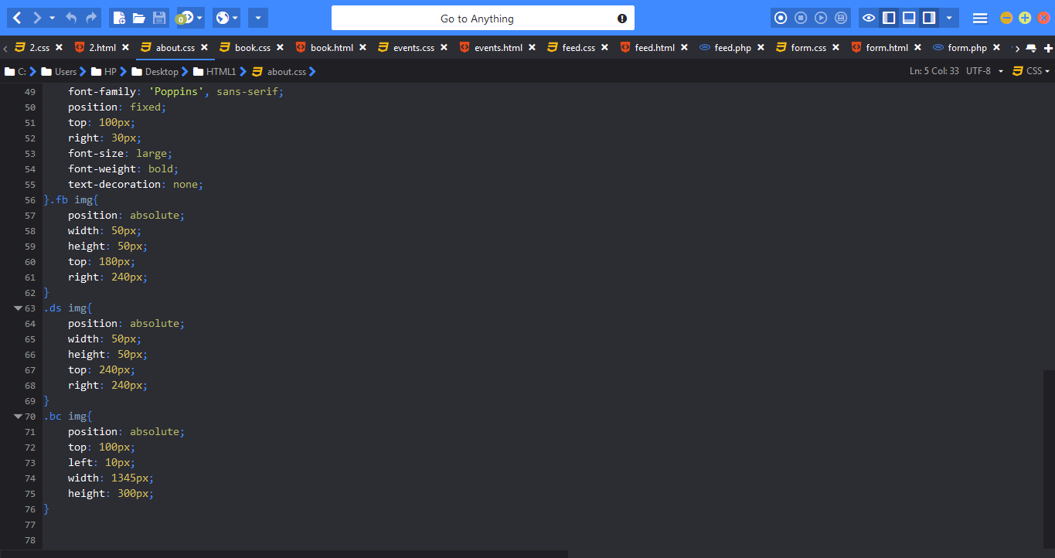

*Fig 11-E.4 About-Css*

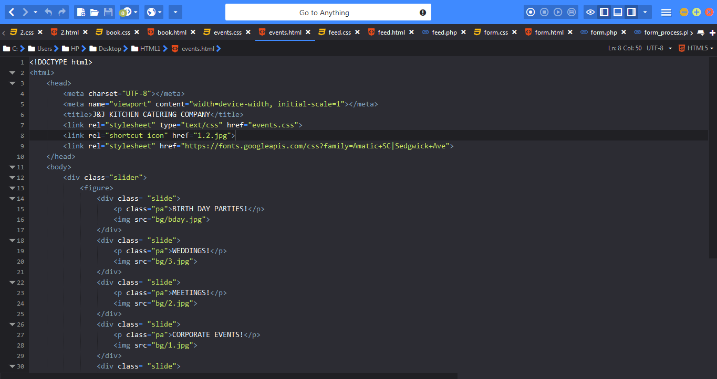

*Fig 11-E.5 Events*

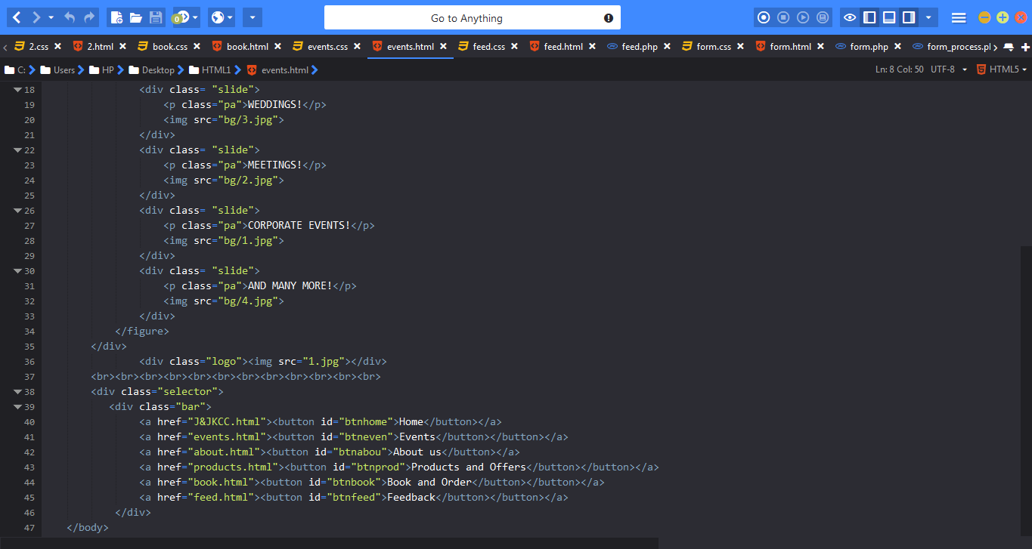

*Fig 11-E.5 Events*

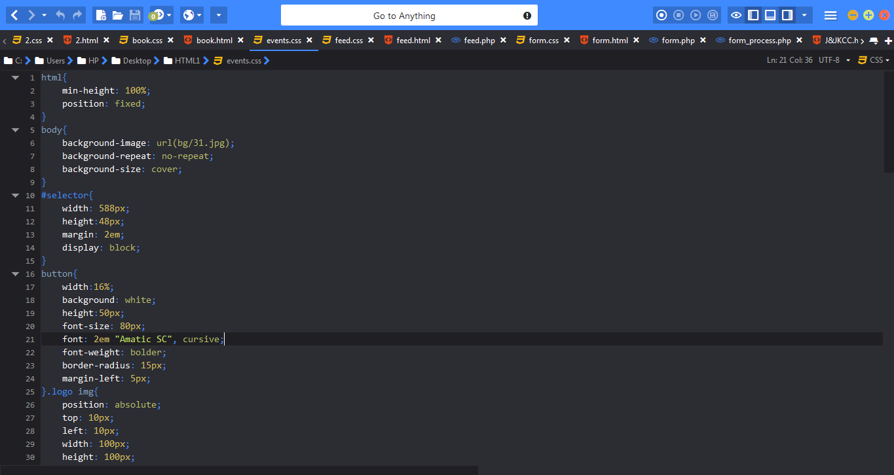

*Fig 11-E.6 Events-Css*

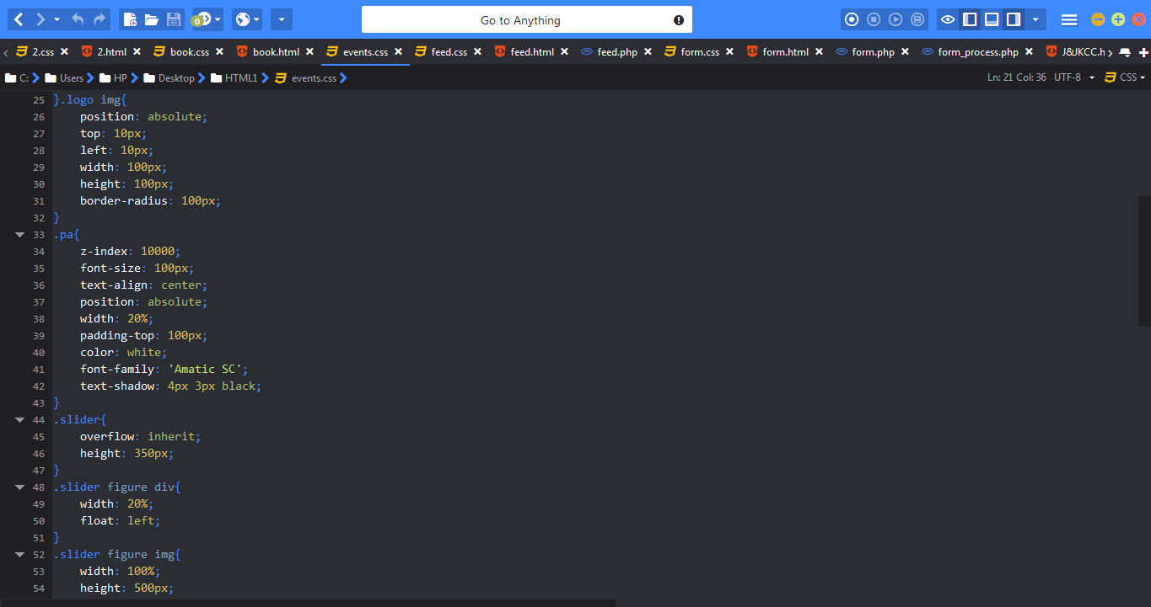

*Fig 11-E.6 Events-Css*

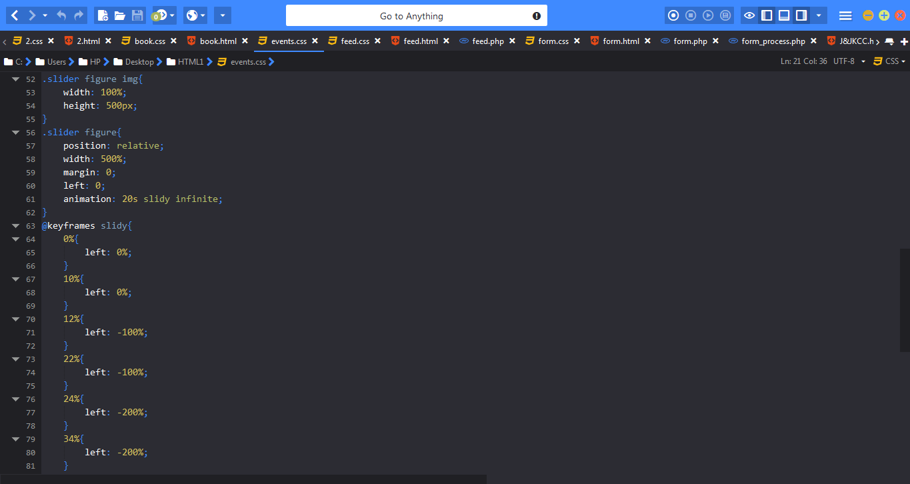

*Fig 11-E.6 Events-Css*

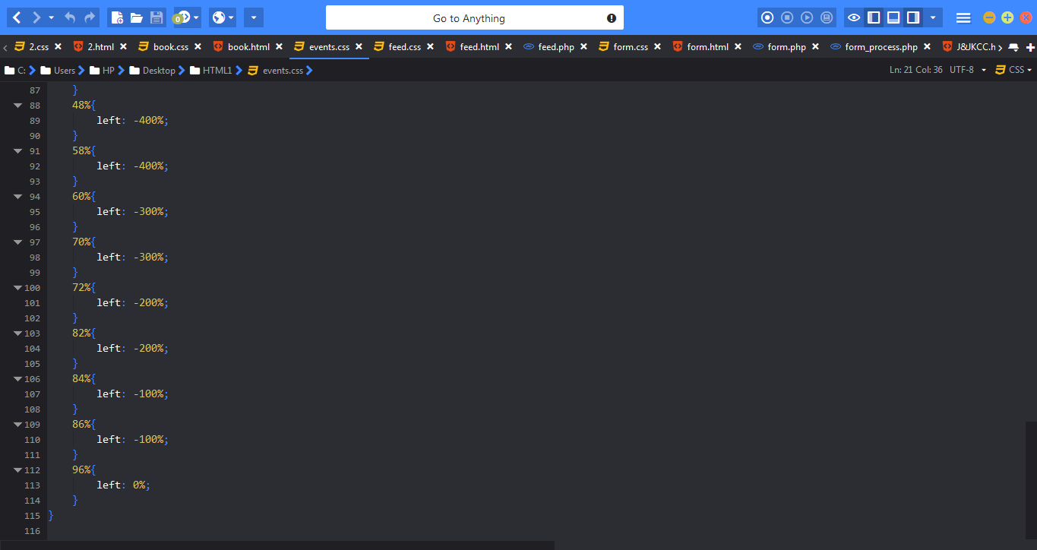

*Fig 11-E.6 Events-Css*

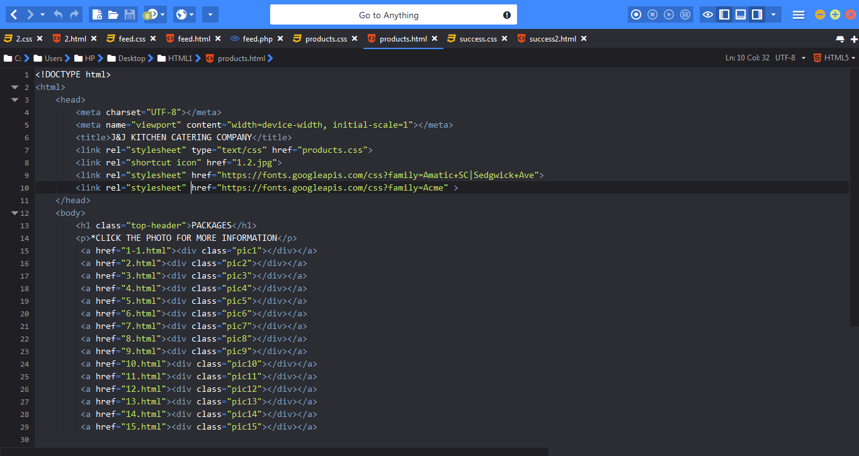

*Fig 11-E.7 Products*

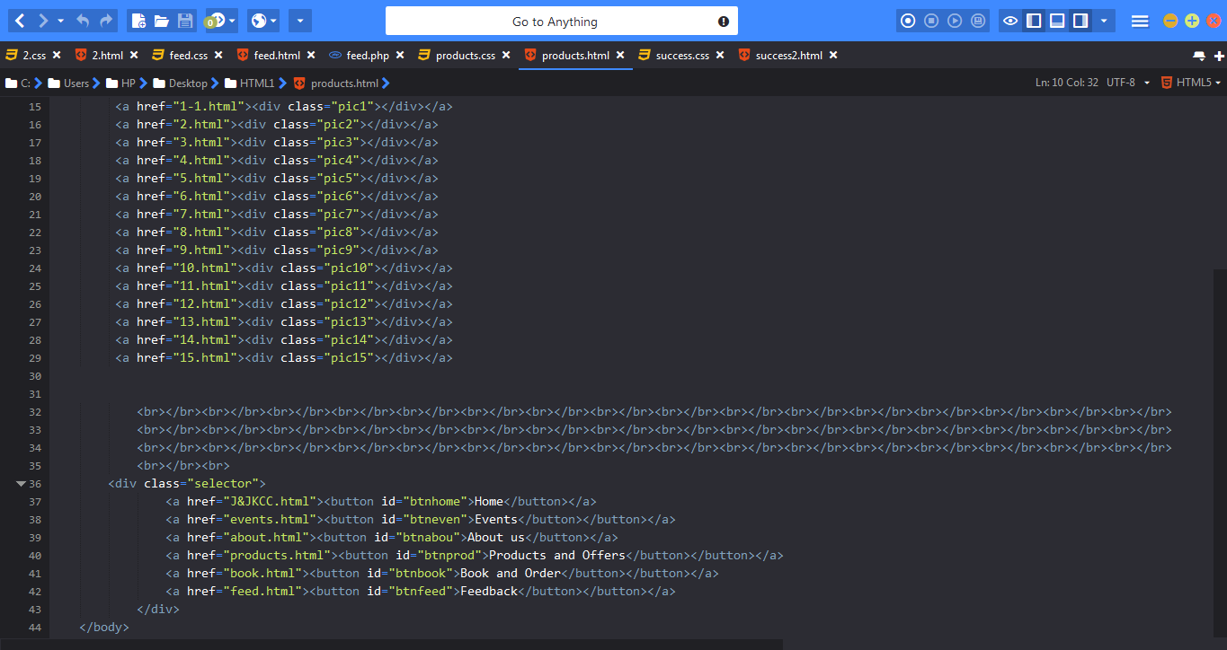

*Fig 11-E.7 Products*

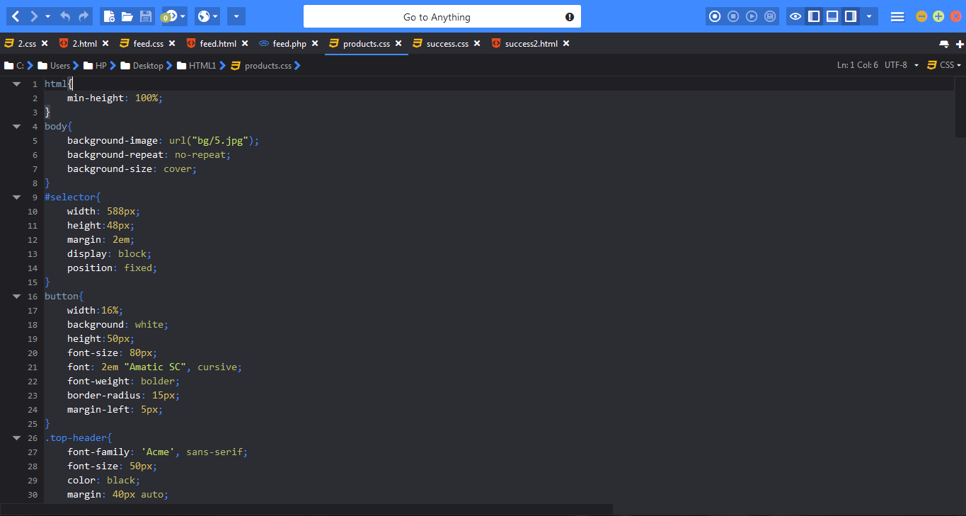

*Fig 11-E.8 Products-Css*

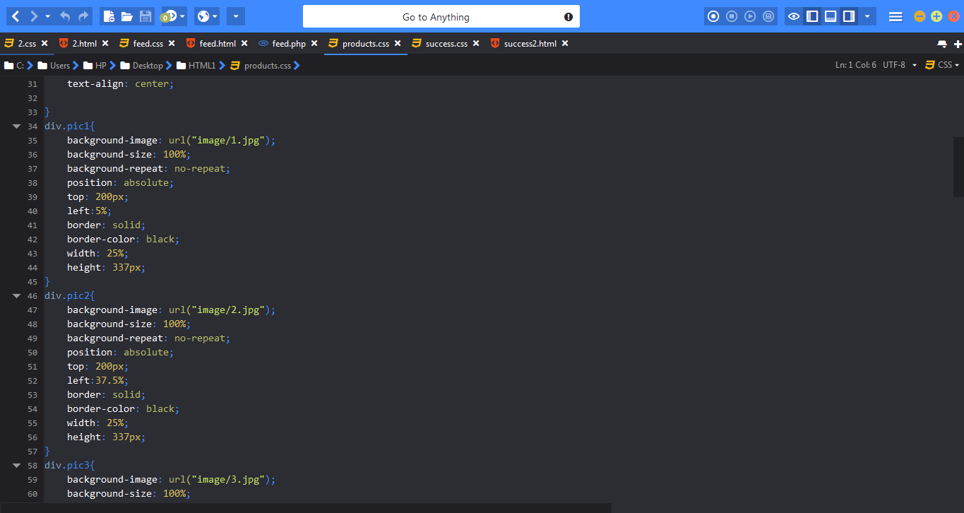

*Fig 11-E.8 Products-Css*

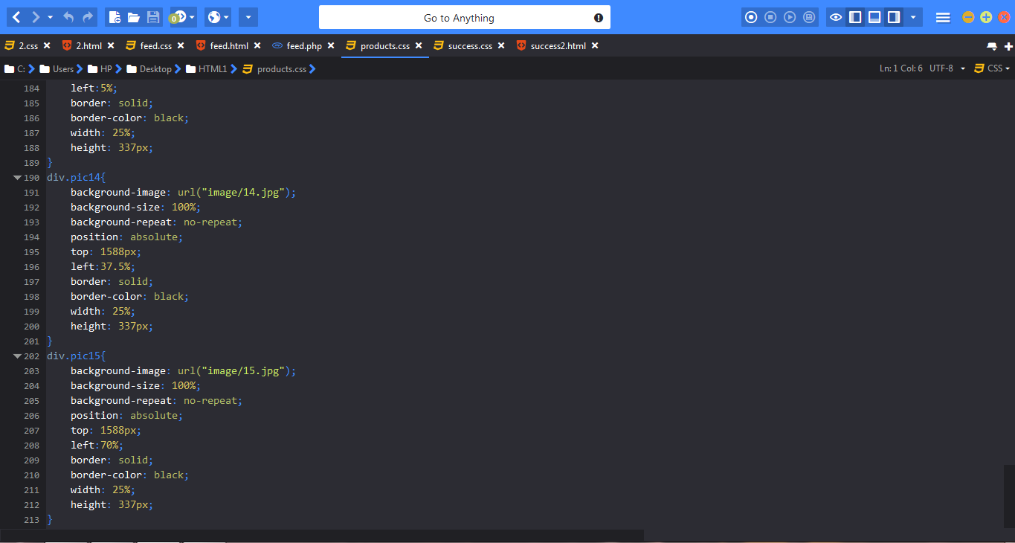

*Fig 11-E.8 Products-Css*

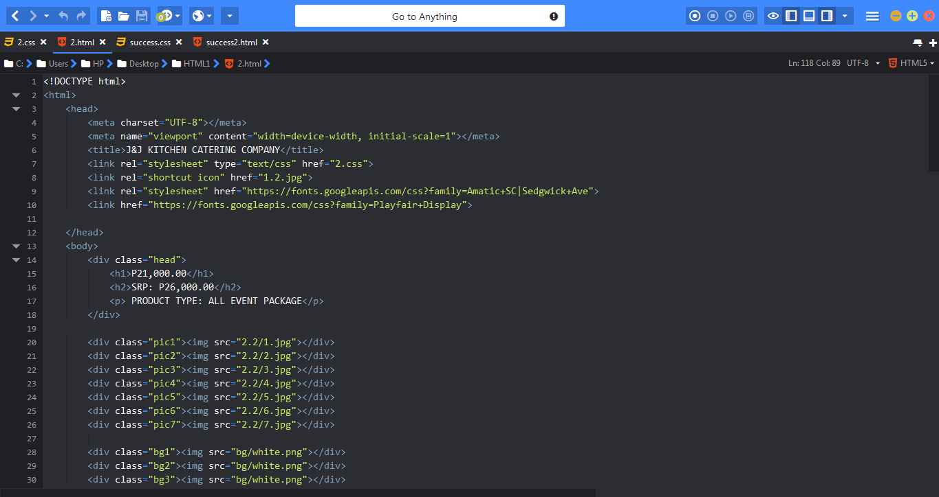

*Fig 11-E.9 Products (Sample)*

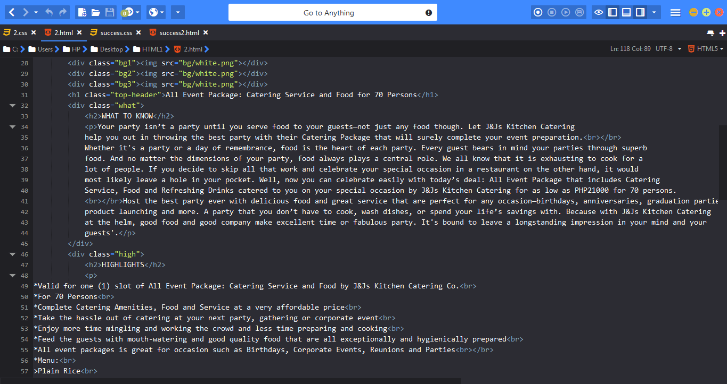

*Fig 11-E.9 Products (Sample)*

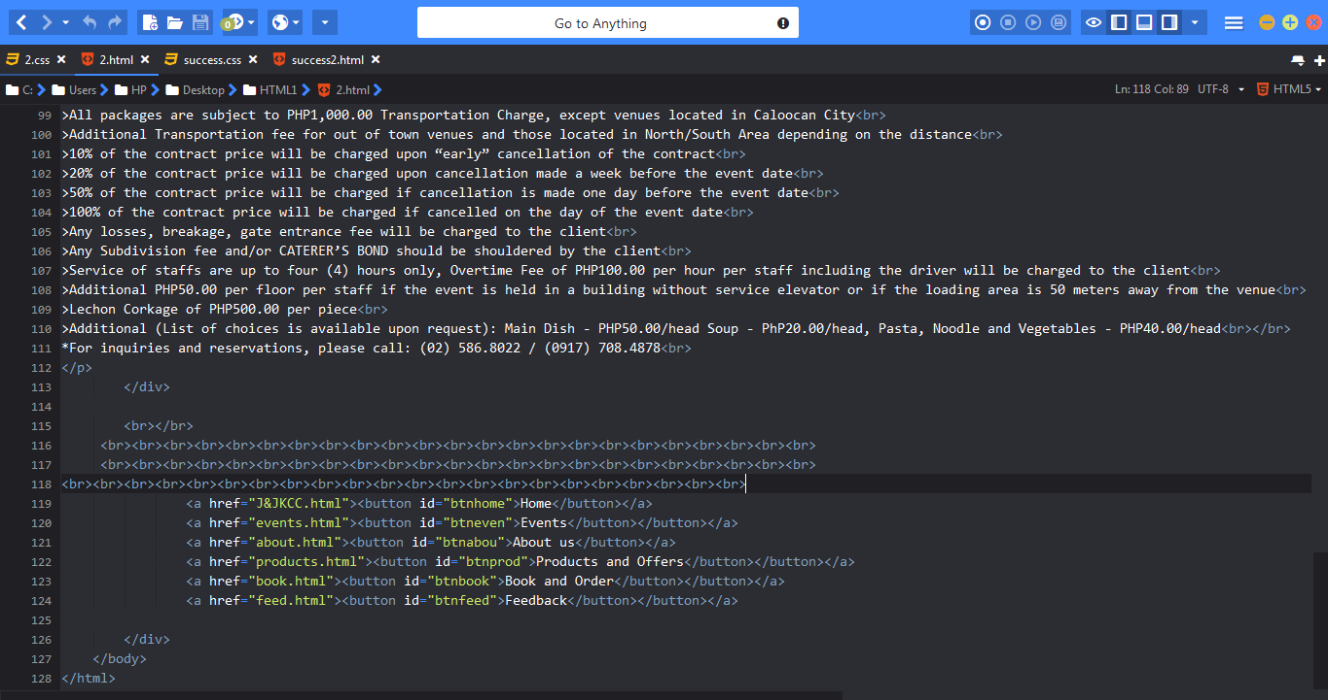

*Fig 11-E.9 Products (Sample)*

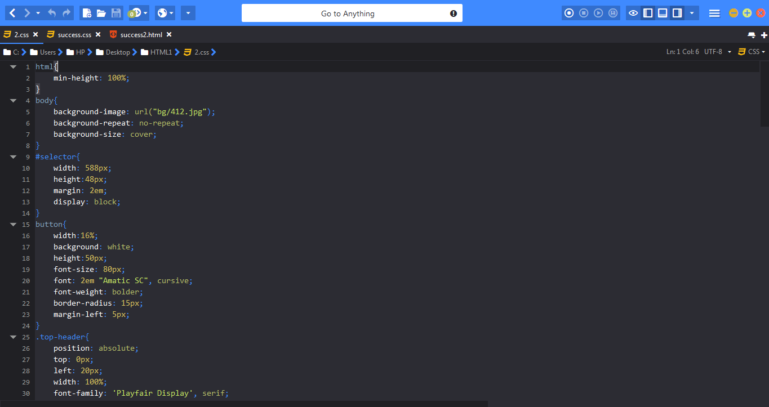

*Fig 11-E.10 Products (Sample)-Css*

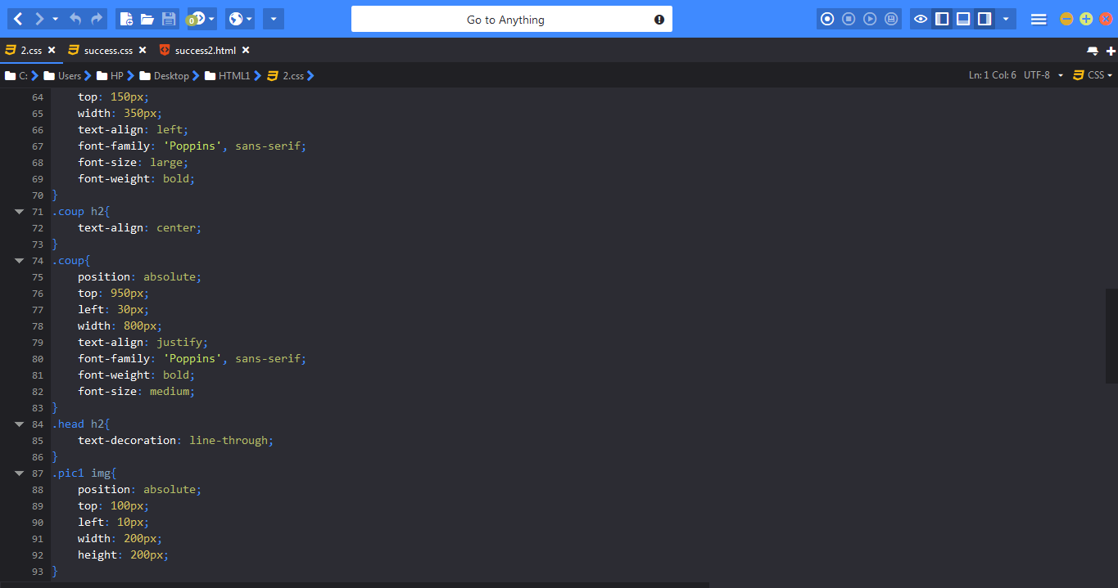

*Fig 11-E.10 Products (Sample)-Css*

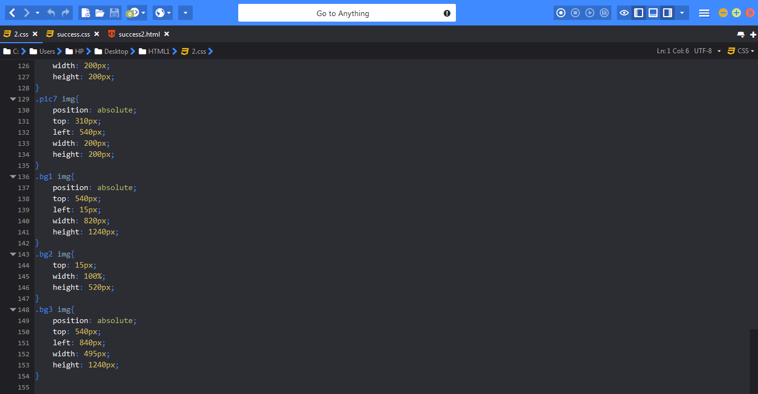

*Fig 11-E.10 Products (Sample)-Css*

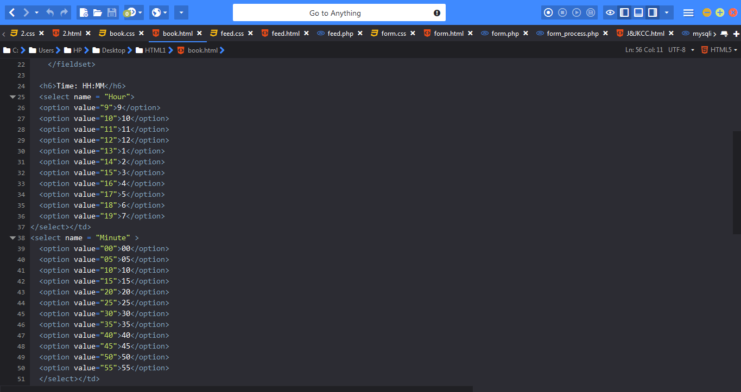

*Fig 11-E.11 Book*

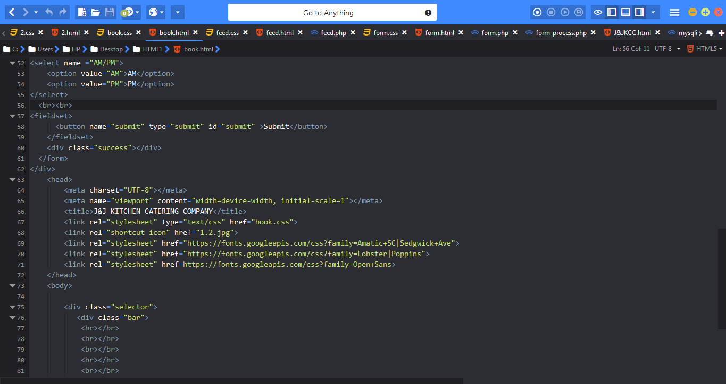

*Fig 11-E.11 Book*

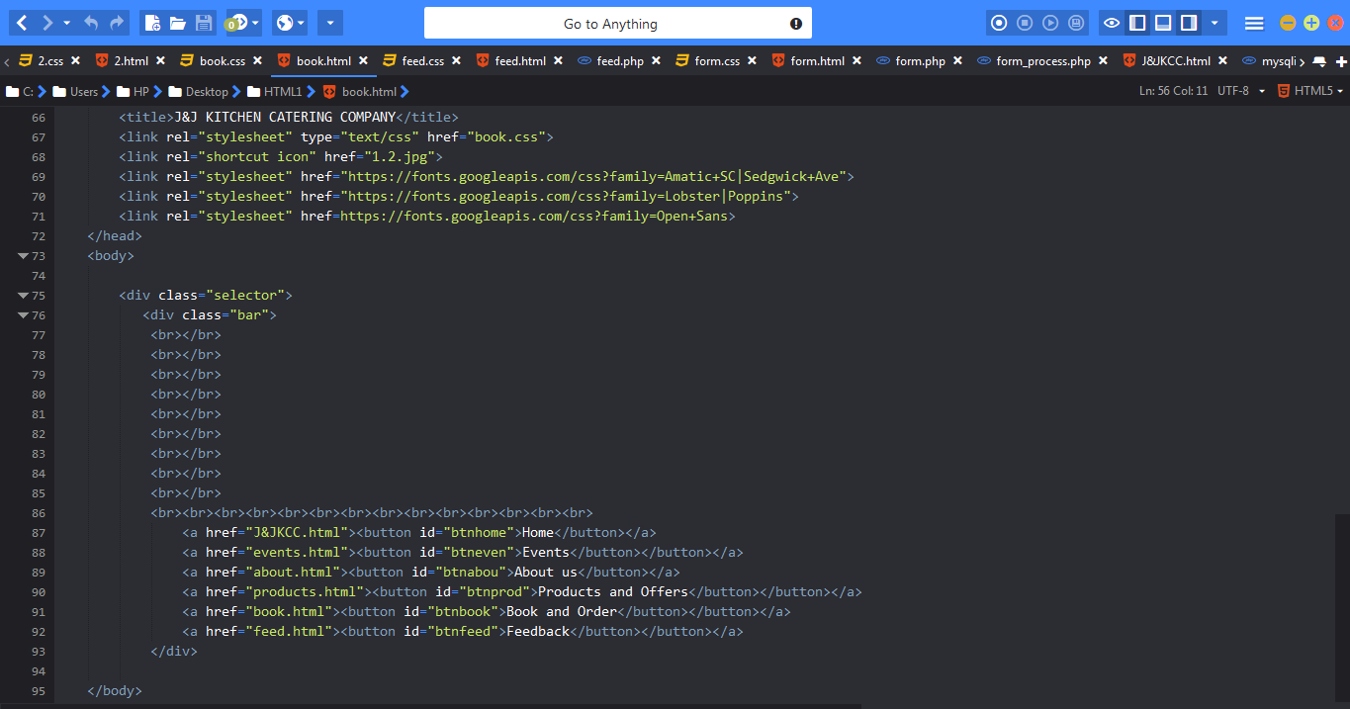

*Fig 11-E.11 Book*

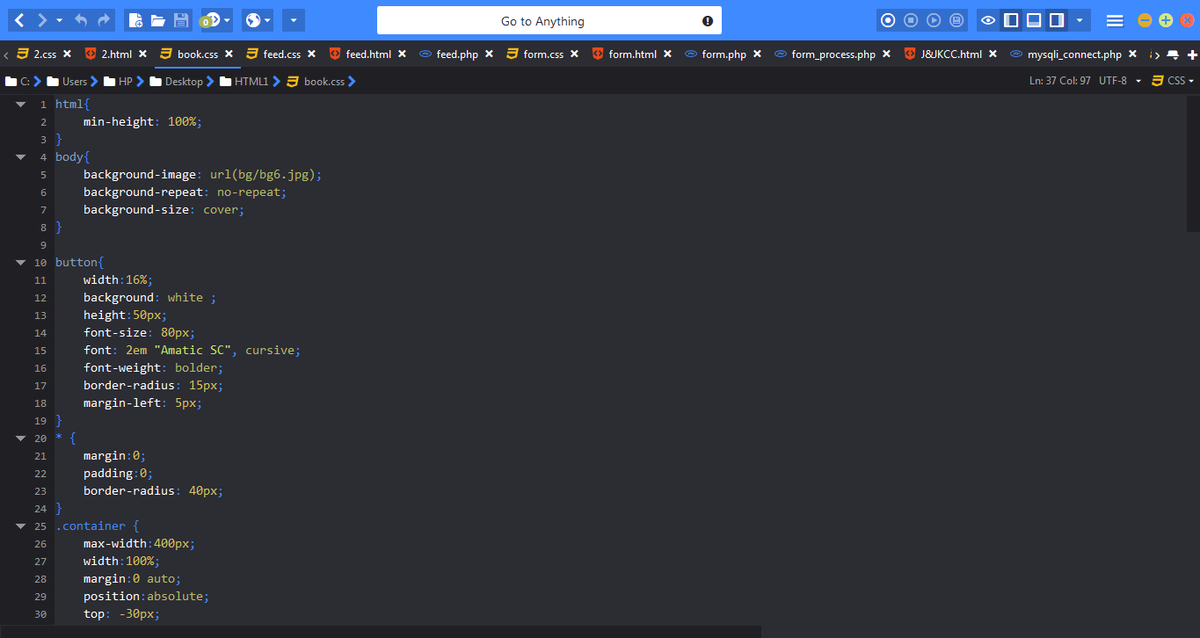

*Fig 11-E.12 Book-Css*

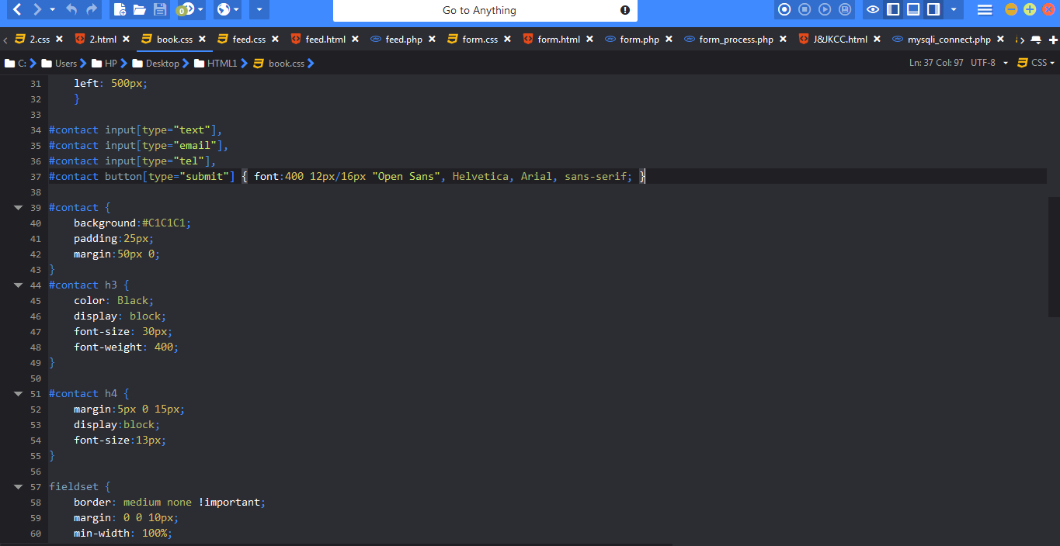

*Fig 11-E.12 Book-Css*

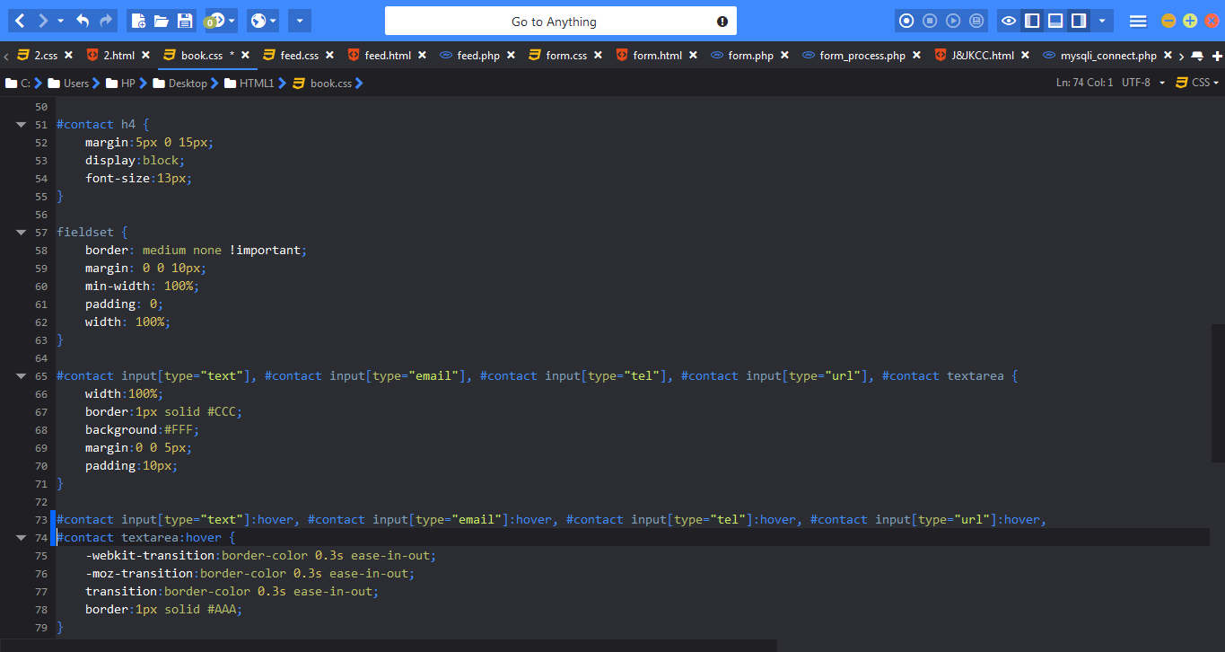

*Fig 11-E.12 Book-Css*

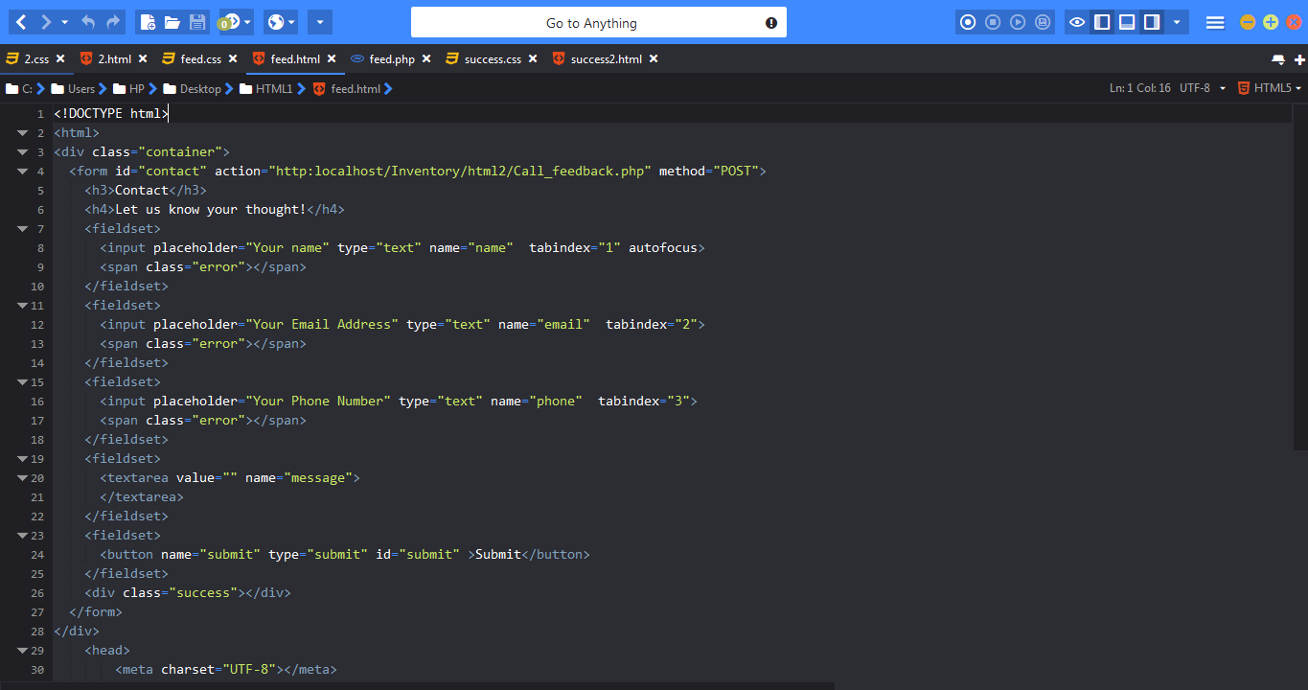

*Fig 11-E.13 Feedback*

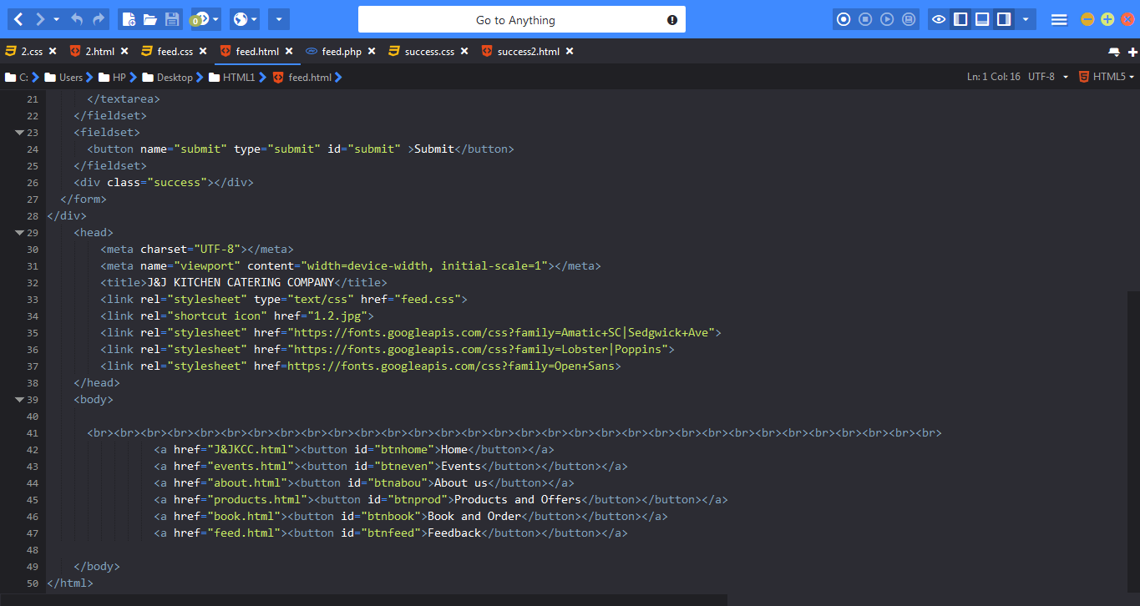

*Fig 11-E.13 Feedback*

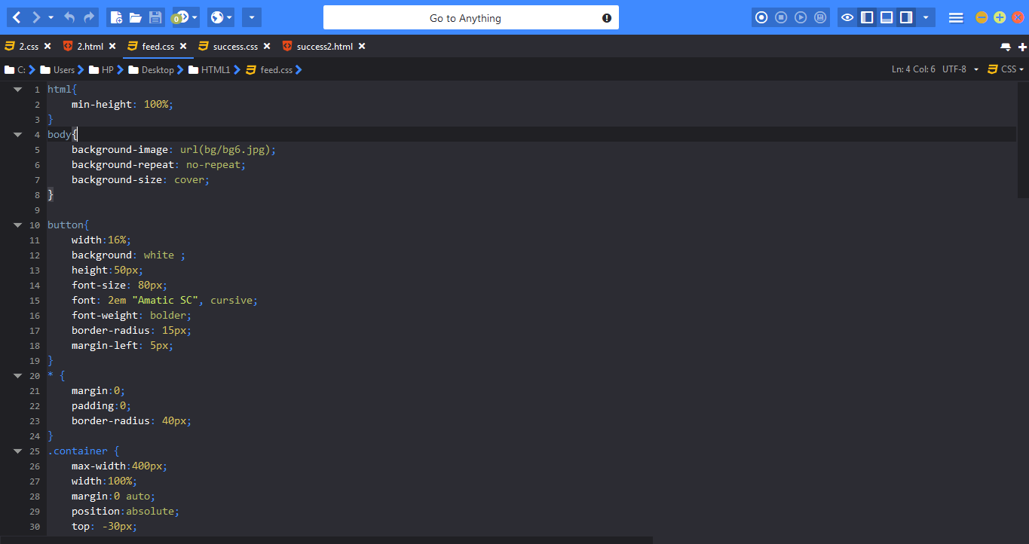

*Fig 11-E.14 Feedback-Css*

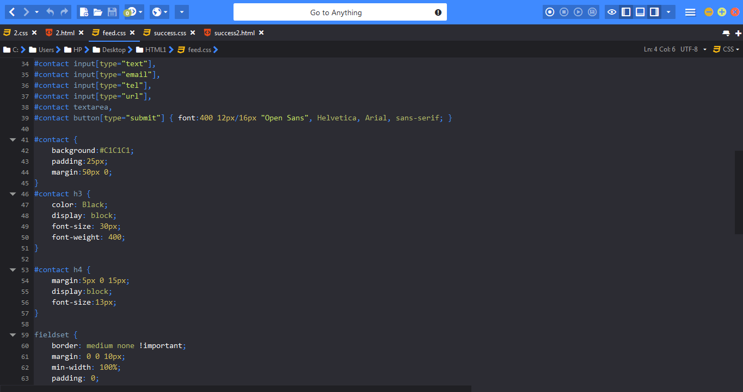

*Fig 11-E.14 Feedback-Css*

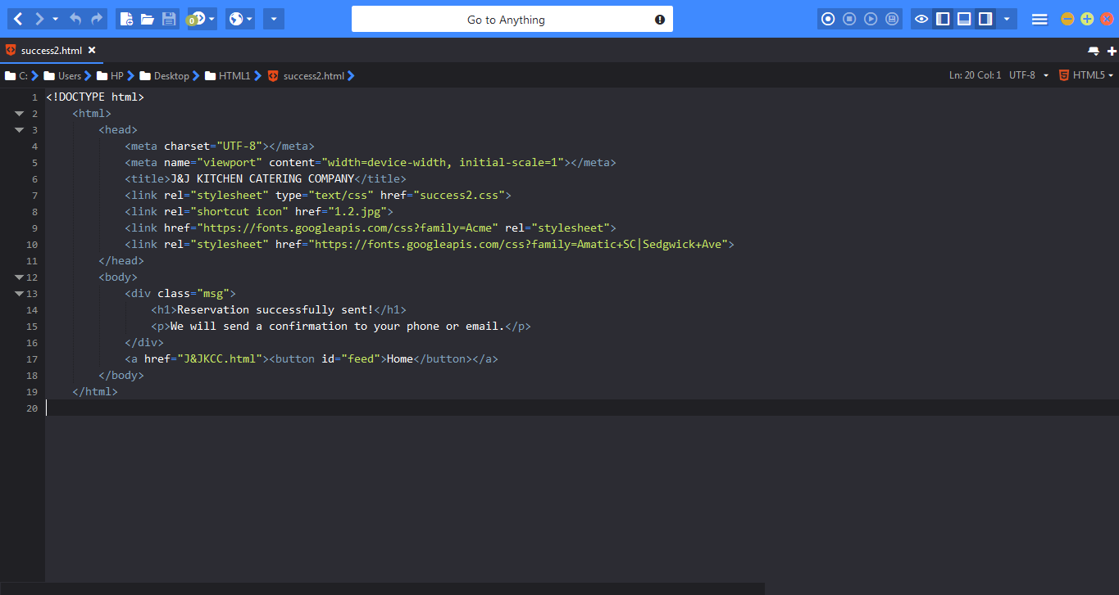

*Fig 11-E.15 Confirmation*

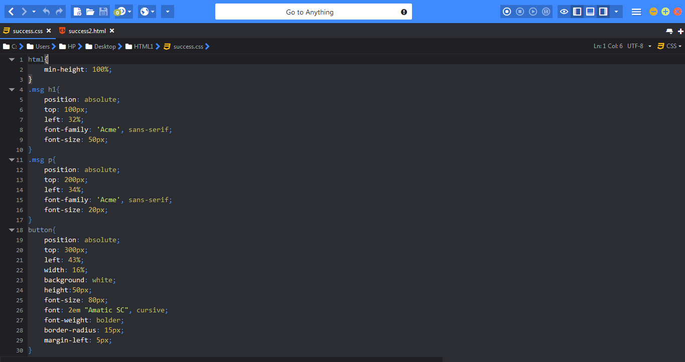

*Fig 11-E.16 Confirmation-Css*

**Examples Codes for Order Management**

﻿**Code for PA1edit.vb**

﻿Public Class PA1edit

Private Sub Refresh1_Click(sender As Object, e As EventArgs) Handles Refresh1.Click

Lbl_P1A_name.Text = P1A_name.Text

Lbl_P1A_price.Text = P1A_price.Text

Lbl_P1A_pax.Text = P1A_pax.Text

Lbl_P1A_entry1.Text = P1A_entry1.Text

Lbl_P1A_entry2.Text = P1A_entry2.Text

Lbl_P1A_entry3.Text = P1A_entry3.Text

Lbl_P1A_entry4.Text = P1A_entry4.Text

Lbl_P1A_entry5.Text = P1A_entry5.Text

Lbl_P1A_entry6.Text = P1A_entry6.Text

Lbl_P1A_entry7.Text = P1A_entry7.Text

Lbl_P1A_entry8.Text = P1A_entry8.Text

Lbl_P1A_entry9.Text = P1A_entry9.Text

Lbl_P1A_entry10.Text = P1A_entry10.Text

Lbl_P1A_entry11.Text = P1A_entry11.Text

Lbl_P1A_entry12.Text = P1A_entry12.Text

Lbl_P1A_add1.Text = P1A_add1.Text

Lbl_P1A_add2.Text = P1A_add2.Text

Lbl_P1A_add3.Text = P1A_add3.Text

Lbl_P1A_add4.Text = P1A_add4.Text

Lbl_P1A_add5.Text = P1A_add5.Text

Lbl_P1A_add6.Text = P1A_add6.Text

Lbl_P1A_add7.Text = P1A_add7.Text

Lbl_P1A_add8.Text = P1A_add8.Text

Lbl_P1A_add9.Text = P1A_add9.Text

Lbl_P1A_add10.Text = P1A_add10.Text

Lbl_P1A_add11.Text = P1A_add11.Text

Lbl_P1A_add12.Text = P1A_add12.Text

Lbl_P1A_add1p.Text = P1A_add1p.Text

Lbl_P1A_add2p.Text = P1A_add2p.Text

Lbl_P1A_add3p.Text = P1A_add3p.Text

Lbl_P1A_add4p.Text = P1A_add4p.Text

Lbl_P1A_add5p.Text = P1A_add5p.Text

Lbl_P1A_add6p.Text = P1A_add6p.Text

Lbl_P1A_add7p.Text = P1A_add7p.Text

Lbl_P1A_add8p.Text = P1A_add8p.Text

Lbl_P1A_add9p.Text = P1A_add9p.Text

Lbl_P1A_add10p.Text = P1A_add10p.Text

Lbl_P1A_add11p.Text = P1A_add11p.Text

Lbl_P1A_add12p.Text = P1A_add12p.Text

Lbl_P1A_inc1.Text = P1A_inc1.Text

Lbl_P1A_inc2.Text = P1A_inc2.Text

Lbl_P1A_inc3.Text = P1A_inc3.Text

Lbl_P1A_inc4.Text = P1A_inc4.Text

Lbl_P1A_inc5.Text = P1A_inc5.Text

Lbl_P1A_inc6.Text = P1A_inc6.Text

Lbl_P1A_inc7.Text = P1A_inc7.Text

Lbl_P1A_inc8.Text = P1A_inc8.Text

Lbl_P1A_inc9.Text = P1A_inc9.Text

Lbl_P1A_inc10.Text = P1A_inc10.Text

Lbl_P1A_inc11.Text = P1A_inc11.Text

Lbl_P1A_inc12.Text = P1A_inc12.Text

Lbl_P1A_inc13.Text = P1A_inc13.Text

Lbl_P1A_inc14.Text = P1A_inc14.Text

Lbl_P1A_inc15.Text = P1A_inc15.Text

Lbl_P1A_inc16.Text = P1A_inc16.Text

Lbl_P1A_inc17.Text = P1A_inc17.Text

Lbl_P1A_inc18.Text = P1A_inc18.Text

Lbl_P1A_service1.Text = P1A_service1.Text

Lbl_P1A_service2.Text = P1A_service2.Text

Lbl_P1A_service3.Text = P1A_service3.Text

Lbl_P1A_service4.Text = P1A_service4.Text

Lbl_P1A_service5.Text = P1A_service5.Text

Lbl_P1A_service6.Text = P1A_service6.Text

Lbl_P1A_service7.Text = P1A_service7.Text

Lbl_P1A_service8.Text = P1A_service8.Text

Lbl_P1A_service9.Text = P1A_service9.Text

Lbl_P1A_service10.Text = P1A_service10.Text

Lbl_P1A_service11.Text = P1A_service11.Text

Lbl_P1A_service1p.Text = P1A_service1p.Text

Lbl_P1A_service2p.Text = P1A_service2p.Text

Lbl_P1A_service3p.Text = P1A_service3p.Text

Lbl_P1A_service4p.Text = P1A_service4p.Text

Lbl_P1A_service5p.Text = P1A_service5p.Text

Lbl_P1A_service6p.Text = P1A_service6p.Text

Lbl_P1A_service7p.Text = P1A_service7p.Text

Lbl_P1A_service8p.Text = P1A_service8p.Text

Lbl_P1A_service9p.Text = P1A_service9p.Text

Lbl_P1A_service10p.Text = P1A_service10p.Text

Lbl_P1A_service11p.Text = P1A_service11p.Text

Lbl_P1A_service12p.Text = P1A_service12p.Text

Lbl_P1A_Description.Text = Lbl_P1A_Description.Text

End Sub

Private Sub SampleEdit_Load(sender As Object, e As EventArgs) Handles MyBase.Load

P1A_name.Text = Lbl_P1A_name.Text

P1A_price.Text = Lbl_P1A_price.Text

P1A_pax.Text = Lbl_P1A_pax.Text

P1A_entry1.Text = Lbl_P1A_entry1.Text

P1A_entry2.Text = Lbl_P1A_entry2.Text

P1A_entry3.Text = Lbl_P1A_entry3.Text

P1A_entry4.Text = Lbl_P1A_entry4.Text

P1A_entry5.Text = Lbl_P1A_entry5.Text

P1A_entry6.Text = Lbl_P1A_entry6.Text

P1A_entry7.Text = Lbl_P1A_entry7.Text

P1A_entry8.Text = Lbl_P1A_entry8.Text

P1A_entry9.Text = Lbl_P1A_entry9.Text

P1A_entry10.Text = Lbl_P1A_entry10.Text

P1A_entry11.Text = Lbl_P1A_entry11.Text

P1A_entry12.Text = Lbl_P1A_entry12.Text

P1A_add1.Text = Lbl_P1A_add1.Text

P1A_add2.Text = Lbl_P1A_add2.Text

P1A_add3.Text = Lbl_P1A_add3.Text

P1A_add4.Text = Lbl_P1A_add4.Text

P1A_add5.Text = Lbl_P1A_add5.Text

P1A_add6.Text = Lbl_P1A_add6.Text

P1A_add7.Text = Lbl_P1A_add7.Text

P1A_add8.Text = Lbl_P1A_add8.Text

P1A_add9.Text = Lbl_P1A_add9.Text

P1A_add10.Text = Lbl_P1A_add10.Text

P1A_add11.Text = Lbl_P1A_add11.Text

P1A_add12.Text = Lbl_P1A_add12.Text

P1A_add1p.Text = Lbl_P1A_add1p.Text

P1A_add2p.Text = Lbl_P1A_add2p.Text

P1A_add3p.Text = Lbl_P1A_add3p.Text

P1A_add4p.Text = Lbl_P1A_add4p.Text

P1A_add5p.Text = Lbl_P1A_add5p.Text

P1A_add6p.Text = Lbl_P1A_add6p.Text

P1A_add7p.Text = Lbl_P1A_add7p.Text

P1A_add8p.Text = Lbl_P1A_add8p.Text

P1A_add9p.Text = Lbl_P1A_add9p.Text

P1A_add10p.Text = Lbl_P1A_add10p.Text

P1A_add11p.Text = Lbl_P1A_add11p.Text

P1A_add12p.Text = Lbl_P1A_add12p.Text

P1A_inc1.Text = Lbl_P1A_inc1.Text

P1A_inc2.Text = Lbl_P1A_inc2.Text

P1A_inc3.Text = Lbl_P1A_inc3.Text

P1A_inc4.Text = Lbl_P1A_inc4.Text

P1A_inc5.Text = Lbl_P1A_inc5.Text

P1A_inc6.Text = Lbl_P1A_inc6.Text

P1A_inc7.Text = Lbl_P1A_inc7.Text

P1A_inc8.Text = Lbl_P1A_inc8.Text

P1A_inc9.Text = Lbl_P1A_inc9.Text

P1A_inc10.Text = Lbl_P1A_inc10.Text

P1A_inc11.Text = Lbl_P1A_inc11.Text

P1A_inc12.Text = Lbl_P1A_inc12.Text

P1A_inc13.Text = Lbl_P1A_inc13.Text

P1A_inc14.Text = Lbl_P1A_inc14.Text

P1A_inc15.Text = Lbl_P1A_inc15.Text

P1A_inc16.Text = Lbl_P1A_inc16.Text

P1A_inc17.Text = Lbl_P1A_inc17.Text

P1A_inc18.Text = Lbl_P1A_inc18.Text

P1A_service1.Text = Lbl_P1A_service1.Text

P1A_service2.Text = Lbl_P1A_service2.Text

P1A_service3.Text = Lbl_P1A_service3.Text

P1A_service4.Text = Lbl_P1A_service4.Text

P1A_service5.Text = Lbl_P1A_service5.Text

P1A_service6.Text = Lbl_P1A_service6.Text

P1A_service7.Text = Lbl_P1A_service7.Text

P1A_service8.Text = Lbl_P1A_service8.Text

P1A_service9.Text = Lbl_P1A_service9.Text

P1A_service10.Text = Lbl_P1A_service10.Text

P1A_service11.Text = Lbl_P1A_service11.Text

P1A_service1p.Text = Lbl_P1A_service1p.Text

P1A_service2p.Text = Lbl_P1A_service2p.Text

P1A_service3p.Text = Lbl_P1A_service3p.Text

P1A_service4p.Text = Lbl_P1A_service4p.Text

P1A_service5p.Text = Lbl_P1A_service5p.Text

P1A_service6p.Text = Lbl_P1A_service6p.Text

P1A_service7p.Text = Lbl_P1A_service7p.Text

P1A_service8p.Text = Lbl_P1A_service8p.Text

P1A_service9p.Text = Lbl_P1A_service9p.Text

P1A_service10p.Text = Lbl_P1A_service10p.Text

P1A_service11p.Text = Lbl_P1A_service11p.Text

P1A_service12p.Text = Lbl_P1A_service12p.Text

P1A_what.Text = Lbl_P1A_what.Text

End Sub

End Class

**Code for PA1edit.Designer.vb**

<Global.Microsoft.VisualBasic.CompilerServices.DesignerGenerated()>

Partial Class PA1a

Inherits System.Windows.Forms.Form

'Form overrides dispose to clean up the component list.

<System.Diagnostics.DebuggerNonUserCode()>

Protected Overrides Sub Dispose(ByVal disposing As Boolean)

Try

If disposing AndAlso components IsNot Nothing Then

components.Dispose()

End If

Finally

MyBase.Dispose(disposing)

End Try

End Sub

'Required by the Windows Form Designer

Private components As System.ComponentModel.IContainer

'NOTE: The following procedure is required by the Windows Form Designer

'It can be modified using the Windows Form Designer.

'Do not modify it using the code editor.

<System.Diagnostics.DebuggerStepThrough()>

Private Sub InitializeComponent()

Dim resources As System.ComponentModel.ComponentResourceManager = New System.ComponentModel.ComponentResourceManager(GetType(PA1a))

Me.TabControl1 = New System.Windows.Forms.TabControl()

Me.TabPage1 = New System.Windows.Forms.TabPage()

Me.TextBox13 = New System.Windows.Forms.TextBox()

Me.TextBox12 = New System.Windows.Forms.TextBox()

Me.TextBox5 = New System.Windows.Forms.TextBox()

Me.TextBox4 = New System.Windows.Forms.TextBox()

Me.TextBox3 = New System.Windows.Forms.TextBox()

Me.TextBox2 = New System.Windows.Forms.TextBox()

Me.TextBox1 = New System.Windows.Forms.TextBox()

Me.PictureBox1 = New System.Windows.Forms.PictureBox()

Me.TabPage2 = New System.Windows.Forms.TabPage()

Me.TextBox15 = New System.Windows.Forms.TextBox()

Me.TextBox14 = New System.Windows.Forms.TextBox()

Me.PictureBox2 = New System.Windows.Forms.PictureBox()

Me.TextBox11 = New System.Windows.Forms.TextBox()

Me.TextBox10 = New System.Windows.Forms.TextBox()

Me.TextBox9 = New System.Windows.Forms.TextBox()

Me.TextBox8 = New System.Windows.Forms.TextBox()

Me.TextBox7 = New System.Windows.Forms.TextBox()

Me.TextBox6 = New System.Windows.Forms.TextBox()

Me.TabPage3 = New System.Windows.Forms.TabPage()

Me.TextBox17 = New System.Windows.Forms.TextBox()

Me.TextBox16 = New System.Windows.Forms.TextBox()

Me.TabControl1.SuspendLayout()

Me.TabPage1.SuspendLayout()

CType(Me.PictureBox1, System.ComponentModel.ISupportInitialize).BeginInit()

Me.TabPage2.SuspendLayout()

CType(Me.PictureBox2, System.ComponentModel.ISupportInitialize).BeginInit()

Me.TabPage3.SuspendLayout()

Me.SuspendLayout()

'

'TabControl1

'

Me.TabControl1.Controls.Add(Me.TabPage1)

Me.TabControl1.Controls.Add(Me.TabPage2)

Me.TabControl1.Controls.Add(Me.TabPage3)

Me.TabControl1.Location = New System.Drawing.Point(-1, -1)

Me.TabControl1.Name = "TabControl1"

Me.TabControl1.SelectedIndex = 0

Me.TabControl1.Size = New System.Drawing.Size(786, 463)

Me.TabControl1.TabIndex = 1

'

'TabPage1

'

Me.TabPage1.Controls.Add(Me.TextBox13)

Me.TabPage1.Controls.Add(Me.TextBox12)

Me.TabPage1.Controls.Add(Me.TextBox5)

Me.TabPage1.Controls.Add(Me.TextBox4)

Me.TabPage1.Controls.Add(Me.TextBox3)

Me.TabPage1.Controls.Add(Me.TextBox2)

Me.TabPage1.Controls.Add(Me.TextBox1)

Me.TabPage1.Controls.Add(Me.PictureBox1)

Me.TabPage1.Location = New System.Drawing.Point(4, 22)

Me.TabPage1.Name = "TabPage1"

Me.TabPage1.Padding = New System.Windows.Forms.Padding(3)

Me.TabPage1.Size = New System.Drawing.Size(778, 437)

Me.TabPage1.TabIndex = 0

Me.TabPage1.Text = "DESCRIPTION"

Me.TabPage1.UseVisualStyleBackColor = True

'

'TextBox13

'

Me.TextBox13.BorderStyle = System.Windows.Forms.BorderStyle.None

Me.TextBox13.Font = New System.Drawing.Font("Microsoft Sans Serif", 12.0!, System.Drawing.FontStyle.Bold, System.Drawing.GraphicsUnit.Point, CType(0, Byte))

Me.TextBox13.Location = New System.Drawing.Point(462, 398)

Me.TextBox13.Multiline = True

Me.TextBox13.Name = "TextBox13"

Me.TextBox13.Size = New System.Drawing.Size(268, 33)

Me.TextBox13.TabIndex = 7

Me.TextBox13.Text = "GOOD FOR 50 PERSONS"

'

'TextBox12

'

Me.TextBox12.BorderStyle = System.Windows.Forms.BorderStyle.None

Me.TextBox12.Font = New System.Drawing.Font("Microsoft Sans Serif", 12.0!, System.Drawing.FontStyle.Bold, System.Drawing.GraphicsUnit.Point, CType(0, Byte))

Me.TextBox12.Location = New System.Drawing.Point(462, 372)

Me.TextBox12.Multiline = True

Me.TextBox12.Name = "TextBox12"

Me.TextBox12.Size = New System.Drawing.Size(184, 33)

Me.TextBox12.TabIndex = 6

Me.TextBox12.Text = "PRICE: PHP 15,000"

'

'TextBox5

'

Me.TextBox5.BorderStyle = System.Windows.Forms.BorderStyle.None

Me.TextBox5.Font = New System.Drawing.Font("Microsoft Sans Serif", 9.75!, System.Drawing.FontStyle.Regular, System.Drawing.GraphicsUnit.Point, CType(0, Byte))

Me.TextBox5.Location = New System.Drawing.Point(8, 207)

Me.TextBox5.Multiline = True

Me.TextBox5.Name = "TextBox5"

Me.TextBox5.Size = New System.Drawing.Size(448, 207)

Me.TextBox5.TabIndex = 5

Me.TextBox5.Text = resources.GetString("TextBox5.Text")

'

'TextBox4

'

Me.TextBox4.BorderStyle = System.Windows.Forms.BorderStyle.None

Me.TextBox4.Font = New System.Drawing.Font("Microsoft Sans Serif", 12.0!, System.Drawing.FontStyle.Bold, System.Drawing.GraphicsUnit.Point, CType(0, Byte))

Me.TextBox4.Location = New System.Drawing.Point(8, 181)

Me.TextBox4.Multiline = True

Me.TextBox4.Name = "TextBox4"

Me.TextBox4.Size = New System.Drawing.Size(184, 33)

Me.TextBox4.TabIndex = 4

Me.TextBox4.Text = "HIGHLIGHTS"

'

'TextBox3

'

Me.TextBox3.BorderStyle = System.Windows.Forms.BorderStyle.None

Me.TextBox3.Font = New System.Drawing.Font("Microsoft Sans Serif", 9.75!, System.Drawing.FontStyle.Regular, System.Drawing.GraphicsUnit.Point, CType(0, Byte))

Me.TextBox3.Location = New System.Drawing.Point(6, 98)

Me.TextBox3.Multiline = True

Me.TextBox3.Name = "TextBox3"

Me.TextBox3.Size = New System.Drawing.Size(448, 66)

Me.TextBox3.TabIndex = 3

Me.TextBox3.Text = resources.GetString("TextBox3.Text")

'

'TextBox2

'

Me.TextBox2.BorderStyle = System.Windows.Forms.BorderStyle.None

Me.TextBox2.Font = New System.Drawing.Font("Microsoft Sans Serif", 9.75!, System.Drawing.FontStyle.Regular, System.Drawing.GraphicsUnit.Point, CType(0, Byte))

Me.TextBox2.Location = New System.Drawing.Point(8, 36)

Me.TextBox2.Multiline = True

Me.TextBox2.Name = "TextBox2"

Me.TextBox2.Size = New System.Drawing.Size(448, 66)

Me.TextBox2.TabIndex = 2

Me.TextBox2.Text = resources.GetString("TextBox2.Text")

'

'TextBox1

'

Me.TextBox1.BorderStyle = System.Windows.Forms.BorderStyle.None

Me.TextBox1.Font = New System.Drawing.Font("Microsoft Sans Serif", 12.0!, System.Drawing.FontStyle.Bold, System.Drawing.GraphicsUnit.Point, CType(0, Byte))

Me.TextBox1.Location = New System.Drawing.Point(6, 6)

Me.TextBox1.Multiline = True

Me.TextBox1.Name = "TextBox1"

Me.TextBox1.Size = New System.Drawing.Size(184, 33)

Me.TextBox1.TabIndex = 1

Me.TextBox1.Text = "WHAT TO KNOW"

'

'PictureBox1

'

Me.PictureBox1.Image = Global.Verification.My.Resources.Resources.All_Event_Package_Economy_

Me.PictureBox1.Location = New System.Drawing.Point(462, 3)

Me.PictureBox1.Name = "PictureBox1"

Me.PictureBox1.Size = New System.Drawing.Size(313, 354)

Me.PictureBox1.SizeMode = System.Windows.Forms.PictureBoxSizeMode.StretchImage

Me.PictureBox1.TabIndex = 0

Me.PictureBox1.TabStop = False

'

'TabPage2

'

Me.TabPage2.Controls.Add(Me.TextBox15)

Me.TabPage2.Controls.Add(Me.TextBox14)

Me.TabPage2.Controls.Add(Me.PictureBox2)

Me.TabPage2.Controls.Add(Me.TextBox11)

Me.TabPage2.Controls.Add(Me.TextBox10)

Me.TabPage2.Controls.Add(Me.TextBox9)

Me.TabPage2.Controls.Add(Me.TextBox8)

Me.TabPage2.Controls.Add(Me.TextBox7)

Me.TabPage2.Controls.Add(Me.TextBox6)

Me.TabPage2.Location = New System.Drawing.Point(4, 22)

Me.TabPage2.Name = "TabPage2"

Me.TabPage2.Padding = New System.Windows.Forms.Padding(3)

Me.TabPage2.Size = New System.Drawing.Size(778, 437)

Me.TabPage2.TabIndex = 1

Me.TabPage2.Text = "PACKAGE CONTENTS"

Me.TabPage2.UseVisualStyleBackColor = True

'

'TextBox15

'

Me.TextBox15.BorderStyle = System.Windows.Forms.BorderStyle.None

Me.TextBox15.Font = New System.Drawing.Font("Microsoft Sans Serif", 9.75!, System.Drawing.FontStyle.Regular, System.Drawing.GraphicsUnit.Point, CType(0, Byte))

Me.TextBox15.Location = New System.Drawing.Point(3, 252)

Me.TextBox15.Multiline = True

Me.TextBox15.Name = "TextBox15"

Me.TextBox15.Size = New System.Drawing.Size(393, 185)

Me.TextBox15.TabIndex = 13

Me.TextBox15.Text = resources.GetString("TextBox15.Text")

'

'TextBox14

'

Me.TextBox14.BorderStyle = System.Windows.Forms.BorderStyle.None

Me.TextBox14.Font = New System.Drawing.Font("Microsoft Sans Serif", 12.0!, System.Drawing.FontStyle.Bold, System.Drawing.GraphicsUnit.Point, CType(0, Byte))

Me.TextBox14.Location = New System.Drawing.Point(6, 224)

Me.TextBox14.Multiline = True

Me.TextBox14.Name = "TextBox14"

Me.TextBox14.Size = New System.Drawing.Size(380, 33)

Me.TextBox14.TabIndex = 12

Me.TextBox14.Text = "OTHER SERVICES"

'

'PictureBox2

'

Me.PictureBox2.Image = Global.Verification.My.Resources.Resources.PA1content

Me.PictureBox2.Location = New System.Drawing.Point(439, 3)

Me.PictureBox2.Name = "PictureBox2"

Me.PictureBox2.Size = New System.Drawing.Size(336, 338)

Me.PictureBox2.SizeMode = System.Windows.Forms.PictureBoxSizeMode.StretchImage

Me.PictureBox2.TabIndex = 11

Me.PictureBox2.TabStop = False

'

'TextBox11

'

Me.TextBox11.BorderStyle = System.Windows.Forms.BorderStyle.None

Me.TextBox11.Font = New System.Drawing.Font("Microsoft Sans Serif", 9.75!, System.Drawing.FontStyle.Regular, System.Drawing.GraphicsUnit.Point, CType(0, Byte))

Me.TextBox11.Location = New System.Drawing.Point(402, 369)

Me.TextBox11.Multiline = True

Me.TextBox11.Name = "TextBox11"

Me.TextBox11.Size = New System.Drawing.Size(448, 88)

Me.TextBox11.TabIndex = 10

Me.TextBox11.Text = "->Main Dish - PHP50.00/head" & Global.Microsoft.VisualBasic.ChrW(13) & Global.Microsoft.VisualBasic.ChrW(10) & "->Soup - PHP20.00/head" & Global.Microsoft.VisualBasic.ChrW(13) & Global.Microsoft.VisualBasic.ChrW(10) & "->Pasta, Noodle and Vegetabl" &

"es - PHP40.00/head"

'

'TextBox10

'

Me.TextBox10.BorderStyle = System.Windows.Forms.BorderStyle.None

Me.TextBox10.Font = New System.Drawing.Font("Microsoft Sans Serif", 12.0!, System.Drawing.FontStyle.Bold, System.Drawing.GraphicsUnit.Point, CType(0, Byte))

Me.TextBox10.Location = New System.Drawing.Point(402, 347)

Me.TextBox10.Multiline = True

Me.TextBox10.Name = "TextBox10"

Me.TextBox10.Size = New System.Drawing.Size(380, 33)

Me.TextBox10.TabIndex = 9

Me.TextBox10.Text = "ADDITIONALS (PAYABLE TO MERCHANT)"

'

'TextBox9

'

Me.TextBox9.BorderStyle = System.Windows.Forms.BorderStyle.None

Me.TextBox9.Font = New System.Drawing.Font("Microsoft Sans Serif", 9.75!, System.Drawing.FontStyle.Regular, System.Drawing.GraphicsUnit.Point, CType(0, Byte))

Me.TextBox9.Location = New System.Drawing.Point(217, 29)

Me.TextBox9.Multiline = True

Me.TextBox9.Name = "TextBox9"

Me.TextBox9.Size = New System.Drawing.Size(203, 189)

Me.TextBox9.TabIndex = 8

Me.TextBox9.Text = resources.GetString("TextBox9.Text")

'

'TextBox8

'

Me.TextBox8.BorderStyle = System.Windows.Forms.BorderStyle.None

Me.TextBox8.Font = New System.Drawing.Font("Microsoft Sans Serif", 12.0!, System.Drawing.FontStyle.Bold, System.Drawing.GraphicsUnit.Point, CType(0, Byte))

Me.TextBox8.Location = New System.Drawing.Point(217, 6)

Me.TextBox8.Multiline = True

Me.TextBox8.Name = "TextBox8"

Me.TextBox8.Size = New System.Drawing.Size(184, 33)

Me.TextBox8.TabIndex = 7

Me.TextBox8.Text = "PACKAGE INCLUDES"

'

'TextBox7

'

Me.TextBox7.BorderStyle = System.Windows.Forms.BorderStyle.None

Me.TextBox7.Font = New System.Drawing.Font("Microsoft Sans Serif", 9.75!, System.Drawing.FontStyle.Regular, System.Drawing.GraphicsUnit.Point, CType(0, Byte))

Me.TextBox7.Location = New System.Drawing.Point(8, 29)

Me.TextBox7.Multiline = True

Me.TextBox7.Name = "TextBox7"

Me.TextBox7.Size = New System.Drawing.Size(184, 126)

Me.TextBox7.TabIndex = 6

Me.TextBox7.Text = "->Plain Rice" & Global.Microsoft.VisualBasic.ChrW(13) & Global.Microsoft.VisualBasic.ChrW(10) & "->Soy Chicken" & Global.Microsoft.VisualBasic.ChrW(13) & Global.Microsoft.VisualBasic.ChrW(10) & "->Roast Pork in Gravy Sauce" & Global.Microsoft.VisualBasic.ChrW(13) & Global.Microsoft.VisualBasic.ChrW(10) & "->Baked Macaroni" & Global.Microsoft.VisualBasic.ChrW(13) & Global.Microsoft.VisualBasic.ChrW(10) & "->Buc" &

"o Pandan" & Global.Microsoft.VisualBasic.ChrW(13) & Global.Microsoft.VisualBasic.ChrW(10) & "->Bottomless Iced Tea" & Global.Microsoft.VisualBasic.ChrW(13) & Global.Microsoft.VisualBasic.ChrW(10) & "->Purified Ice Water" & Global.Microsoft.VisualBasic.ChrW(13) & Global.Microsoft.VisualBasic.ChrW(10)

'

'TextBox6

'

Me.TextBox6.BorderStyle = System.Windows.Forms.BorderStyle.None

Me.TextBox6.Font = New System.Drawing.Font("Microsoft Sans Serif", 12.0!, System.Drawing.FontStyle.Bold, System.Drawing.GraphicsUnit.Point, CType(0, Byte))

Me.TextBox6.Location = New System.Drawing.Point(8, 6)

Me.TextBox6.Multiline = True

Me.TextBox6.Name = "TextBox6"

Me.TextBox6.Size = New System.Drawing.Size(184, 33)

Me.TextBox6.TabIndex = 2

Me.TextBox6.Text = "MENU"

'

'TabPage3

'

Me.TabPage3.Controls.Add(Me.TextBox17)

Me.TabPage3.Controls.Add(Me.TextBox16)

Me.TabPage3.Location = New System.Drawing.Point(4, 22)

Me.TabPage3.Name = "TabPage3"

Me.TabPage3.Padding = New System.Windows.Forms.Padding(3)

Me.TabPage3.Size = New System.Drawing.Size(778, 437)

Me.TabPage3.TabIndex = 2

Me.TabPage3.Text = "TERMS & CONDITIONS"

Me.TabPage3.UseVisualStyleBackColor = True

'

'TextBox17

'

Me.TextBox17.BorderStyle = System.Windows.Forms.BorderStyle.None

Me.TextBox17.Font = New System.Drawing.Font("Microsoft Sans Serif", 9.75!, System.Drawing.FontStyle.Regular, System.Drawing.GraphicsUnit.Point, CType(0, Byte))

Me.TextBox17.Location = New System.Drawing.Point(8, 32)

Me.TextBox17.Multiline = True

Me.TextBox17.Name = "TextBox17"

Me.TextBox17.Size = New System.Drawing.Size(734, 395)

Me.TextBox17.TabIndex = 14

Me.TextBox17.Text = resources.GetString("TextBox17.Text")

'

'TextBox16

'

Me.TextBox16.BorderStyle = System.Windows.Forms.BorderStyle.None

Me.TextBox16.Font = New System.Drawing.Font("Microsoft Sans Serif", 12.0!, System.Drawing.FontStyle.Bold, System.Drawing.GraphicsUnit.Point, CType(0, Byte))

Me.TextBox16.Location = New System.Drawing.Point(6, 6)

Me.TextBox16.Multiline = True

Me.TextBox16.Name = "TextBox16"

Me.TextBox16.Size = New System.Drawing.Size(380, 33)

Me.TextBox16.TabIndex = 13

Me.TextBox16.Text = "TERMS & CONDITIONS"

'

'PA1a

'

Me.AutoScaleDimensions = New System.Drawing.SizeF(6.0!, 13.0!)

Me.AutoScaleMode = System.Windows.Forms.AutoScaleMode.Font

Me.ClientSize = New System.Drawing.Size(784, 461)

Me.Controls.Add(Me.TabControl1)

Me.Name = "PA1a"

Me.Text = "PA1a"

Me.TabControl1.ResumeLayout(False)

Me.TabPage1.ResumeLayout(False)

Me.TabPage1.PerformLayout()

CType(Me.PictureBox1, System.ComponentModel.ISupportInitialize).EndInit()

Me.TabPage2.ResumeLayout(False)

Me.TabPage2.PerformLayout()

CType(Me.PictureBox2, System.ComponentModel.ISupportInitialize).EndInit()

Me.TabPage3.ResumeLayout(False)

Me.TabPage3.PerformLayout()

Me.ResumeLayout(False)

End Sub

Friend WithEvents TabControl1 As TabControl

Friend WithEvents TabPage1 As TabPage

Friend WithEvents TextBox13 As TextBox

Friend WithEvents TextBox12 As TextBox

Friend WithEvents TextBox5 As TextBox

Friend WithEvents TextBox4 As TextBox

Friend WithEvents TextBox3 As TextBox

Friend WithEvents TextBox2 As TextBox

Friend WithEvents TextBox1 As TextBox

Friend WithEvents PictureBox1 As PictureBox

Friend WithEvents TabPage2 As TabPage

Friend WithEvents TextBox15 As TextBox

Friend WithEvents TextBox14 As TextBox

Friend WithEvents PictureBox2 As PictureBox

Friend WithEvents TextBox11 As TextBox

Friend WithEvents TextBox10 As TextBox

Friend WithEvents TextBox9 As TextBox

Friend WithEvents TextBox8 As TextBox

Friend WithEvents TextBox7 As TextBox

Friend WithEvents TextBox6 As TextBox

Friend WithEvents TabPage3 As TabPage

Friend WithEvents TextBox17 As TextBox

Friend WithEvents TextBox16 As TextBox

End Class

**Code for PB2edit.vb**

Public Class PB2edit

Private Sub Refresh1_Click(sender As Object, e As EventArgs) Handles Refresh1B2.Click

Lbl_P2B_name.Text = P2B_name.Text

Lbl_P2B_price.Text = P2B_price.Text

Lbl_P2B_pax.Text = P2B_pax.Text

Lbl_P2B_entry1.Text = P2B_entry1.Text

Lbl_P2B_entry2.Text = P2B_entry2.Text

Lbl_P2B_entry3.Text = P2B_entry3.Text

Lbl_P2B_entry4.Text = P2B_entry4.Text

Lbl_P2B_entry5.Text = P2B_entry5.Text

Lbl_P2B_entry6.Text = P2B_entry6.Text

Lbl_P2B_entry7.Text = P2B_entry7.Text

Lbl_P2B_entry8.Text = P2B_entry8.Text

Lbl_P2B_entry9.Text = P2B_entry9.Text

Lbl_P2B_entry10.Text = P2B_entry10.Text

Lbl_P2B_entry11.Text = P2B_entry11.Text

Lbl_P2B_entry12.Text = P2B_entry12.Text

Lbl_P2B_add1.Text = P2B_add1.Text

Lbl_P2B_add2.Text = P2B_add2.Text

Lbl_P2B_add3.Text = P2B_add3.Text

Lbl_P2B_add4.Text = P2B_add4.Text

Lbl_P2B_add5.Text = P2B_add5.Text

Lbl_P2B_add6.Text = P2B_add6.Text

Lbl_P2B_add7.Text = P2B_add7.Text

Lbl_P2B_add8.Text = P2B_add8.Text

Lbl_P2B_add9.Text = P2B_add9.Text

Lbl_P2B_add10.Text = P2B_add10.Text

Lbl_P2B_add11.Text = P2B_add11.Text

Lbl_P2B_add12.Text = P2B_add12.Text

Lbl_P2B_add1p.Text = P2B_add1p.Text

Lbl_P2B_add2p.Text = P2B_add2p.Text

Lbl_P2B_add3p.Text = P2B_add3p.Text

Lbl_P2B_add4p.Text = P2B_add4p.Text

Lbl_P2B_add5p.Text = P2B_add5p.Text

Lbl_P2B_add6p.Text = P2B_add6p.Text

Lbl_P2B_add7p.Text = P2B_add7p.Text

Lbl_P2B_add8p.Text = P2B_add8p.Text

Lbl_P2B_add9p.Text = P2B_add9p.Text

Lbl_P2B_add10p.Text = P2B_add10p.Text

Lbl_P2B_add11p.Text = P2B_add11p.Text

Lbl_P2B_add12p.Text = P2B_add12p.Text

Lbl_P2B_inc1.Text = P2B_inc1.Text

Lbl_P2B_inc2.Text = P2B_inc2.Text

Lbl_P2B_inc3.Text = P2B_inc3.Text

Lbl_P2B_inc4.Text = P2B_inc4.Text

Lbl_P2B_inc5.Text = P2B_inc5.Text

Lbl_P2B_inc6.Text = P2B_inc6.Text

Lbl_P2B_inc7.Text = P2B_inc7.Text

Lbl_P2B_inc8.Text = P2B_inc8.Text

Lbl_P2B_inc9.Text = P2B_inc9.Text

Lbl_P2B_inc10.Text = P2B_inc10.Text

Lbl_P2B_inc11.Text = P2B_inc11.Text

Lbl_P2B_inc12.Text = P2B_inc12.Text

Lbl_P2B_inc13.Text = P2B_inc13.Text

Lbl_P2B_inc14.Text = P2B_inc14.Text

Lbl_P2B_inc15.Text = P2B_inc15.Text

Lbl_P2B_inc16.Text = P2B_inc16.Text

Lbl_P2B_inc17.Text = P2B_inc17.Text

Lbl_P2B_inc18.Text = P2B_inc18.Text

Lbl_P2B_service1.Text = P2B_service1.Text

Lbl_P2B_service2.Text = P2B_service2.Text

Lbl_P2B_service3.Text = P2B_service3.Text

Lbl_P2B_service4.Text = P2B_service4.Text

Lbl_P2B_service5.Text = P2B_service5.Text

Lbl_P2B_service6.Text = P2B_service6.Text

Lbl_P2B_service7.Text = P2B_service7.Text

Lbl_P2B_service8.Text = P2B_service8.Text

Lbl_P2B_service9.Text = P2B_service9.Text

Lbl_P2B_service10.Text = P2B_service10.Text

Lbl_P2B_service11.Text = P2B_service11.Text

Lbl_P2B_service1p.Text = P2B_service1p.Text

Lbl_P2B_service2p.Text = P2B_service2p.Text

Lbl_P2B_service3p.Text = P2B_service3p.Text

Lbl_P2B_service4p.Text = P2B_service4p.Text

Lbl_P2B_service5p.Text = P2B_service5p.Text

Lbl_P2B_service6p.Text = P2B_service6p.Text

Lbl_P2B_service7p.Text = P2B_service7p.Text

Lbl_P2B_service8p.Text = P2B_service8p.Text

Lbl_P2B_service9p.Text = P2B_service9p.Text

Lbl_P2B_service10p.Text = P2B_service10p.Text

Lbl_P2B_service11p.Text = P2B_service11p.Text

Lbl_P2B_service12p.Text = P2B_service12p.Text

Lbl_P2B_Description.Text = Lbl_P2B_Description.Text

End Sub

Private Sub SampleEdit_Load(sender As Object, e As EventArgs) Handles MyBase.Load

P2B_name.Text = Lbl_P2B_name.Text

P2B_price.Text = Lbl_P2B_price.Text

P2B_pax.Text = Lbl_P2B_pax.Text

P2B_entry1.Text = Lbl_P2B_entry1.Text

P2B_entry2.Text = Lbl_P2B_entry2.Text

P2B_entry3.Text = Lbl_P2B_entry3.Text

P2B_entry4.Text = Lbl_P2B_entry4.Text

P2B_entry5.Text = Lbl_P2B_entry5.Text

P2B_entry6.Text = Lbl_P2B_entry6.Text

P2B_entry7.Text = Lbl_P2B_entry7.Text

P2B_entry8.Text = Lbl_P2B_entry8.Text

P2B_entry9.Text = Lbl_P2B_entry9.Text

P2B_entry10.Text = Lbl_P2B_entry10.Text

P2B_entry11.Text = Lbl_P2B_entry11.Text

P2B_entry12.Text = Lbl_P2B_entry12.Text

P2B_add1.Text = Lbl_P2B_add1.Text

P2B_add2.Text = Lbl_P2B_add2.Text

P2B_add3.Text = Lbl_P2B_add3.Text

P2B_add4.Text = Lbl_P2B_add4.Text

P2B_add5.Text = Lbl_P2B_add5.Text

P2B_add6.Text = Lbl_P2B_add6.Text

P2B_add7.Text = Lbl_P2B_add7.Text

P2B_add8.Text = Lbl_P2B_add8.Text

P2B_add9.Text = Lbl_P2B_add9.Text

P2B_add10.Text = Lbl_P2B_add10.Text

P2B_add11.Text = Lbl_P2B_add11.Text

P2B_add12.Text = Lbl_P2B_add12.Text

P2B_add1p.Text = Lbl_P2B_add1p.Text

P2B_add2p.Text = Lbl_P2B_add2p.Text

P2B_add3p.Text = Lbl_P2B_add3p.Text

P2B_add4p.Text = Lbl_P2B_add4p.Text

P2B_add5p.Text = Lbl_P2B_add5p.Text

P2B_add6p.Text = Lbl_P2B_add6p.Text

P2B_add7p.Text = Lbl_P2B_add7p.Text

P2B_add8p.Text = Lbl_P2B_add8p.Text

P2B_add9p.Text = Lbl_P2B_add9p.Text

P2B_add10p.Text = Lbl_P2B_add10p.Text

P2B_add11p.Text = Lbl_P2B_add11p.Text

P2B_add12p.Text = Lbl_P2B_add12p.Text

P2B_inc1.Text = Lbl_P2B_inc1.Text

P2B_inc2.Text = Lbl_P2B_inc2.Text

P2B_inc3.Text = Lbl_P2B_inc3.Text

P2B_inc4.Text = Lbl_P2B_inc4.Text

P2B_inc5.Text = Lbl_P2B_inc5.Text

P2B_inc6.Text = Lbl_P2B_inc6.Text

P2B_inc7.Text = Lbl_P2B_inc7.Text

P2B_inc8.Text = Lbl_P2B_inc8.Text

P2B_inc9.Text = Lbl_P2B_inc9.Text

P2B_inc10.Text = Lbl_P2B_inc10.Text

P2B_inc11.Text = Lbl_P2B_inc11.Text

P2B_inc12.Text = Lbl_P2B_inc12.Text

P2B_inc13.Text = Lbl_P2B_inc13.Text

P2B_inc14.Text = Lbl_P2B_inc14.Text

P2B_inc15.Text = Lbl_P2B_inc15.Text

P2B_inc16.Text = Lbl_P2B_inc16.Text

P2B_inc17.Text = Lbl_P2B_inc17.Text

P2B_inc18.Text = Lbl_P2B_inc18.Text

P2B_service1.Text = Lbl_P2B_service1.Text

P2B_service2.Text = Lbl_P2B_service2.Text

P2B_service3.Text = Lbl_P2B_service3.Text

P2B_service4.Text = Lbl_P2B_service4.Text

P2B_service5.Text = Lbl_P2B_service5.Text

P2B_service6.Text = Lbl_P2B_service6.Text

P2B_service7.Text = Lbl_P2B_service7.Text

P2B_service8.Text = Lbl_P2B_service8.Text

P2B_service9.Text = Lbl_P2B_service9.Text

P2B_service10.Text = Lbl_P2B_service10.Text

P2B_service11.Text = Lbl_P2B_service11.Text

P2B_service1p.Text = Lbl_P2B_service1p.Text

P2B_service2p.Text = Lbl_P2B_service2p.Text

P2B_service3p.Text = Lbl_P2B_service3p.Text

P2B_service4p.Text = Lbl_P2B_service4p.Text

P2B_service5p.Text = Lbl_P2B_service5p.Text

P2B_service6p.Text = Lbl_P2B_service6p.Text

P2B_service7p.Text = Lbl_P2B_service7p.Text

P2B_service8p.Text = Lbl_P2B_service8p.Text

P2B_service9p.Text = Lbl_P2B_service9p.Text

P2B_service10p.Text = Lbl_P2B_service10p.Text

P2B_service11p.Text = Lbl_P2B_service11p.Text

P2B_service12p.Text = Lbl_P2B_service12p.Text

P2B_what.Text = Lbl_P2B_what.Text

End Sub

Private Sub P1A_entry1_TextChanged(sender As Object, e As EventArgs) Handles P2B_entry1.TextChanged

End Sub

Private Sub P1A_entry2_TextChanged(sender As Object, e As EventArgs) Handles P2B_entry2.TextChanged

End Sub

Private Sub P1A_add6p_TextChanged(sender As Object, e As EventArgs) Handles P2B_add6p.TextChanged

End Sub

Private Sub Lbl_P1A_inc5_Click(sender As Object, e As EventArgs) Handles Lbl_P2B_inc5.Click

End Sub

Private Sub Lbl_P1A_service8_Click(sender As Object, e As EventArgs) Handles Lbl_P2B_service8.Click

End Sub

Private Sub P2A_entry11_TextChanged(sender As Object, e As EventArgs) Handles P2B_entry11.TextChanged

End Sub

Private Sub P2A_inc1_TextChanged(sender As Object, e As EventArgs) Handles P2B_inc1.TextChanged

End Sub

Private Sub Lbl_P3A_entry8_Click(sender As Object, e As EventArgs) Handles Lbl_P2B_entry8.Click

End Sub

Private Sub Lbl_P3A_inc16_Click(sender As Object, e As EventArgs) Handles Lbl_P2B_inc16.Click

End Sub

Private Sub P4A_service12p_TextChanged(sender As Object, e As EventArgs) Handles P2B_service12p.TextChanged

End Sub

End Class

**Code for SPD2edit.vb**

﻿Public Class SPD2edit

Private Sub Refresh1_Click(sender As Object, e As EventArgs) Handles Refresh1SD2.Click

Lbl_SP2D_name.Text = SP2D_name.Text

Lbl_SP2D_price.Text = SP2D_price.Text

Lbl_SP2D_pax.Text = SP2D_pax.Text

Lbl_SPD_entry1.Text = SP2D_entry1.Text

Lbl_SP2D_entry2.Text = SP2D_entry2.Text

Lbl_SP2D_entry3.Text = SP2D_entry3.Text

Lbl_SP2D_entry4.Text = SP2D_entry4.Text

Lbl_SP2D_entry5.Text = SP2D_entry5.Text

Lbl_SP2D_entry6.Text = SP2D_entry6.Text

Lbl_SP2D_entry7.Text = SP2D_entry7.Text

Lbl_SP2D_entry8.Text = SP2D_entry8.Text

Lbl_SP2D_entry9.Text = SP2D_entry9.Text

Lbl_SP2D_entry10.Text = SP2D_entry10.Text

Lbl_SP2D_entry11.Text = SP2D_entry11.Text

Lbl_SP2D_entry12.Text = SP2D_entry12.Text

Lbl_SP2D_add1.Text = SP2D_add1.Text

Lbl_SP2D_add2.Text = SP2D_add2.Text

Lbl_SP2D_add3.Text = SP2D_add3.Text

Lbl_SP2D_add4.Text = SP2D_add4.Text

Lbl_SP2D_add5.Text = SP2D_add5.Text

Lbl_SP2D_add6.Text = SP2D_add6.Text

Lbl_SP2D_add7.Text = SP2D_add7.Text

Lbl_SP2D_add8.Text = SP2D_add8.Text

Lbl_SP2D_add9.Text = SP2D_add9.Text

Lbl_SP2D_add10.Text = SP2D_add10.Text

Lbl_SP2D_add11.Text = SP2D_add11.Text

Lbl_SP2D_add12.Text = SP2D_add12.Text

Lbl_SP2D_add1p.Text = SP2D_add1p.Text

Lbl_SP2D_add2p.Text = SP2D_add2p.Text

Lbl_SP2D_add3p.Text = SP2D_add3p.Text

Lbl_SP2D_add4p.Text = SP2D_add4p.Text

Lbl_SP2D_add5p.Text = SP2D_add5p.Text

Lbl_SP2D_add6p.Text = SP2D_add6p.Text

Lbl_SP2D_add7p.Text = SP2D_add7p.Text

Lbl_SP2D_add8p.Text = SP2D_add8p.Text

Lbl_SP2D_add9p.Text = SP2D_add9p.Text

Lbl_SP2D_add10p.Text = SP2D_add10p.Text

Lbl_SP2D_add11p.Text = SP2D_add11p.Text

Lbl_SP2D_add12p.Text = SP2D_add12p.Text

Lbl_SP2D_inc1.Text = SP2D_inc1.Text

Lbl_SP2D_inc2.Text = SP2D_inc2.Text

Lbl_SP2D_inc3.Text = SP2D_inc3.Text

Lbl_SP2D_inc4.Text = SP2D_inc4.Text

Lbl_SP2D_inc5.Text = SP2D_inc5.Text

Lbl_SP2D_inc6.Text = SP2D_inc6.Text

Lbl_SP2D_inc7.Text = SP2D_inc7.Text

Lbl_SP2D_inc8.Text = SP2D_inc8.Text

Lbl_SP2D_inc9.Text = SP2D_inc9.Text

Lbl_SP2D_inc10.Text = SP2D_inc10.Text

Lbl_SP2D_inc11.Text = SP2D_inc11.Text

Lbl_SP2D_inc12.Text = SP2D_inc12.Text

Lbl_SP2D_inc13.Text = SP2D_inc13.Text

Lbl_SP2D_inc14.Text = SP2D_inc14.Text

Lbl_SP2D_inc15.Text = SP2D_inc15.Text

Lbl_SP2D_inc16.Text = SP2D_inc16.Text

Lbl_SP2D_inc17.Text = SP2D_inc17.Text

Lbl_SP2D_inc18.Text = SP2D_inc18.Text

Lbl_SP2D_service1.Text = SP2D_service1.Text

Lbl_SP2D_service2.Text = SP2D_service2.Text

Lbl_SP2D_service3.Text = SP2D_service3.Text

Lbl_SP2D_service4.Text = SP2D_service4.Text

Lbl_SP2D_service5.Text = SP2D_service5.Text

Lbl_SP2D_service6.Text = SP2D_service6.Text

Lbl_SP2D_service7.Text = SP2D_service7.Text

Lbl_SP2D_service8.Text = SP2D_service8.Text

Lbl_SP2D_service9.Text = SP2D_service9.Text

Lbl_SP2D_service10.Text = SP2D_service10.Text

Lbl_SP2D_service11.Text = SP2D_service11.Text

Lbl_SP2D_service1p.Text = SP2D_service1p.Text

Lbl_SP2D_service2p.Text = SP2D_service2p.Text

Lbl_SP2D_service3p.Text = SP2D_service3p.Text

Lbl_SP2D_service4p.Text = SP2D_service4p.Text

Lbl_SP2D_service5p.Text = SP2D_service5p.Text

Lbl_SP2D_service6p.Text = SP2D_service6p.Text

Lbl_SP2D_service7p.Text = SP2D_service7p.Text

Lbl_SP2D_service8p.Text = SP2D_service8p.Text

Lbl_SP2D_service9p.Text = SP2D_service9p.Text

Lbl_SP2D_service10p.Text = SP2D_service10p.Text

Lbl_SP2D_service11p.Text = SP2D_service11p.Text

Lbl_SP2D_service12p.Text = SP2D_service12p.Text

Lbl_SP2D_Description.Text = Lbl_SP2D_Description.Text

End Sub

Private Sub SampleEdit_Load(sender As Object, e As EventArgs) Handles MyBase.Load

SP2D_name.Text = Lbl_SP2D_name.Text

SP2D_price.Text = Lbl_SP2D_price.Text

SP2D_pax.Text = Lbl_SP2D_pax.Text

SP2D_entry1.Text = Lbl_SPD_entry1.Text

SP2D_entry2.Text = Lbl_SP2D_entry2.Text

SP2D_entry3.Text = Lbl_SP2D_entry3.Text

SP2D_entry4.Text = Lbl_SP2D_entry4.Text

SP2D_entry5.Text = Lbl_SP2D_entry5.Text

SP2D_entry6.Text = Lbl_SP2D_entry6.Text

SP2D_entry7.Text = Lbl_SP2D_entry7.Text

SP2D_entry8.Text = Lbl_SP2D_entry8.Text

SP2D_entry9.Text = Lbl_SP2D_entry9.Text

SP2D_entry10.Text = Lbl_SP2D_entry10.Text

SP2D_entry11.Text = Lbl_SP2D_entry11.Text

SP2D_entry12.Text = Lbl_SP2D_entry12.Text

SP2D_add1.Text = Lbl_SP2D_add1.Text

SP2D_add2.Text = Lbl_SP2D_add2.Text

SP2D_add3.Text = Lbl_SP2D_add3.Text

SP2D_add4.Text = Lbl_SP2D_add4.Text

SP2D_add5.Text = Lbl_SP2D_add5.Text

SP2D_add6.Text = Lbl_SP2D_add6.Text

SP2D_add7.Text = Lbl_SP2D_add7.Text

SP2D_add8.Text = Lbl_SP2D_add8.Text

SP2D_add9.Text = Lbl_SP2D_add9.Text

SP2D_add10.Text = Lbl_SP2D_add10.Text

SP2D_add11.Text = Lbl_SP2D_add11.Text

SP2D_add12.Text = Lbl_SP2D_add12.Text

SP2D_add1p.Text = Lbl_SP2D_add1p.Text

SP2D_add2p.Text = Lbl_SP2D_add2p.Text

SP2D_add3p.Text = Lbl_SP2D_add3p.Text

SP2D_add4p.Text = Lbl_SP2D_add4p.Text

SP2D_add5p.Text = Lbl_SP2D_add5p.Text

SP2D_add6p.Text = Lbl_SP2D_add6p.Text

SP2D_add7p.Text = Lbl_SP2D_add7p.Text

SP2D_add8p.Text = Lbl_SP2D_add8p.Text

SP2D_add9p.Text = Lbl_SP2D_add9p.Text

SP2D_add10p.Text = Lbl_SP2D_add10p.Text

SP2D_add11p.Text = Lbl_SP2D_add11p.Text

SP2D_add12p.Text = Lbl_SP2D_add12p.Text

SP2D_inc1.Text = Lbl_SP2D_inc1.Text

SP2D_inc2.Text = Lbl_SP2D_inc2.Text

SP2D_inc3.Text = Lbl_SP2D_inc3.Text

SP2D_inc4.Text = Lbl_SP2D_inc4.Text

SP2D_inc5.Text = Lbl_SP2D_inc5.Text

SP2D_inc6.Text = Lbl_SP2D_inc6.Text

SP2D_inc7.Text = Lbl_SP2D_inc7.Text

SP2D_inc8.Text = Lbl_SP2D_inc8.Text

SP2D_inc9.Text = Lbl_SP2D_inc9.Text

SP2D_inc10.Text = Lbl_SP2D_inc10.Text

SP2D_inc11.Text = Lbl_SP2D_inc11.Text

SP2D_inc12.Text = Lbl_SP2D_inc12.Text

SP2D_inc13.Text = Lbl_SP2D_inc13.Text

SP2D_inc14.Text = Lbl_SP2D_inc14.Text

SP2D_inc15.Text = Lbl_SP2D_inc15.Text

SP2D_inc16.Text = Lbl_SP2D_inc16.Text

SP2D_inc17.Text = Lbl_SP2D_inc17.Text

SP2D_inc18.Text = Lbl_SP2D_inc18.Text

SP2D_service1.Text = Lbl_SP2D_service1.Text

SP2D_service2.Text = Lbl_SP2D_service2.Text

SP2D_service3.Text = Lbl_SP2D_service3.Text

SP2D_service4.Text = Lbl_SP2D_service4.Text

SP2D_service5.Text = Lbl_SP2D_service5.Text

SP2D_service6.Text = Lbl_SP2D_service6.Text

SP2D_service7.Text = Lbl_SP2D_service7.Text

SP2D_service8.Text = Lbl_SP2D_service8.Text

SP2D_service9.Text = Lbl_SP2D_service9.Text

SP2D_service10.Text = Lbl_SP2D_service10.Text

SP2D_service11.Text = Lbl_SP2D_service11.Text

SP2D_service1p.Text = Lbl_SP2D_service1p.Text

SP2D_service2p.Text = Lbl_SP2D_service2p.Text

SP2D_service3p.Text = Lbl_SP2D_service3p.Text

SP2D_service4p.Text = Lbl_SP2D_service4p.Text

SP2D_service5p.Text = Lbl_SP2D_service5p.Text

SP2D_service6p.Text = Lbl_SP2D_service6p.Text

SP2D_service7p.Text = Lbl_SP2D_service7p.Text

SP2D_service8p.Text = Lbl_SP2D_service8p.Text

SP2D_service9p.Text = Lbl_SP2D_service9p.Text

SP2D_service10p.Text = Lbl_SP2D_service10p.Text

SP2D_service11p.Text = Lbl_SP2D_service11p.Text

SP2D_service12p.Text = Lbl_SP2D_service12p.Text

SP2D_what.Text = Lbl_SP2D_what.Text

End Sub

Private Sub P1A_entry1_TextChanged(sender As Object, e As EventArgs) Handles SP2D_entry1.TextChanged

End Sub

Private Sub P1A_entry2_TextChanged(sender As Object, e As EventArgs) Handles SP2D_entry2.TextChanged

End Sub

Private Sub P1A_add6p_TextChanged(sender As Object, e As EventArgs) Handles SP2D_add6p.TextChanged

End Sub

Private Sub Lbl_P1A_inc5_Click(sender As Object, e As EventArgs) Handles Lbl_SP2D_inc5.Click

End Sub

Private Sub Lbl_P1A_service8_Click(sender As Object, e As EventArgs) Handles Lbl_SP2D_service8.Click

End Sub

Private Sub P2A_entry11_TextChanged(sender As Object, e As EventArgs) Handles SP2D_entry11.TextChanged

End Sub

Private Sub P2A_inc1_TextChanged(sender As Object, e As EventArgs) Handles SP2D_inc1.TextChanged

End Sub

Private Sub Lbl_P3A_entry8_Click(sender As Object, e As EventArgs) Handles Lbl_SP2D_entry8.Click

End Sub

Private Sub Lbl_P3A_inc16_Click(sender As Object, e As EventArgs) Handles Lbl_SP2D_inc16.Click

End Sub

Private Sub P4A_service12p_TextChanged(sender As Object, e As EventArgs) Handles SP2D_service12p.TextChanged

End Sub

Private Sub P2B_entry9_TextChanged(sender As Object, e As EventArgs) Handles SP2D_entry9.TextChanged

End Sub

Private Sub GroupBox9_Enter(sender As Object, e As EventArgs)

End Sub

Private Sub Lbl_P4B_add2p_Click(sender As Object, e As EventArgs) Handles Lbl_SP2D_add2p.Click

End Sub

Private Sub P4B_price_TextChanged(sender As Object, e As EventArgs) Handles SP2D_price.TextChanged

End Sub

Private Sub Lbl_P1C_service9_Click(sender As Object, e As EventArgs) Handles Lbl_SP2D_service9.Click

End Sub

Private Sub Lbl_P2C_entry7_Click(sender As Object, e As EventArgs) Handles Lbl_SP2D_entry7.Click

End Sub

Private Sub P2C_inc16_TextChanged(sender As Object, e As EventArgs) Handles SP2D_inc16.TextChanged

End Sub

Private Sub Lbl_P4C_entry4_Click(sender As Object, e As EventArgs) Handles Lbl_SP2D_entry4.Click

End Sub

Private Sub Lbl_P1D_what_Click(sender As Object, e As EventArgs) Handles Lbl_SP2D_what.Click

End Sub

Private Sub Lbl_P1D_inc8_Click(sender As Object, e As EventArgs) Handles Lbl_SP2D_inc8.Click

End Sub

Private Sub P1D_add2_TextChanged(sender As Object, e As EventArgs) Handles SP2D_add2.TextChanged

End Sub

Private Sub Lbl_SP2A_inc2_Click(sender As Object, e As EventArgs) Handles Lbl_SP2D_inc2.Click

End Sub

Private Sub Lbl_SP2A_inc4_Click(sender As Object, e As EventArgs) Handles Lbl_SP2D_inc4.Click

End Sub

Private Sub Lbl_SP2A_inc9_Click(sender As Object, e As EventArgs) Handles Lbl_SP2D_inc9.Click

End Sub

Private Sub Lbl_SP2A_inc12_Click(sender As Object, e As EventArgs) Handles Lbl_SP2D_inc12.Click

End Sub

Private Sub Lbl_SP2B_add1_Click(sender As Object, e As EventArgs) Handles Lbl_SP2D_add1.Click

End Sub

Private Sub Lbl_SP2A_service12p_Click(sender As Object, e As EventArgs) Handles Lbl_SP2D_service12p.Click

End Sub

Private Sub SP2B_inc9_TextChanged(sender As Object, e As EventArgs) Handles SP2D_inc9.TextChanged

End Sub

Private Sub Lbl_SP2C_entry2_Click(sender As Object, e As EventArgs) Handles Lbl_SP2D_entry2.Click

End Sub

Private Sub Lbl_SP2C_entry5_Click(sender As Object, e As EventArgs) Handles Lbl_SP2D_entry5.Click

End Sub

End Class

Welcome:

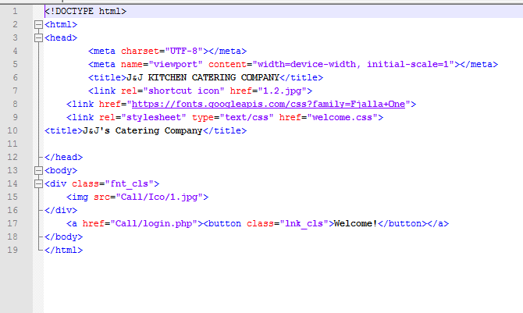

*Fig 11-E.17 Welcome screen*

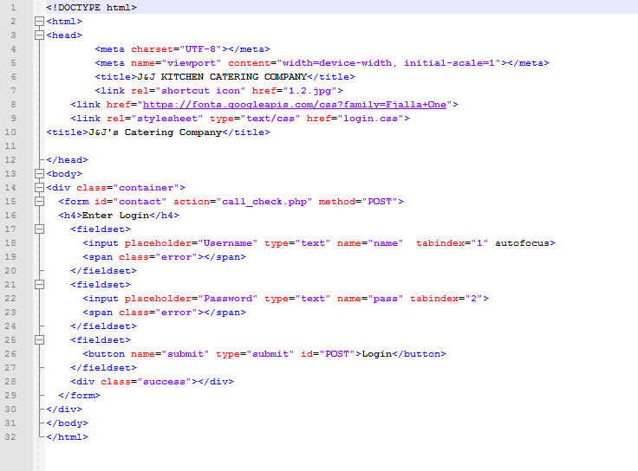Login:

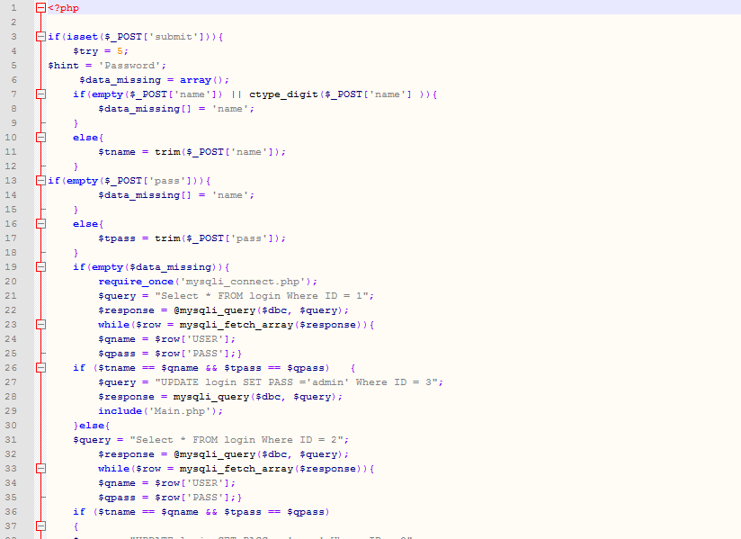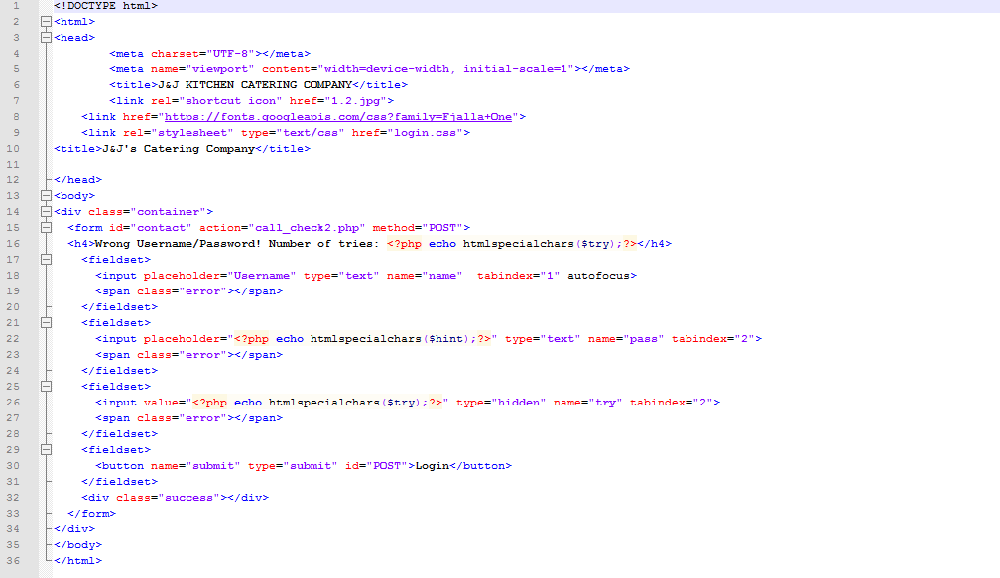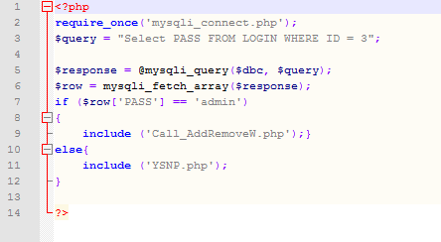

*Fig 11-E.19 Check password*

*Fig 11-E.18 Wrong password*

*Fig 11-E.20 Password check*

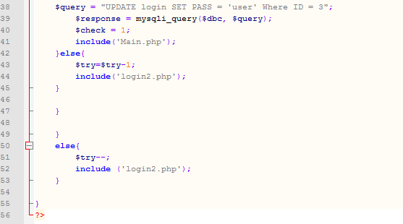

Clearance level low:

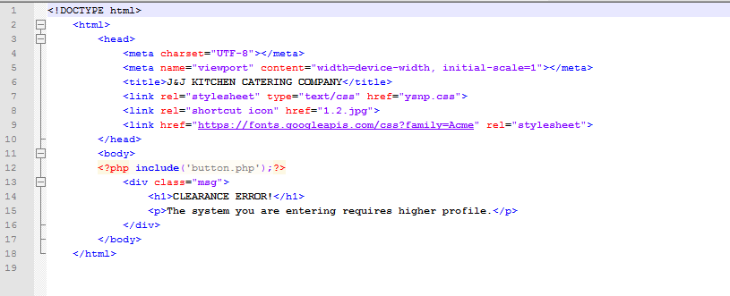

*Fig 11-E.21 Clearance warning*

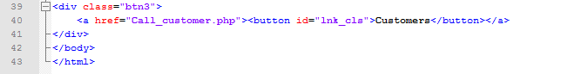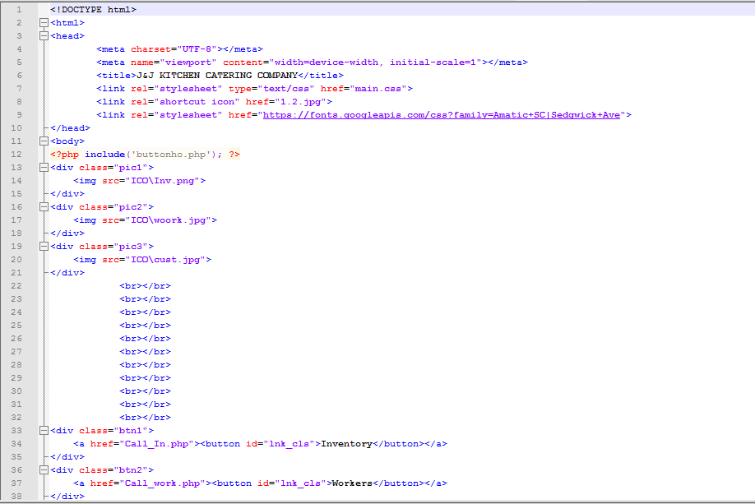Main Screen:

*Fig 11-E.22 Main screen*

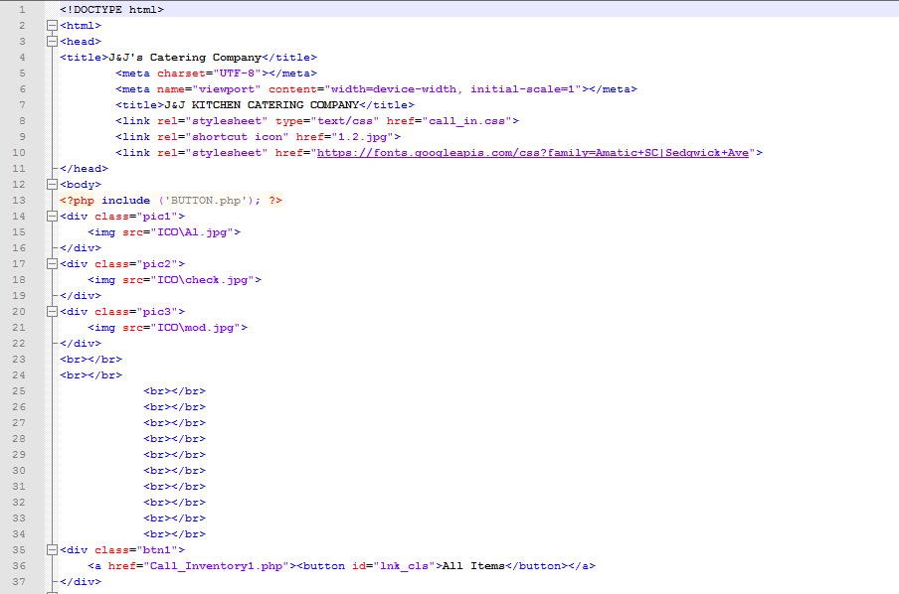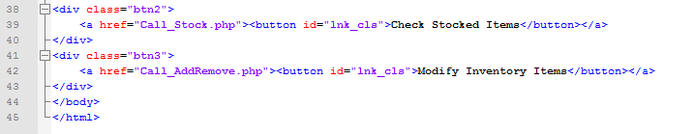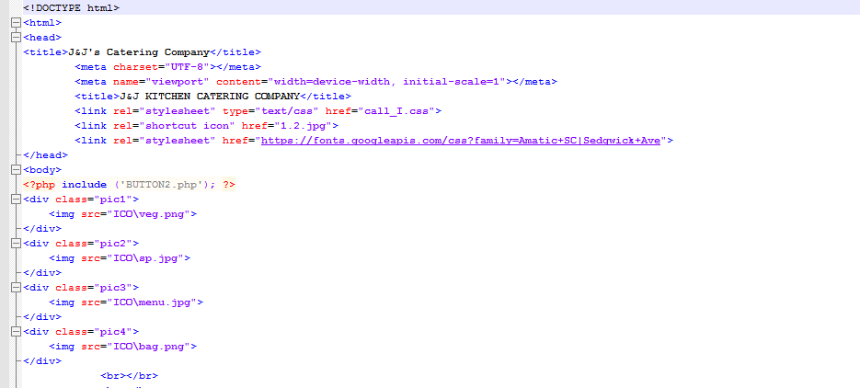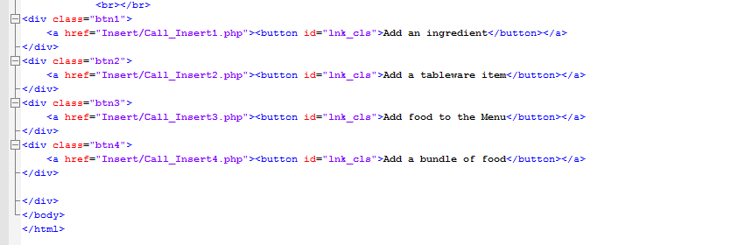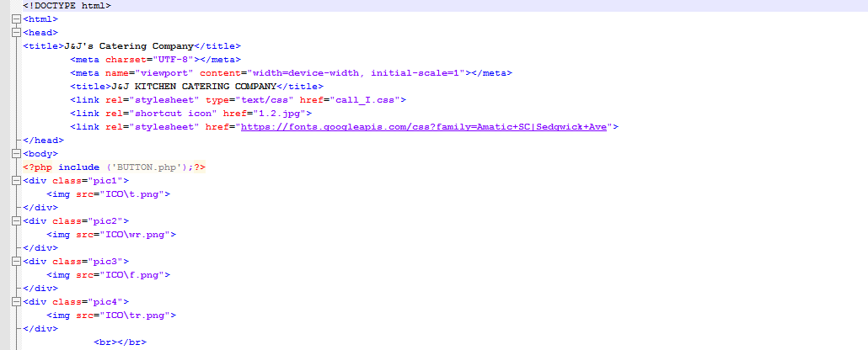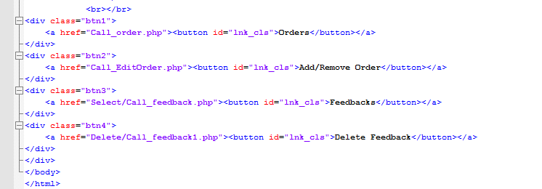

*Fig 11-E.24 Add item screen*

*Fig 11-E.23 Inventory screen*

*Fig 11-E.25 Modify order screen*

Quick Access buttons:

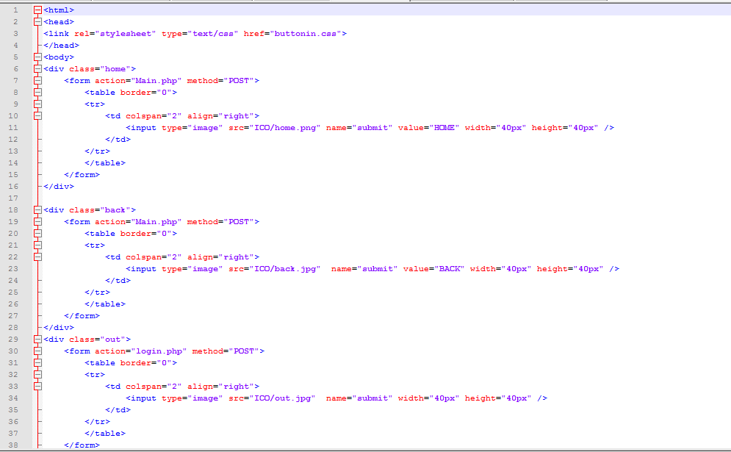

*Fig 11-E.26 Quick access button*

Empty field:

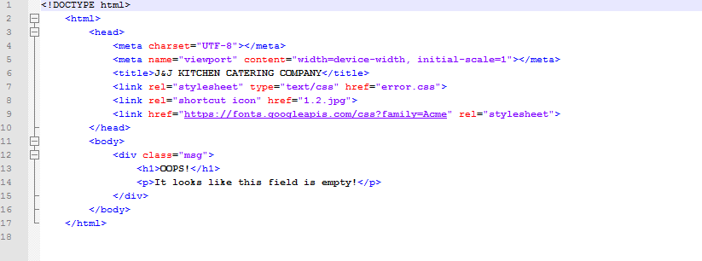

*Fig 11-E.27 Field empty screen*

Inventory Menu:

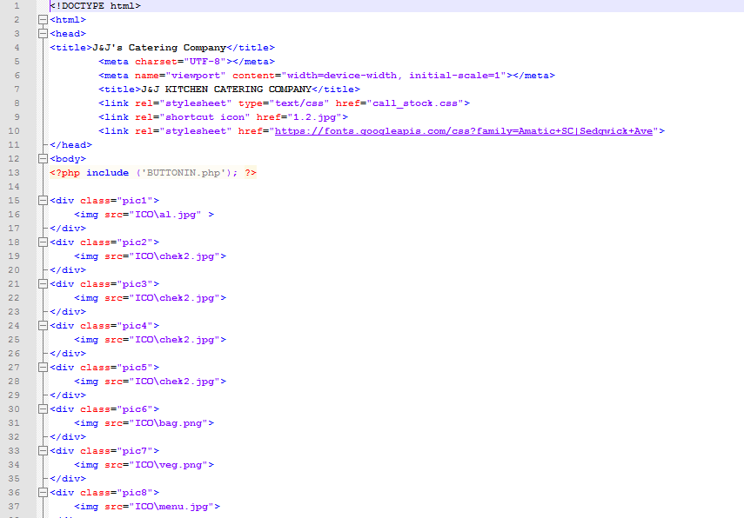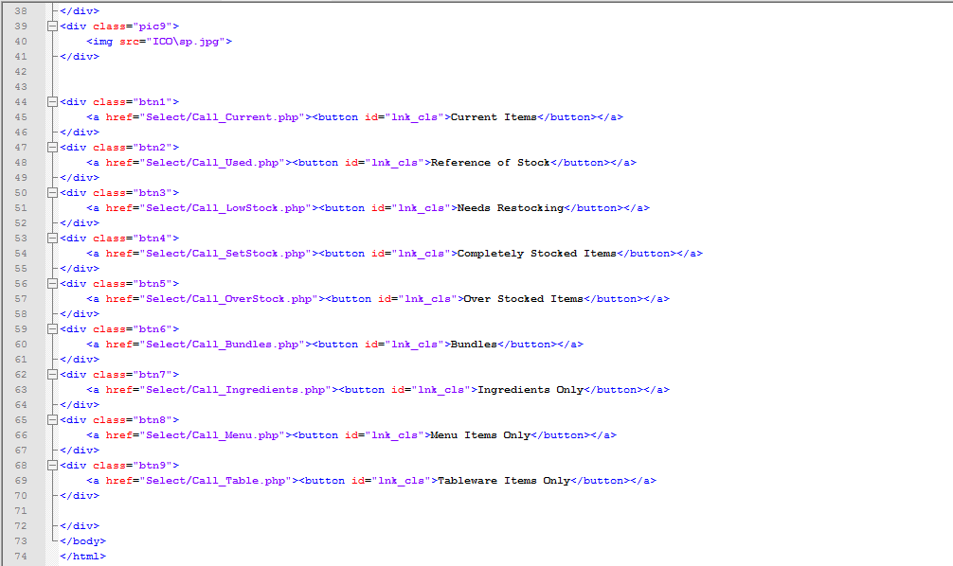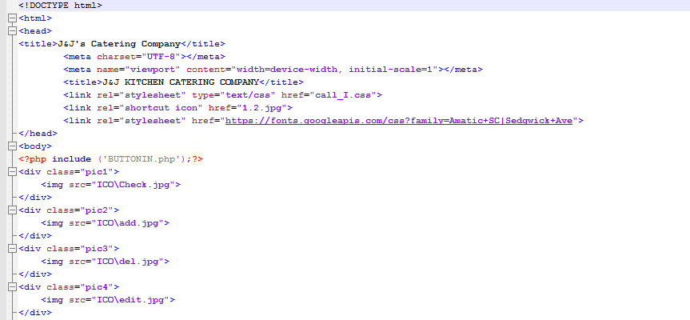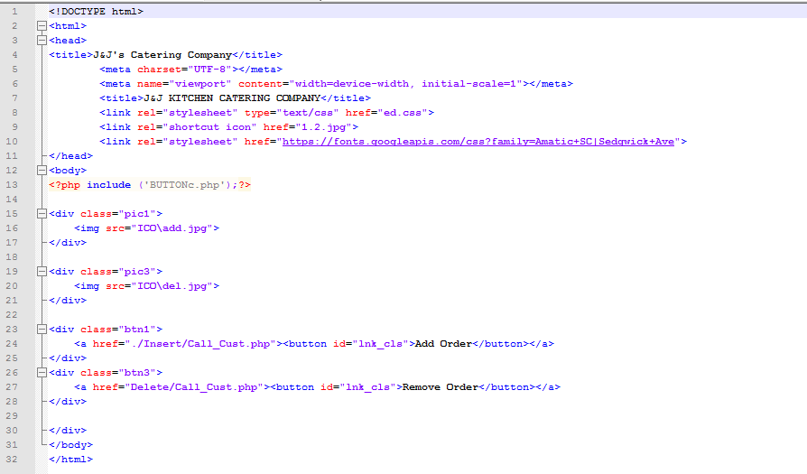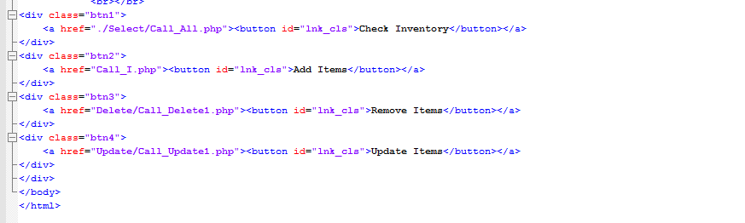

*Fig 11-E.28 Inventory sort screen*

*Fig 11-E.29 Modify inventory screen*

*Fig 11-E.30 Modify orders screen*

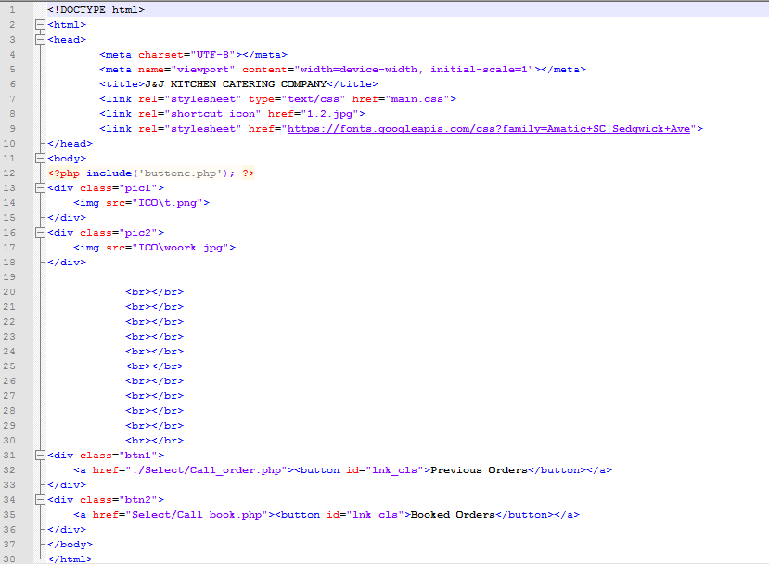

*Fig 11-E.31 View orders*

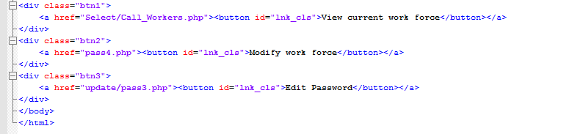Work force menu: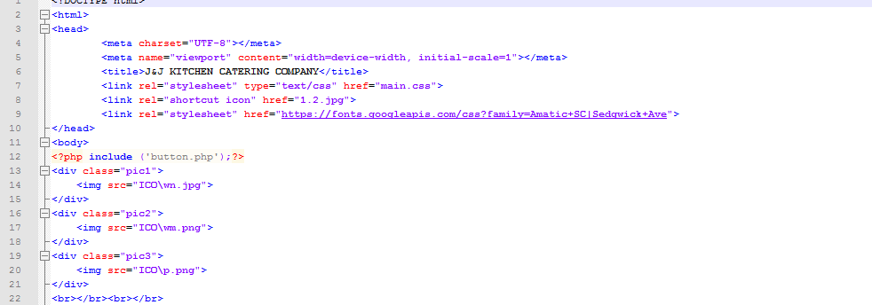

*Fig 11-E.32 Modify workers*

All that Creates and Calls Inventory tables:

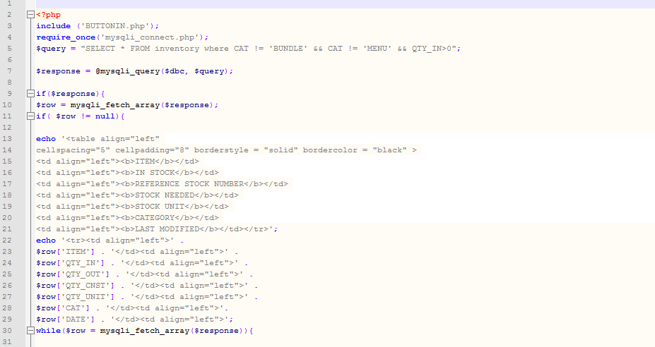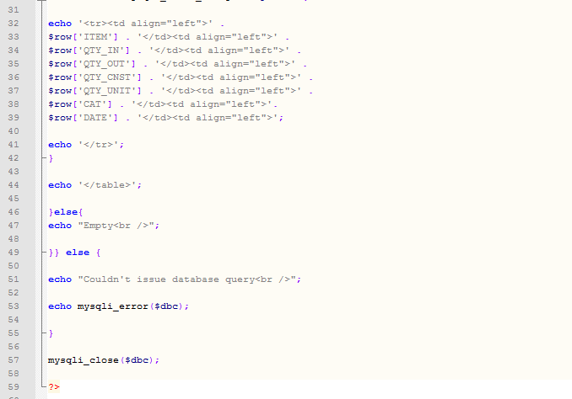

*Fig 11-E.33 Select current items*

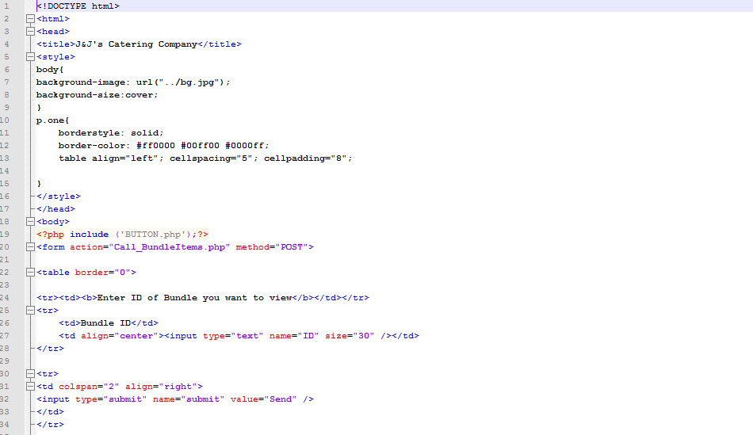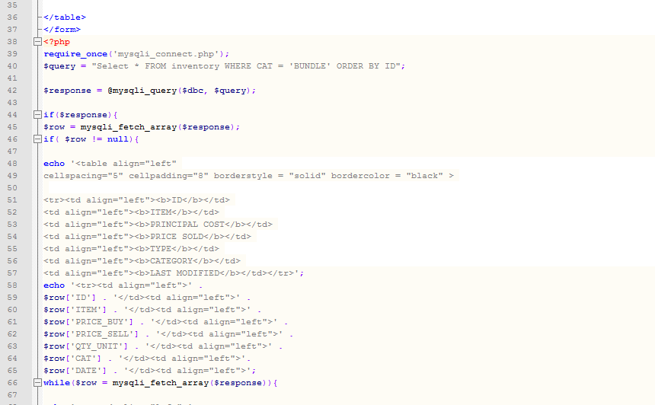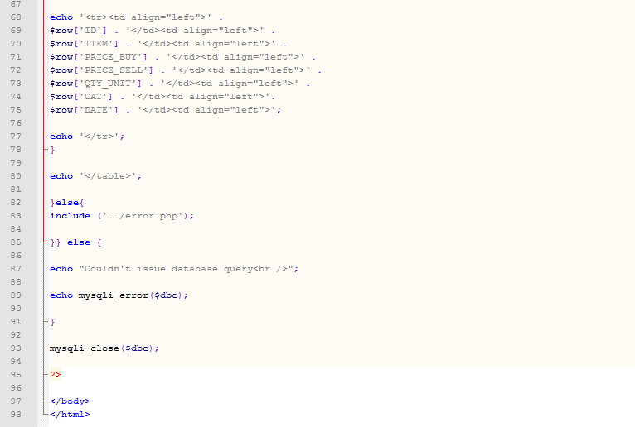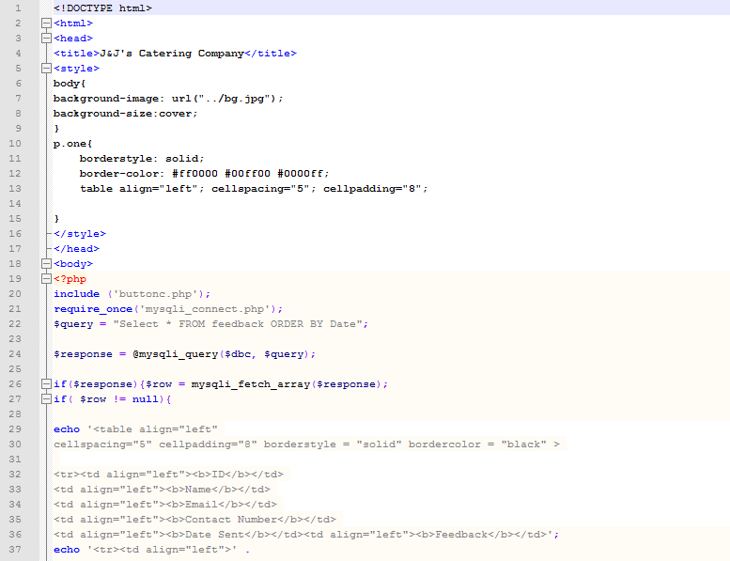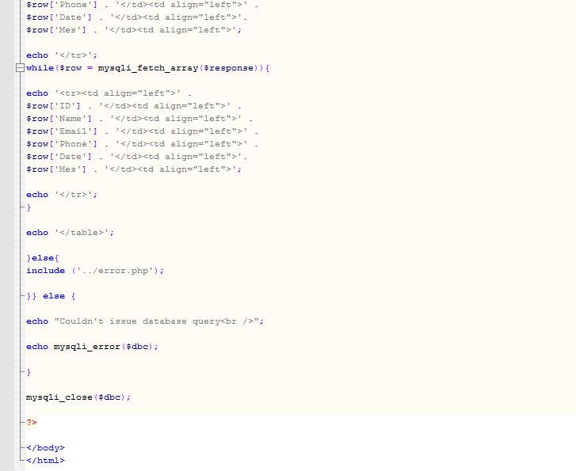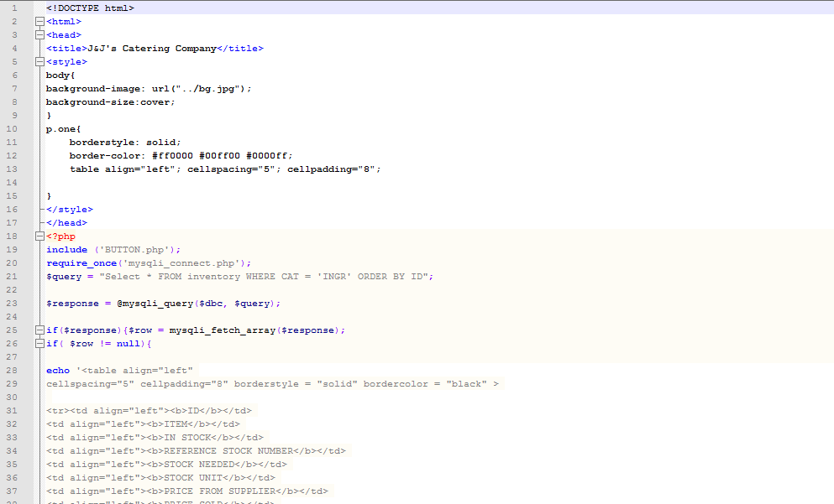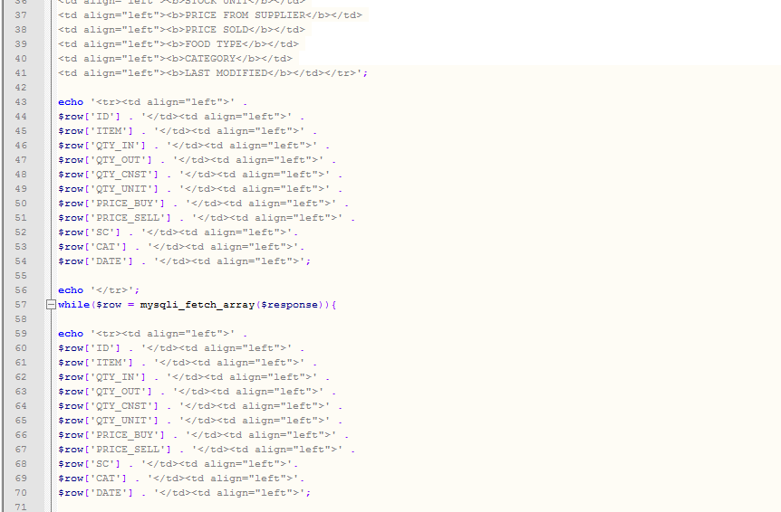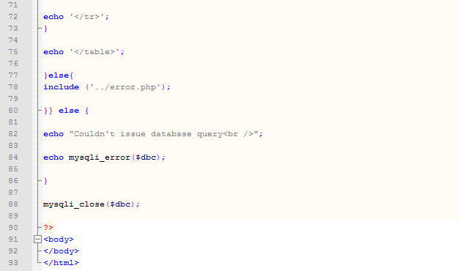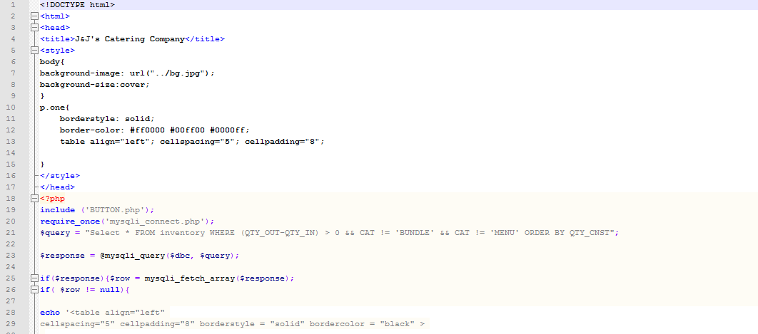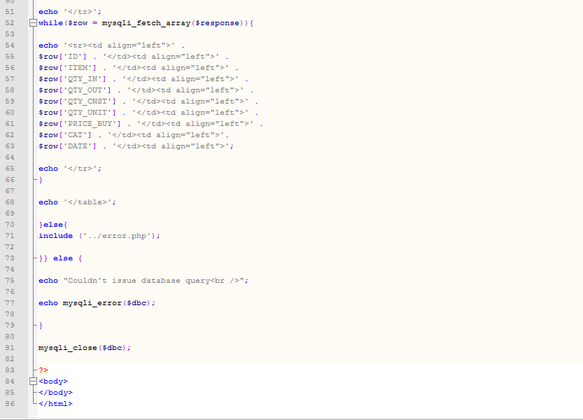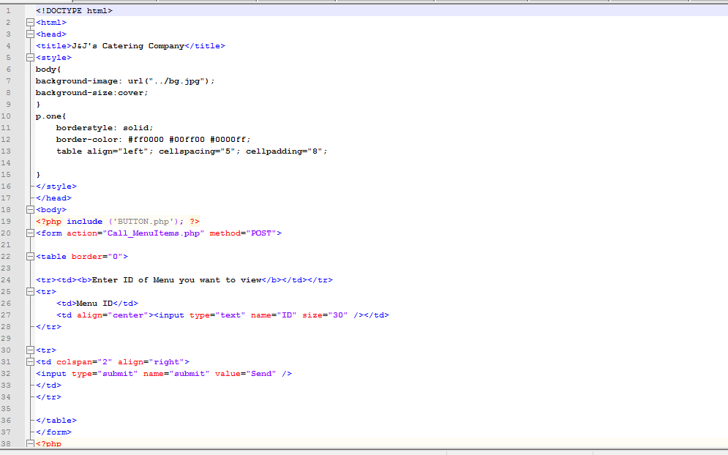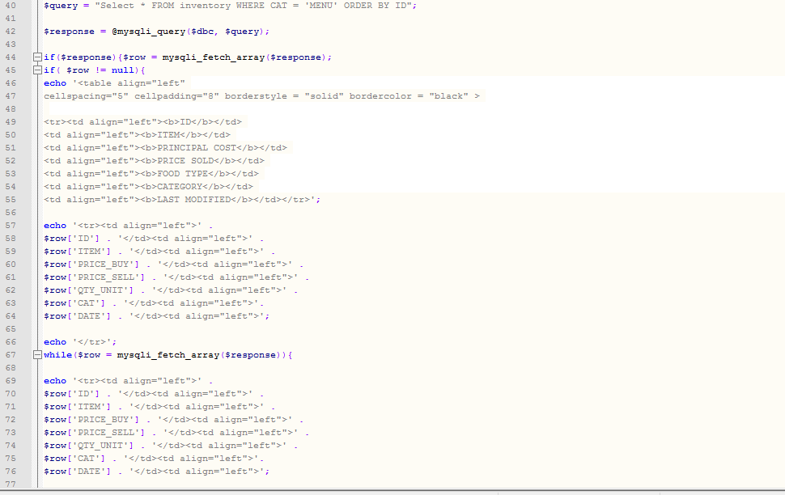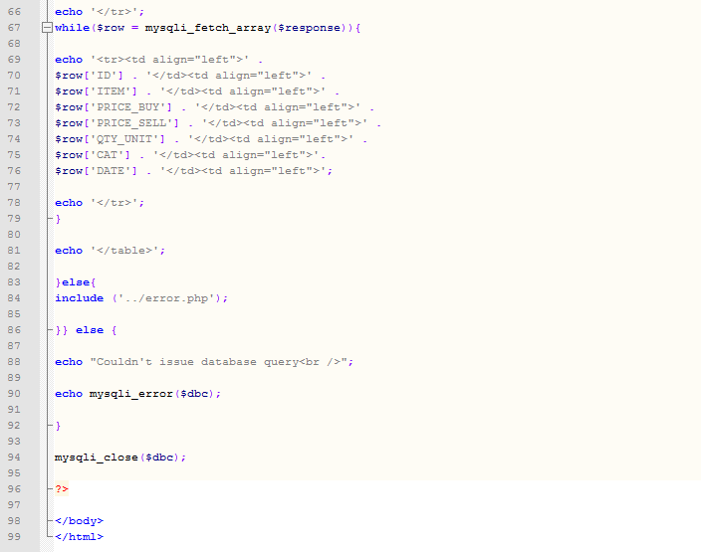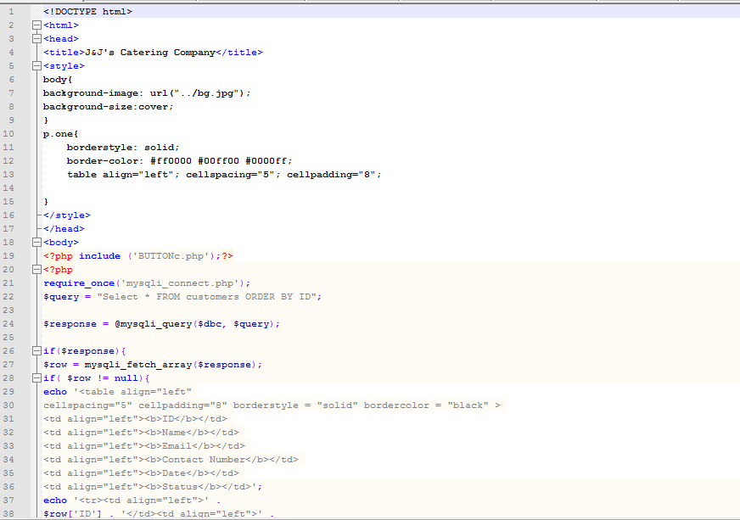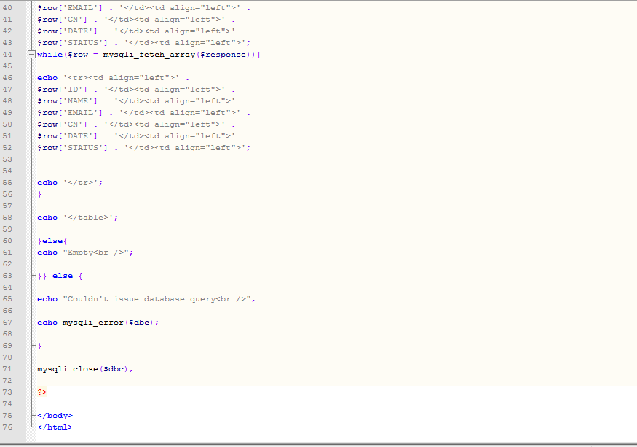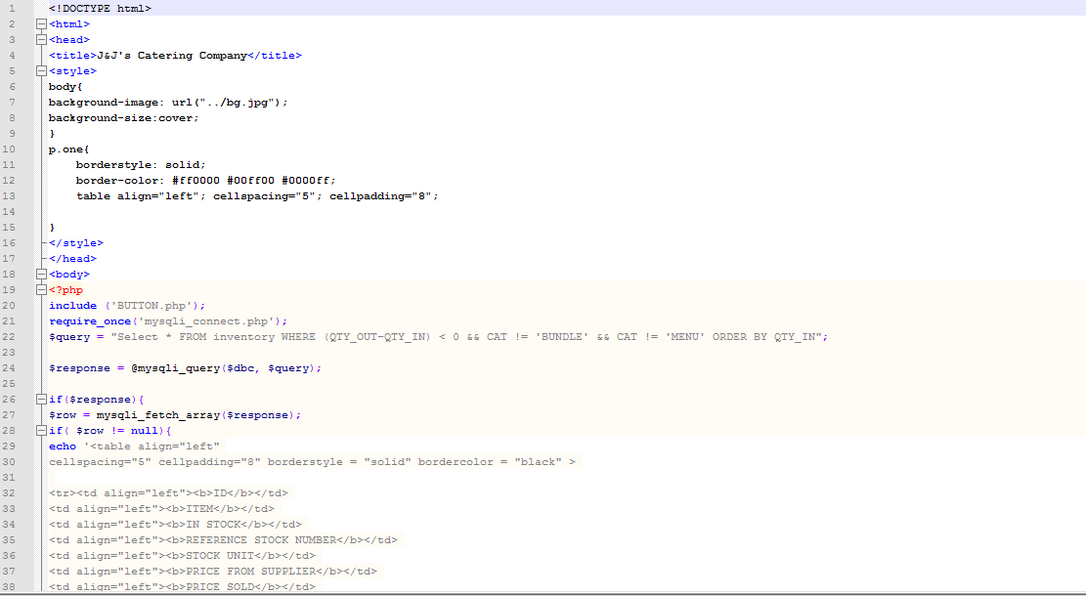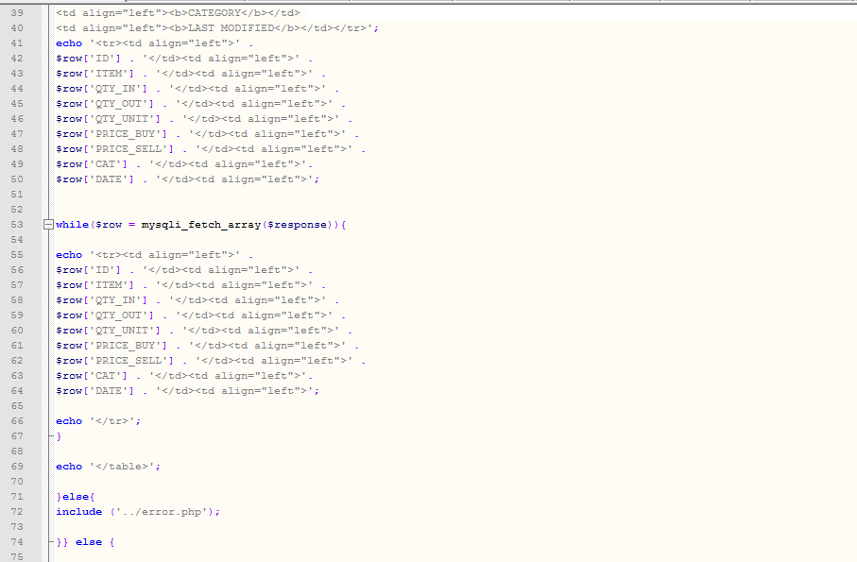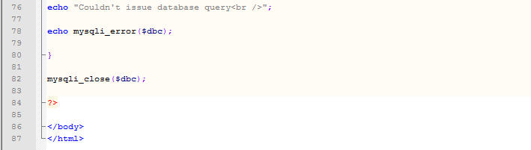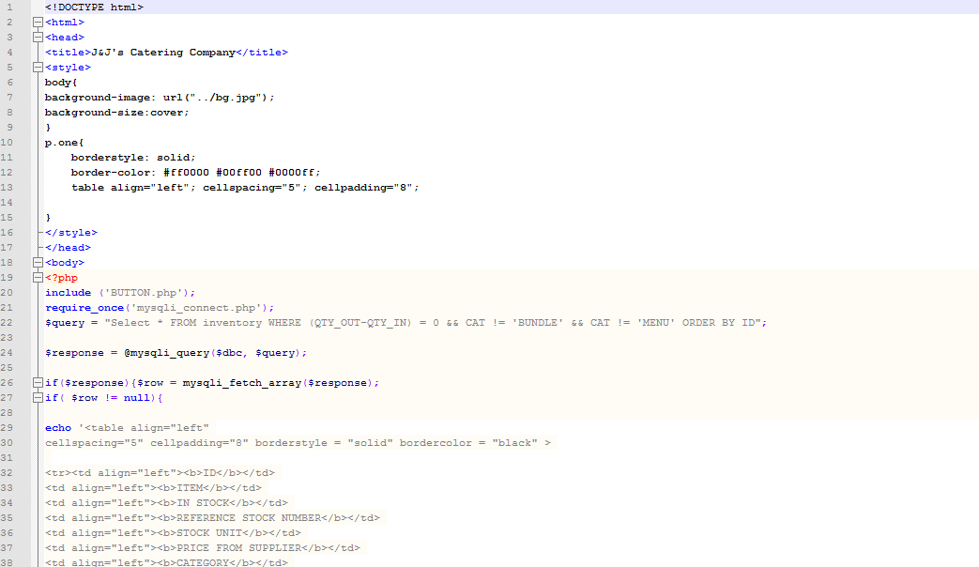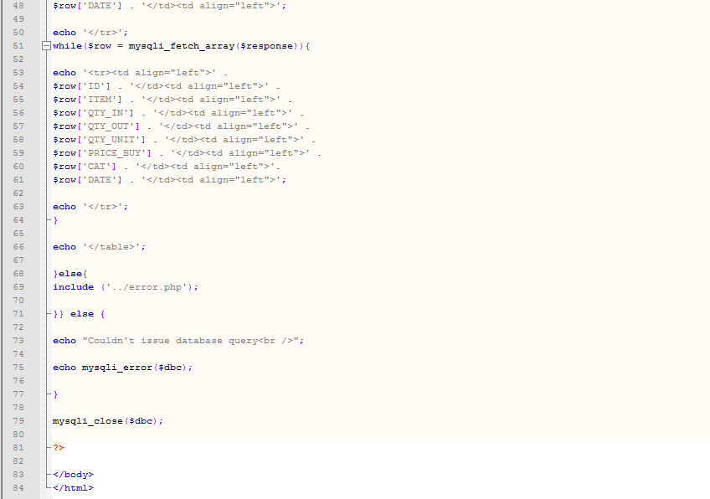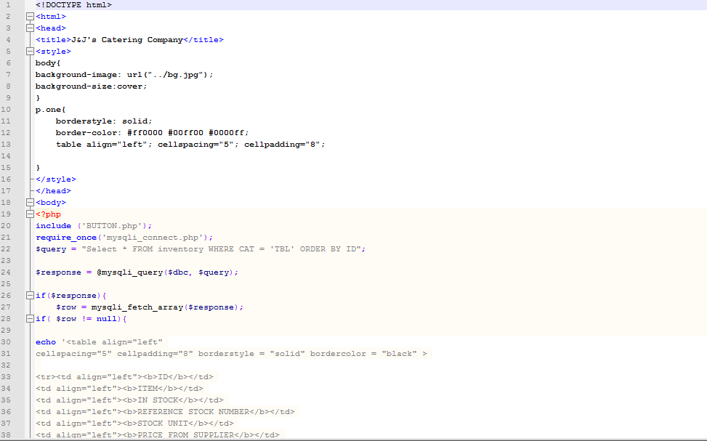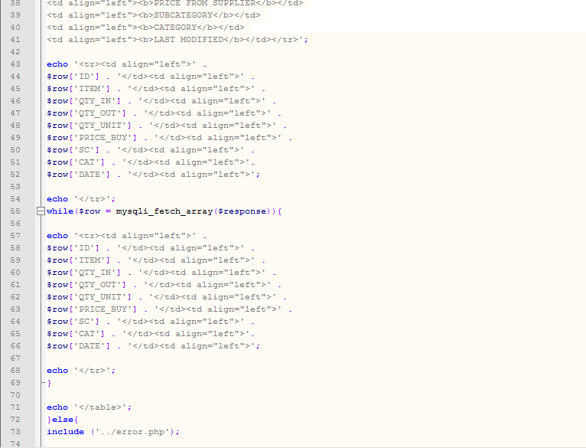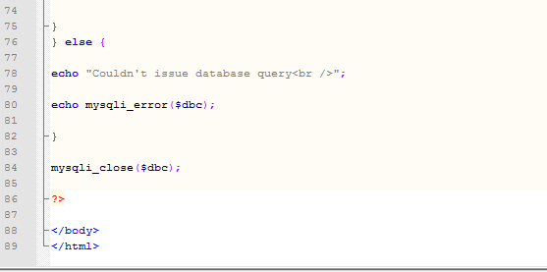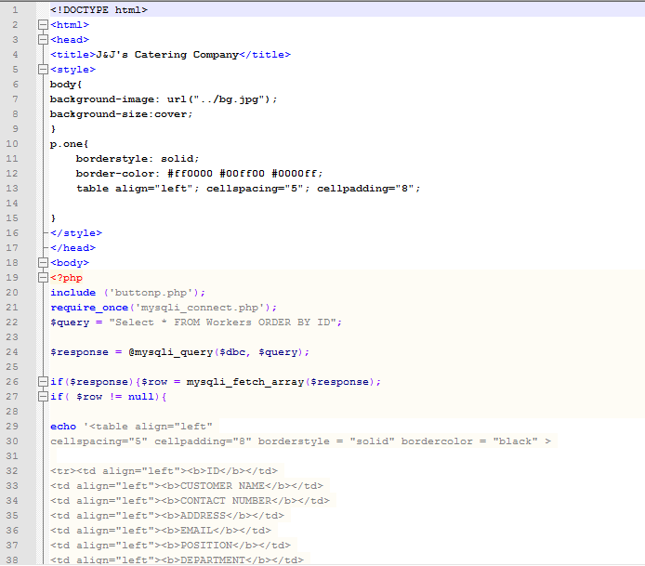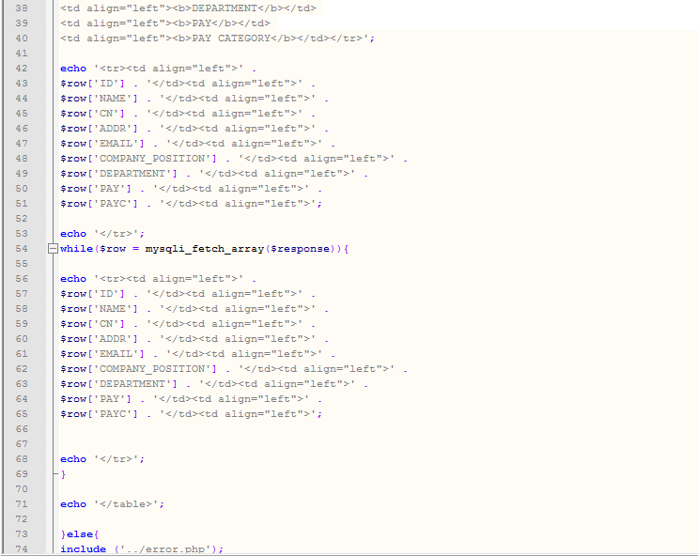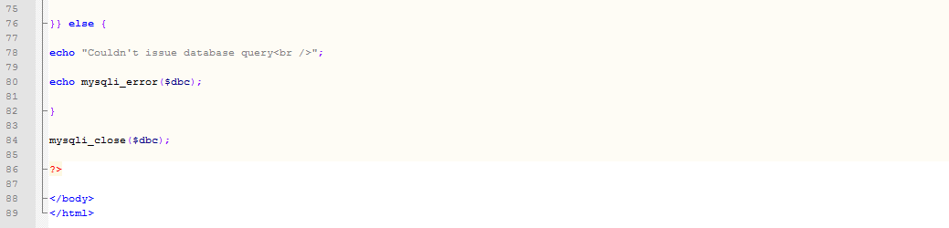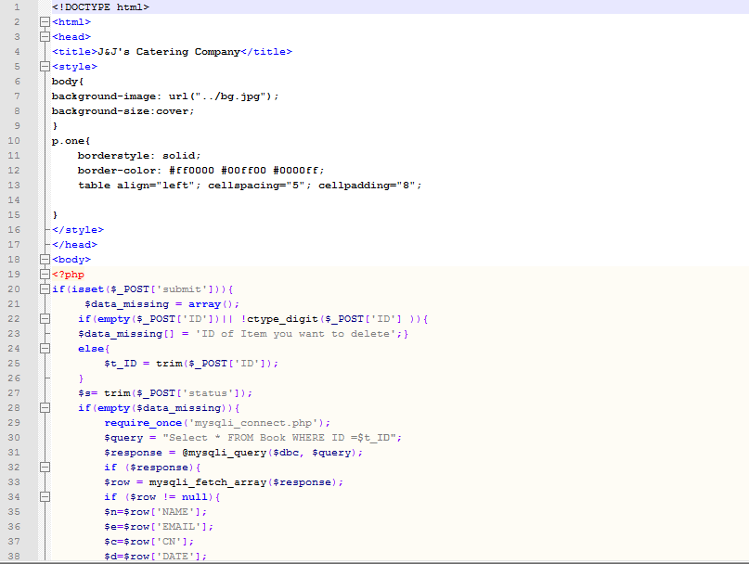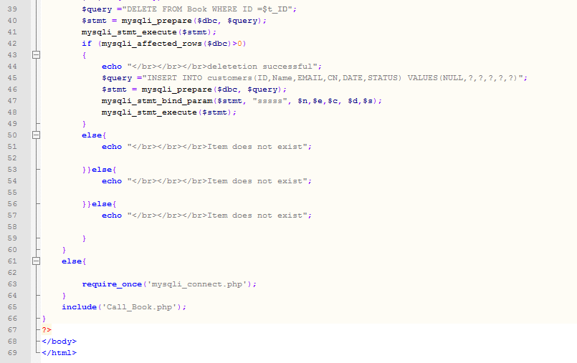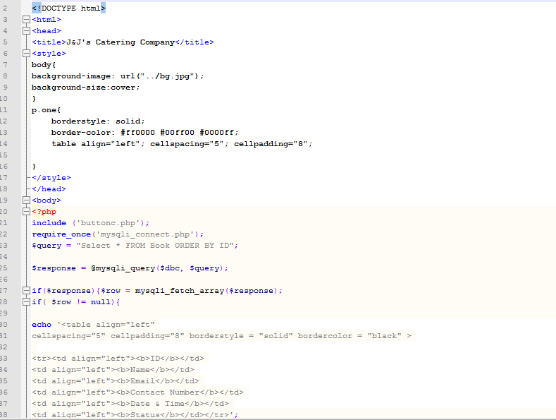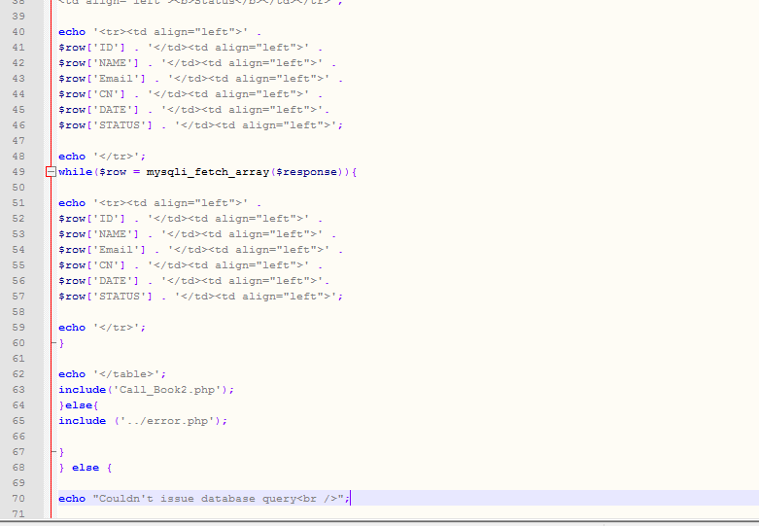

*Fig 11-E.34 Select bundles*

*Fig 11-E.35 Select feedbacks*

*Fig 11-E.36 Select ingredients*

*Fig 11-E.37 Select needs restock*

*Fig 11-E.38 Select menu*

*Fig 11-E.39 Select order history*

*Fig 11-E.40 Select over stock*

*Fig 11-E.41 Select complete stock*

*Fig 11-E.41 Select tableware*

*Fig 11-E.42 Select workers*

*Fig 11-E.43 Delete booking*

Updates Inventory:

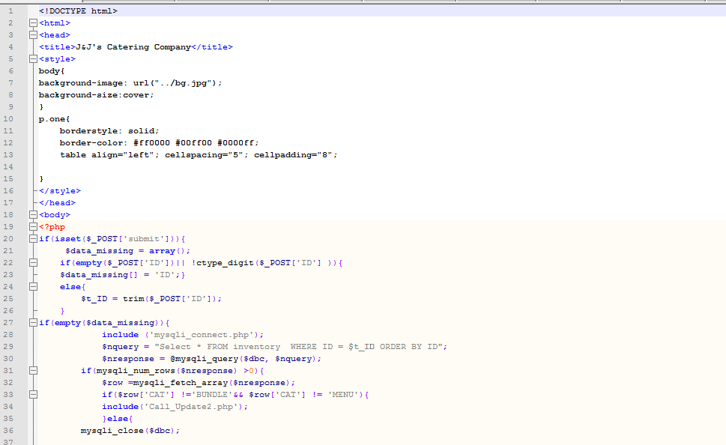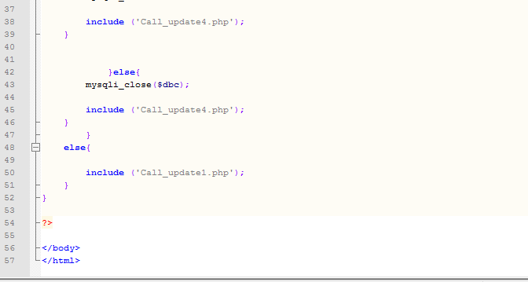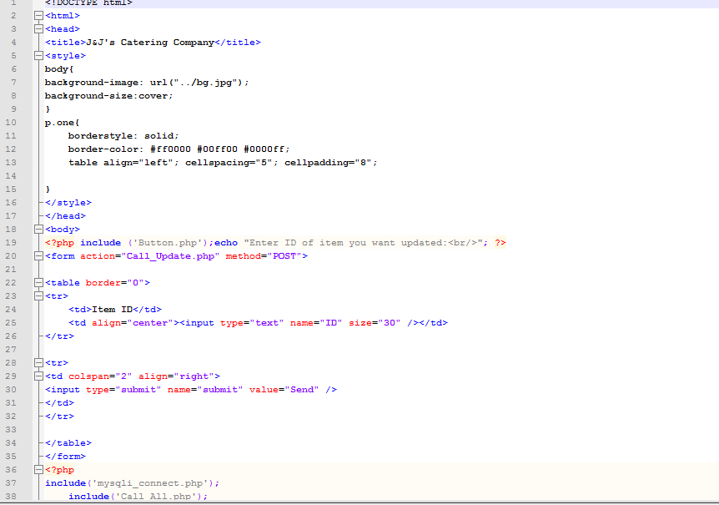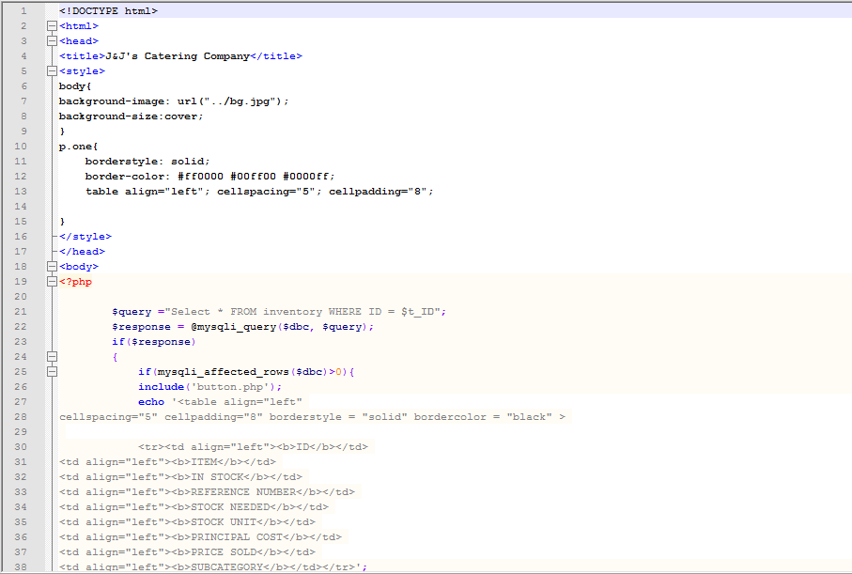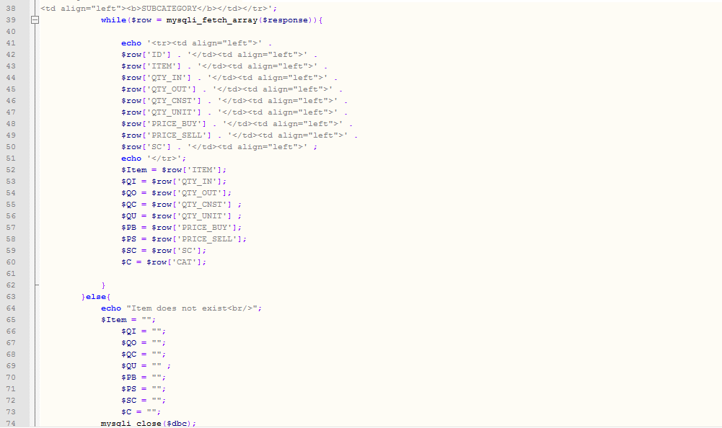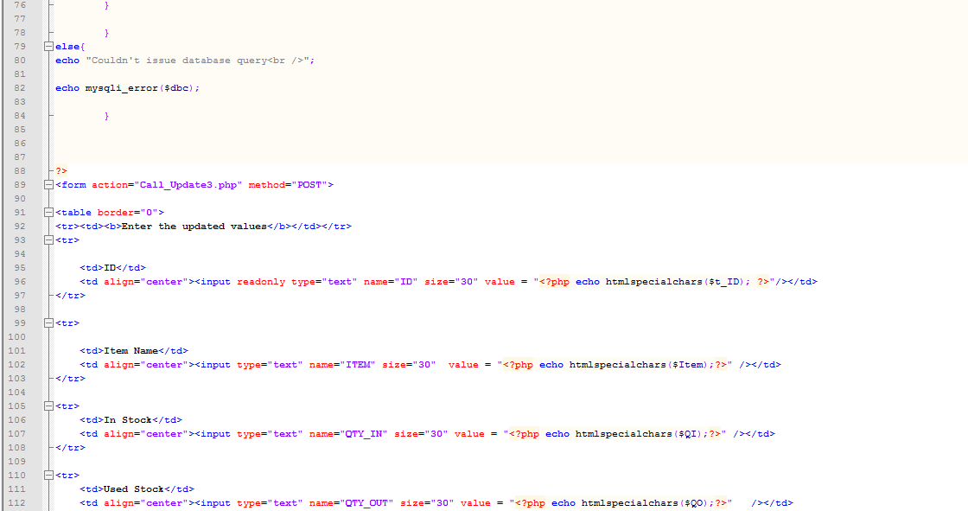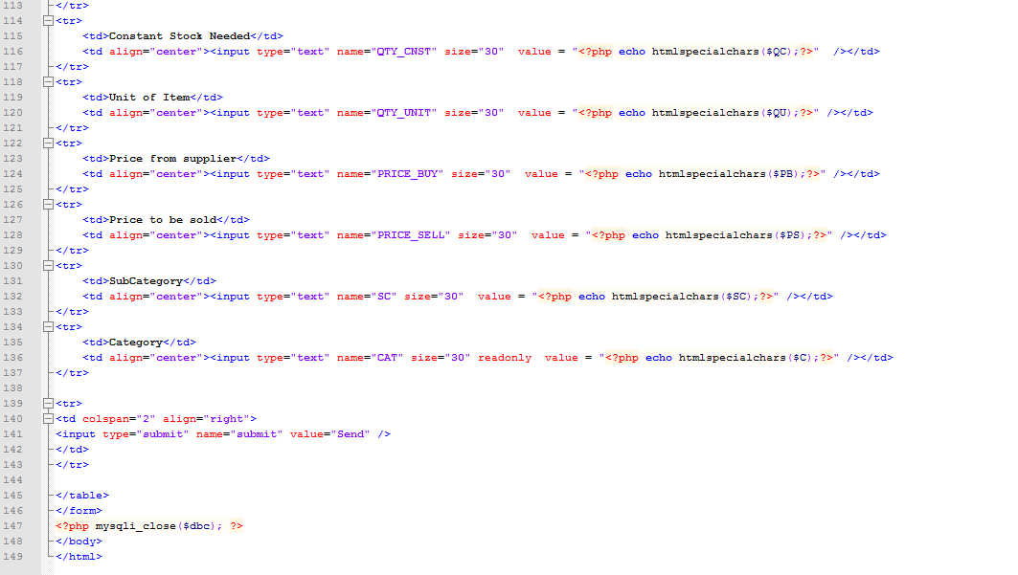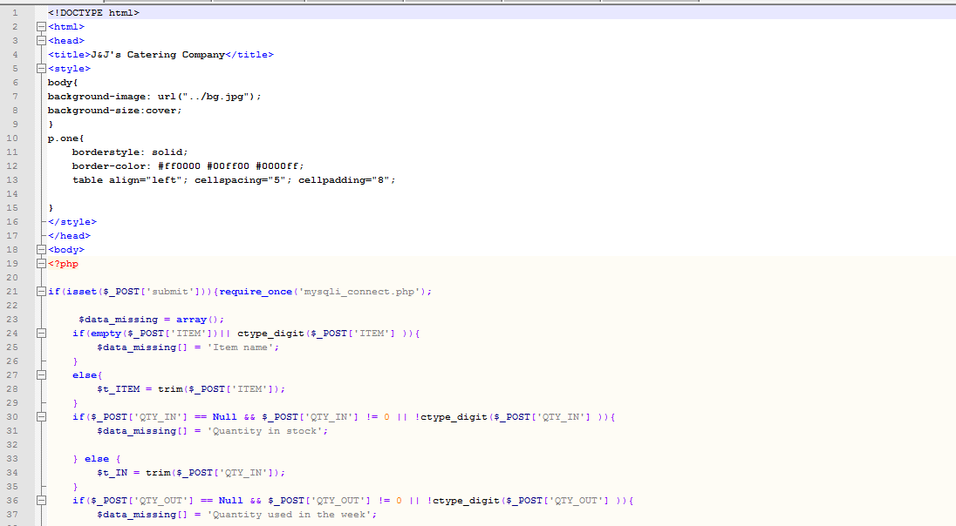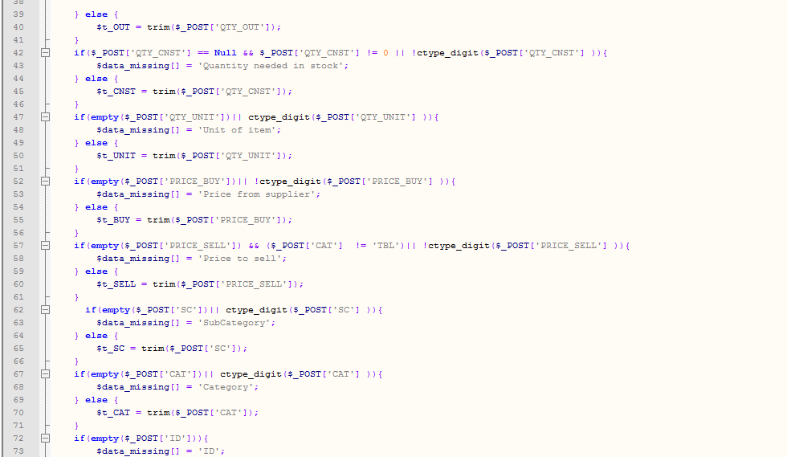

*Fig 11-E.44 Update select*

*Fig 11-E.45 Update select screen*

*Fig 11-E.46 Update select*

*Fig 11-E.47 Update item*

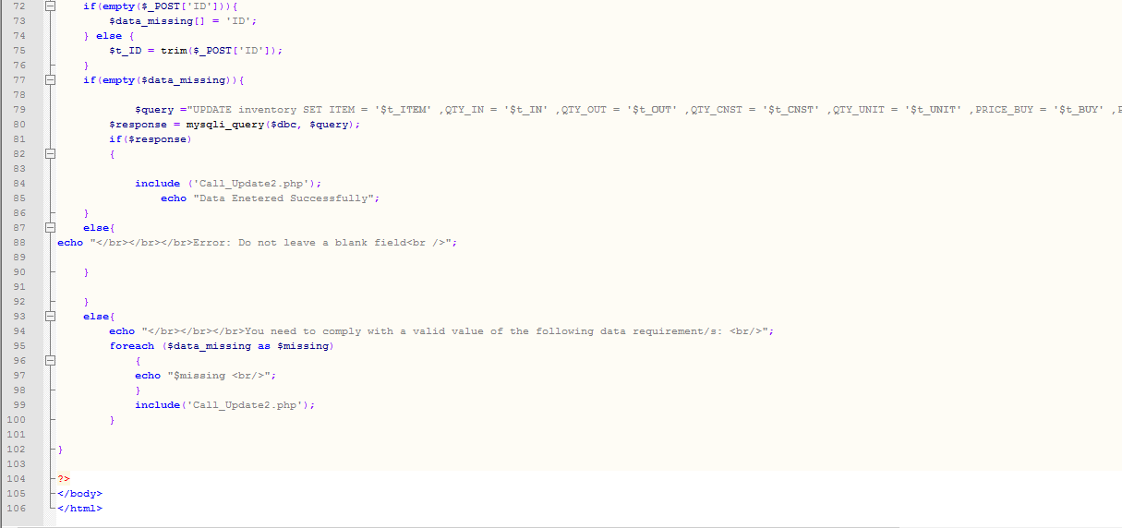

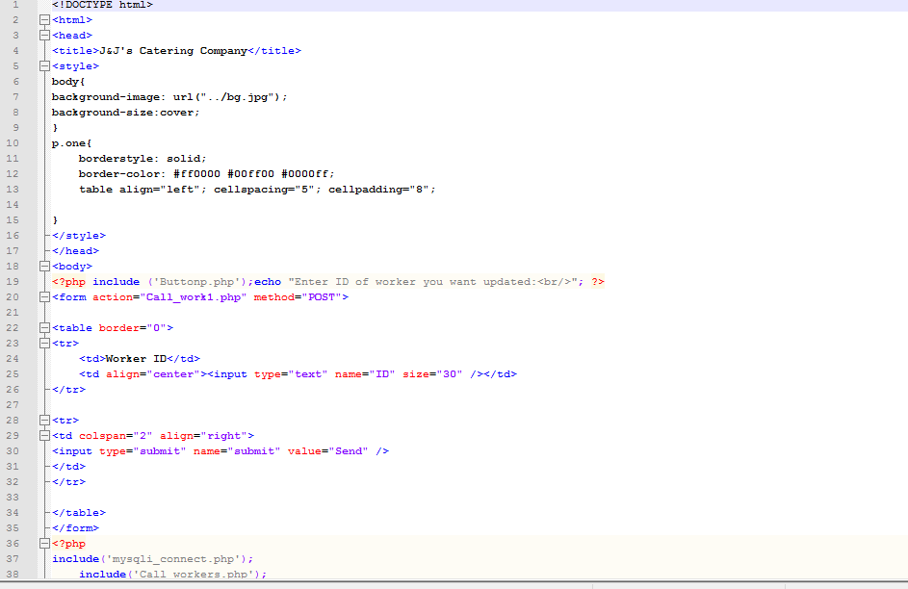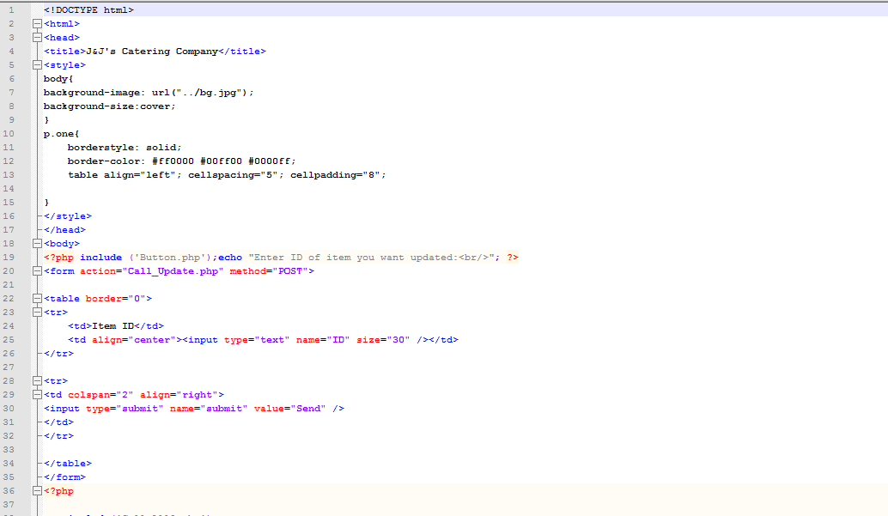

*Fig 11-E.49 Update inventory*

*Fig 11-E.48 Update worker*

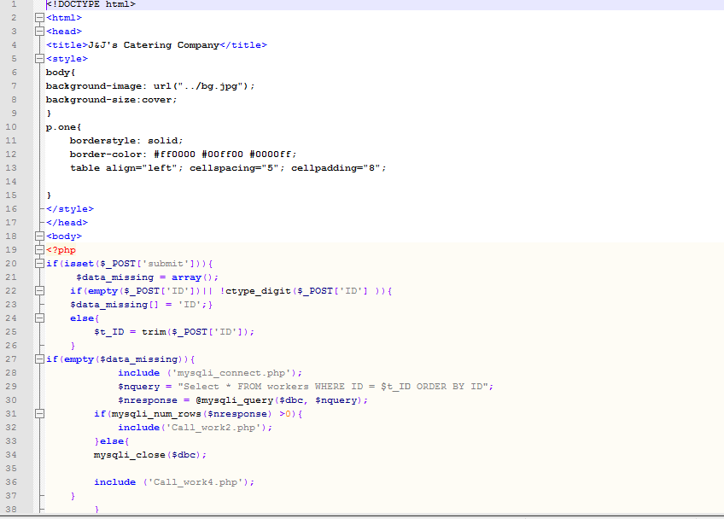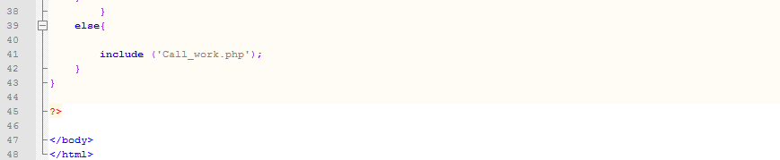

*Fig 11-E.50 Update select worker*

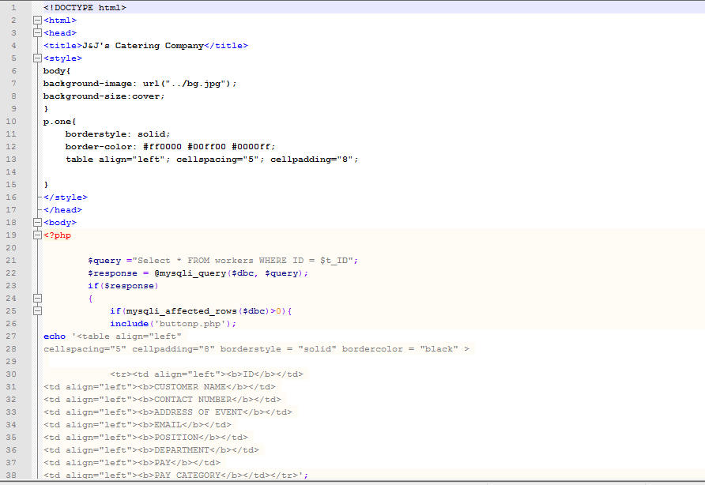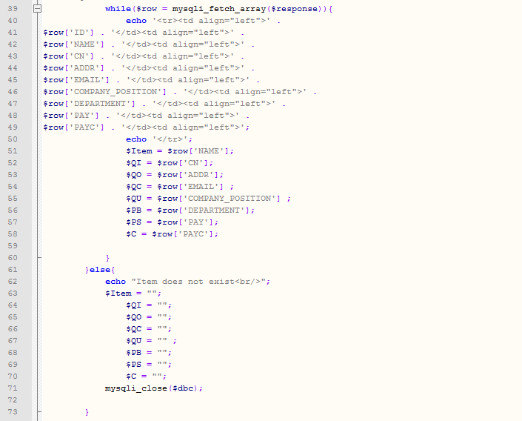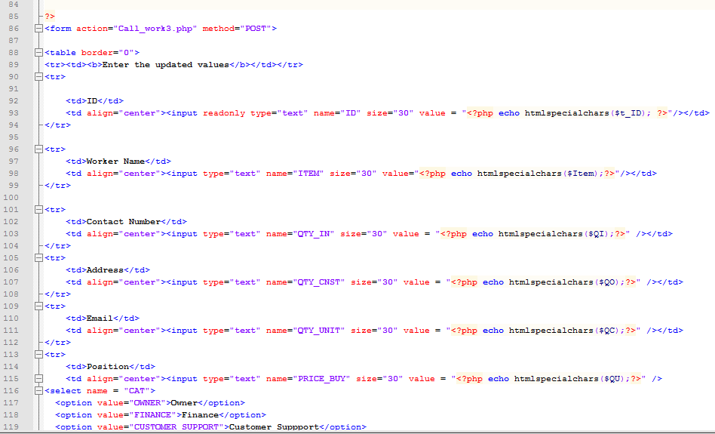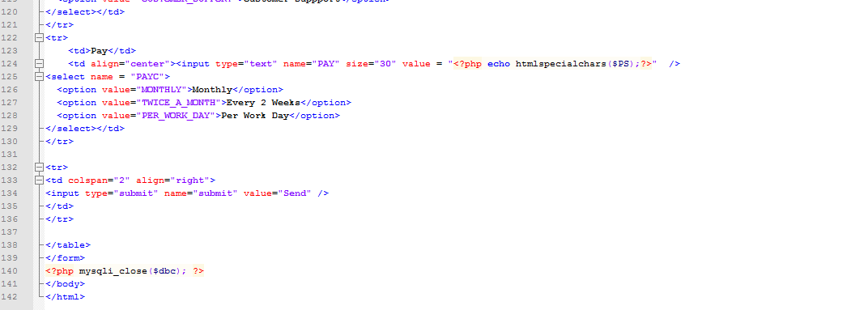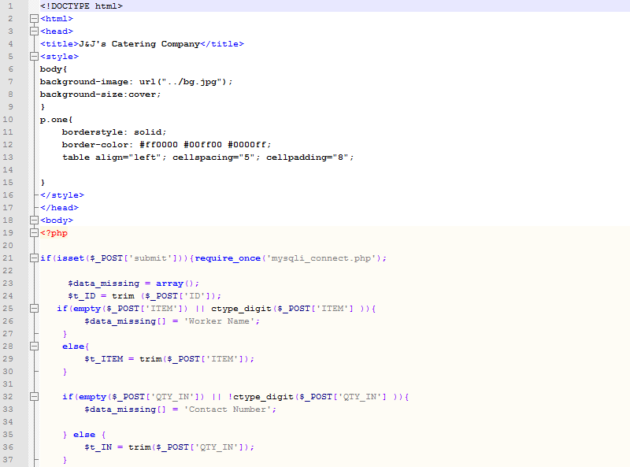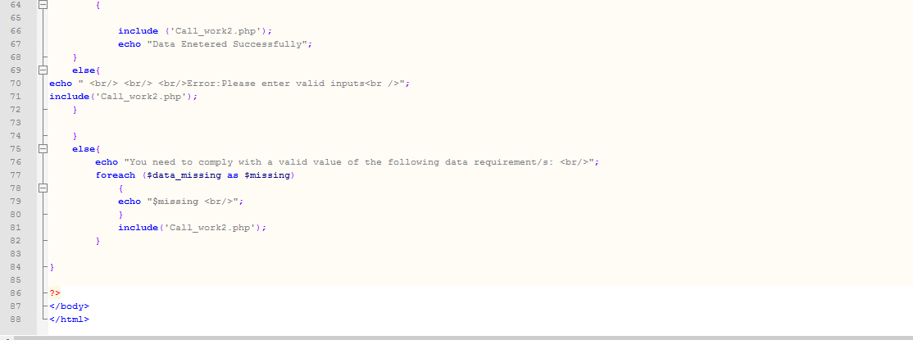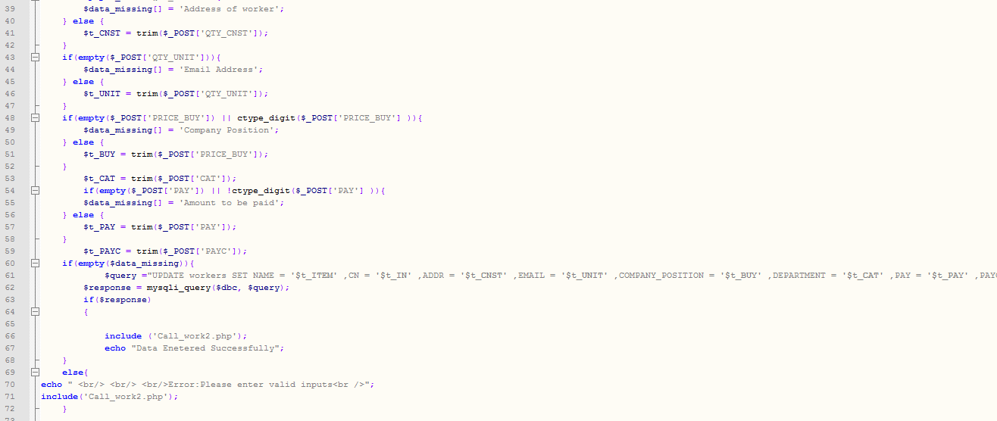

*Fig 11-E.51 Updates worker*

*Fig 11-E.52 Update select*

Insert values to Inventory:

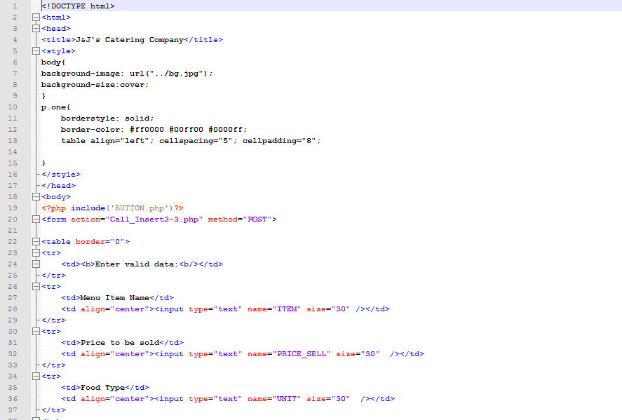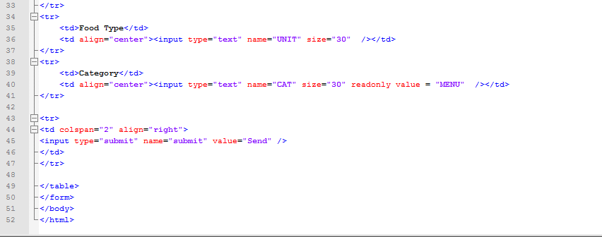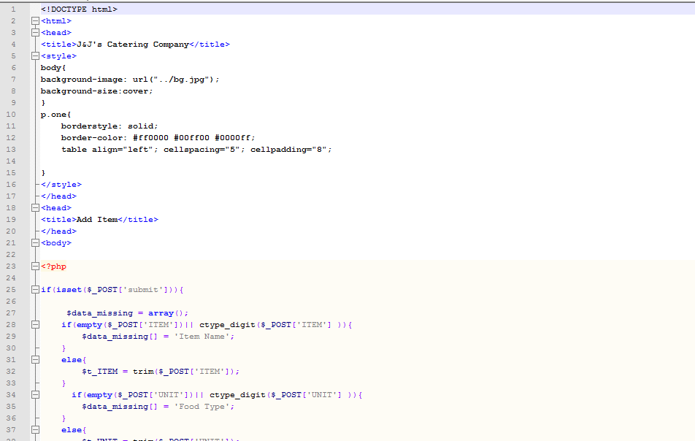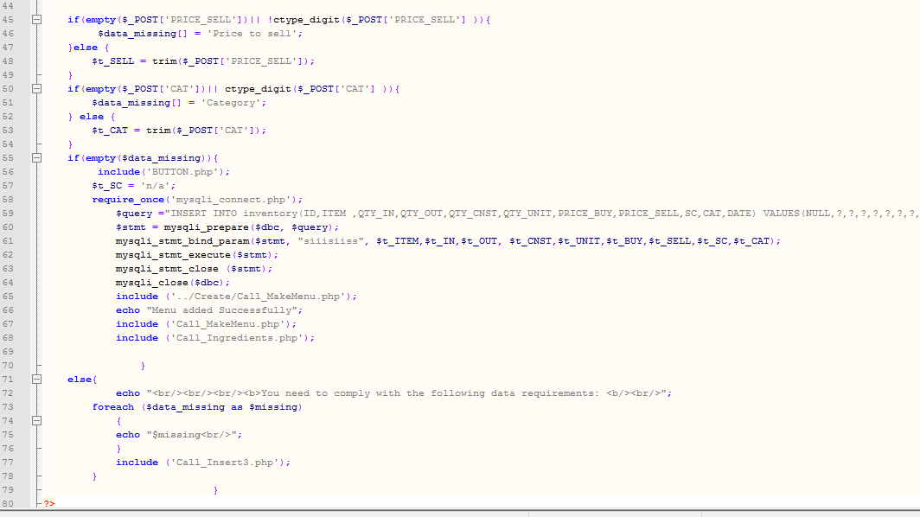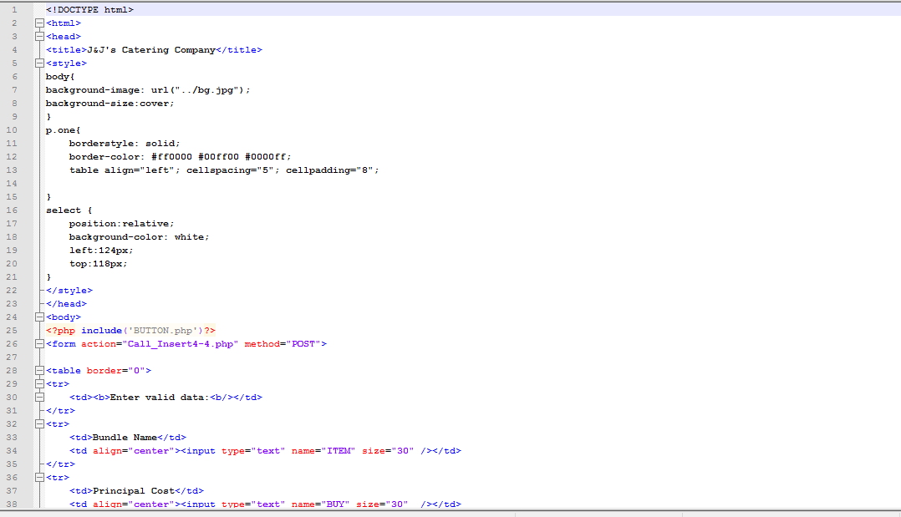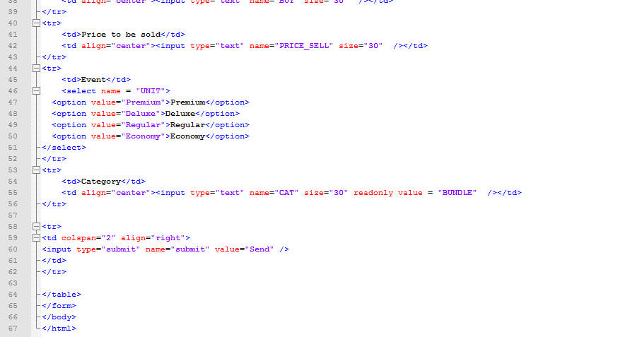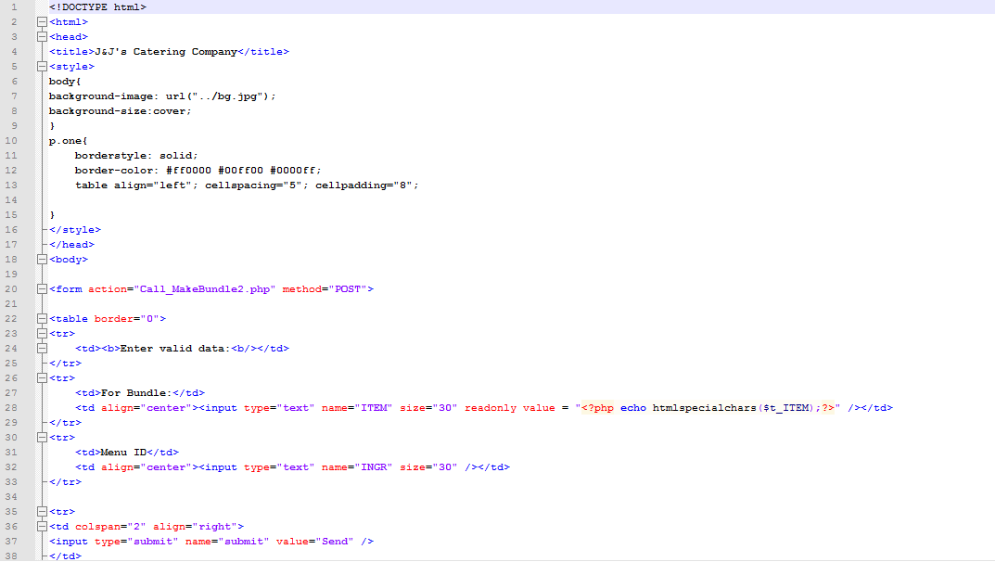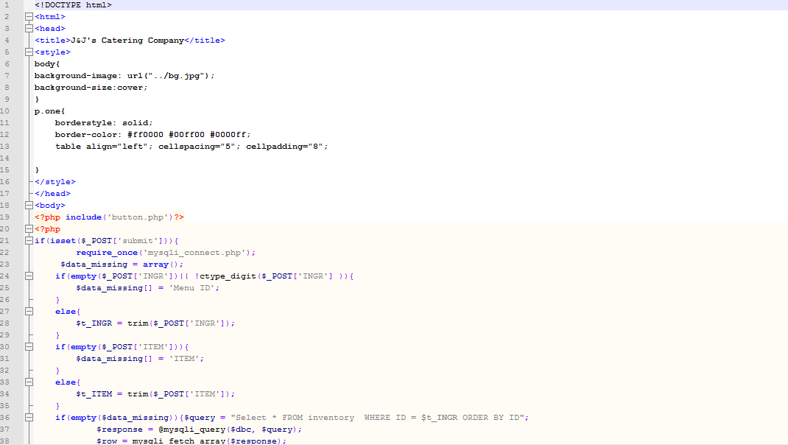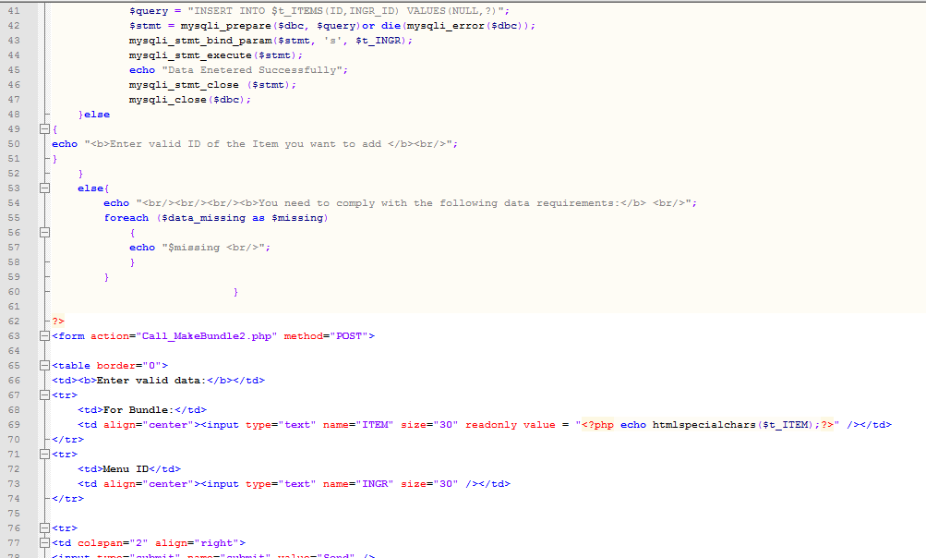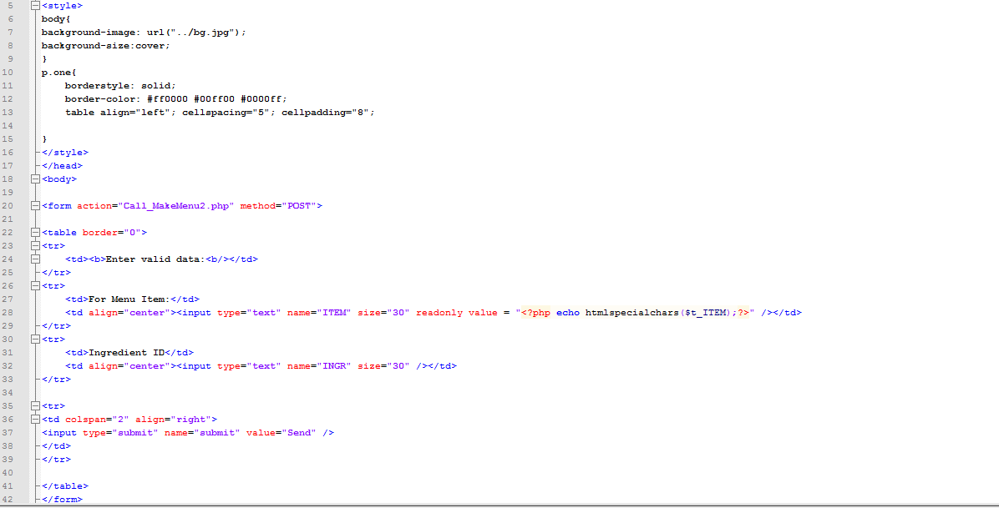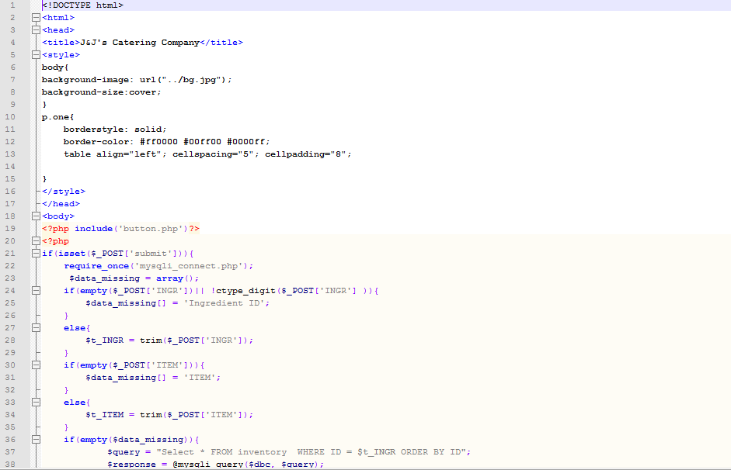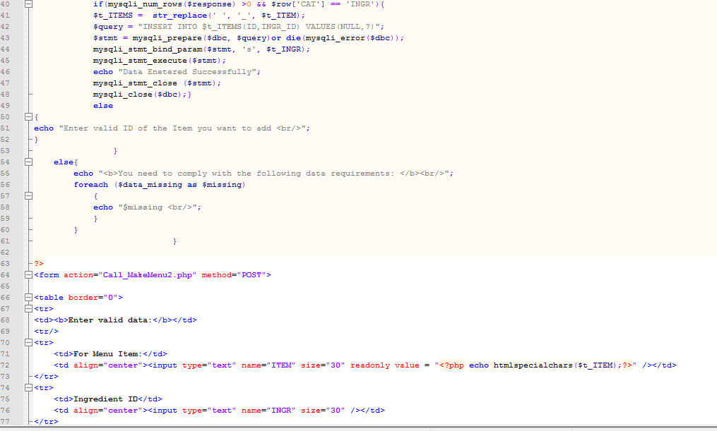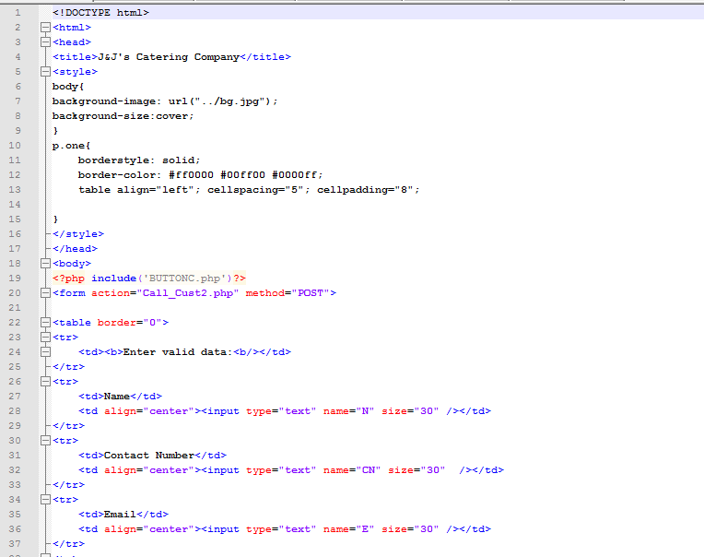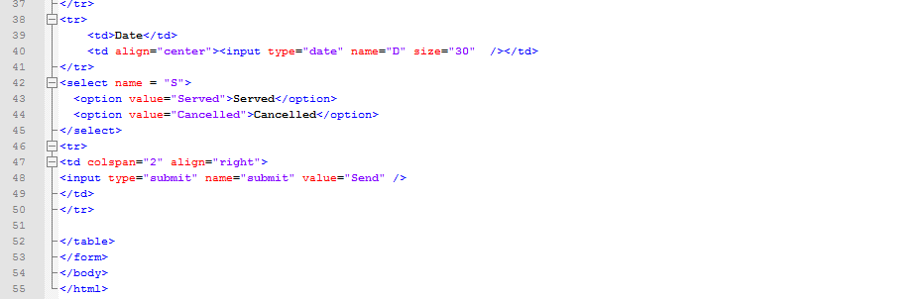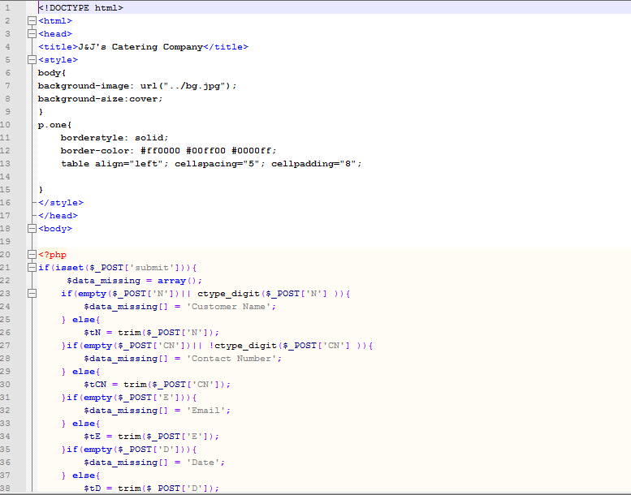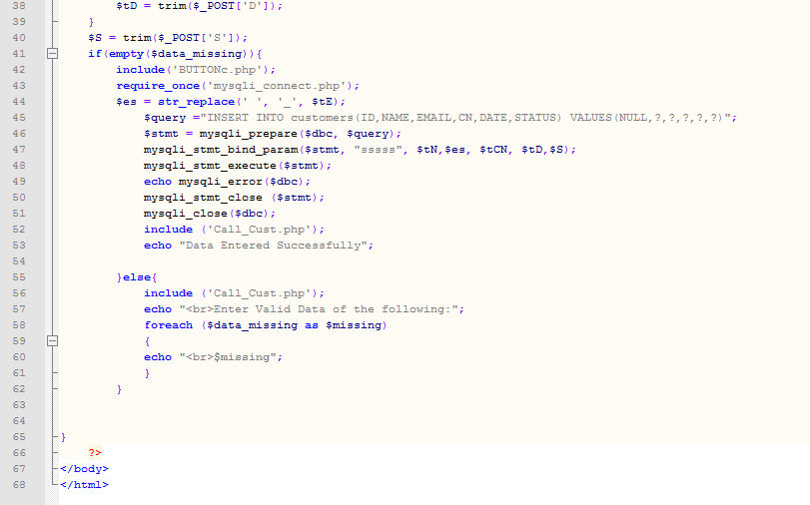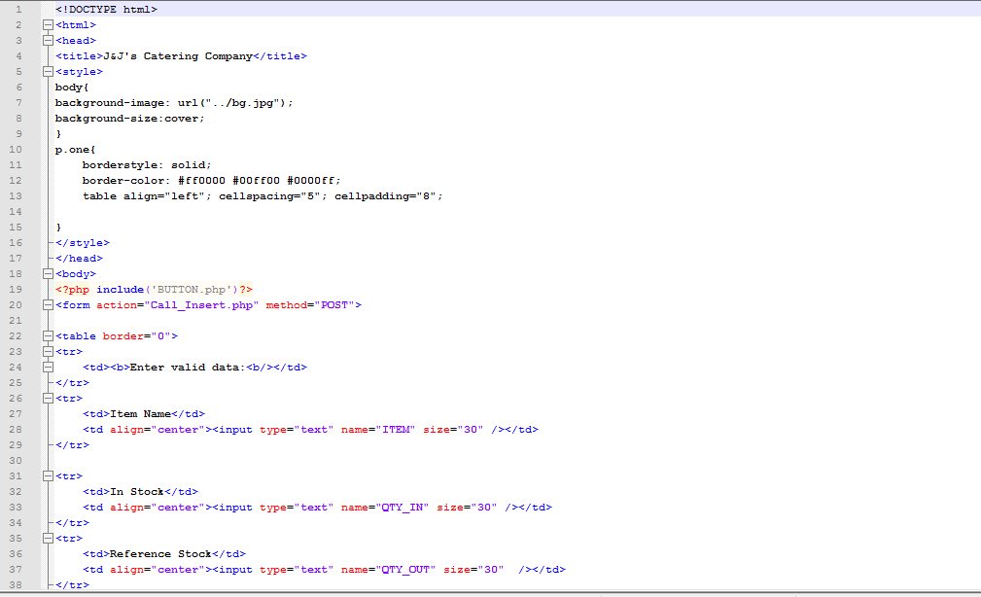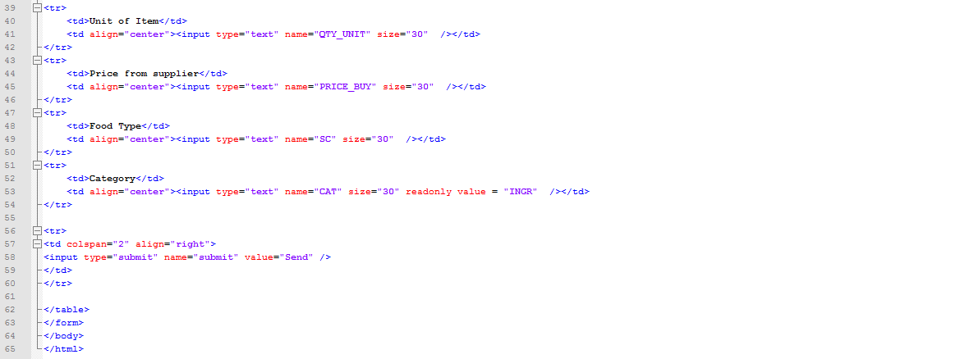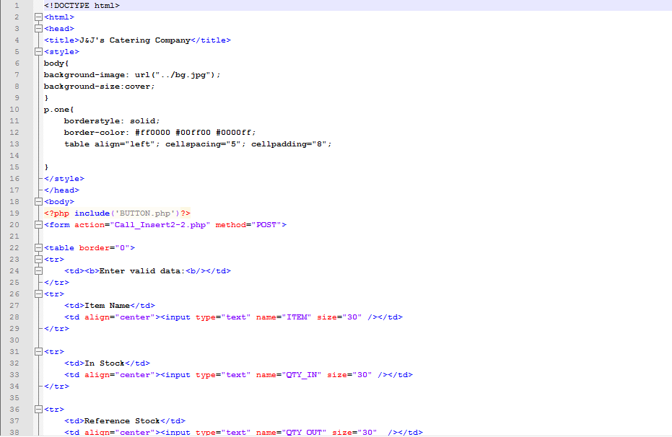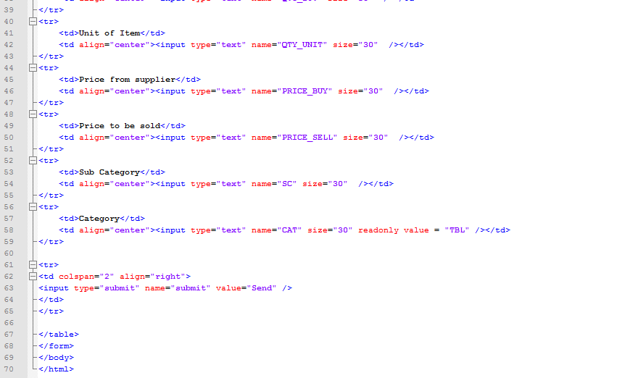

*Fig 11-E.53 Insert menu*

*Fig 11-E.54 Insert to inventory*

*Fig 11-E.55 Insert bundle*

*Fig 11-E.56 Insert menu to bundle*

*Fig 11-E.57 Insert ingredient to menu*

*Fig 11-E.58 Insert order*

*Fig 11-E.59 Insert ingredient*

*Fig 11-E.60 Insert tableware*

Deletes Values from Inventory:

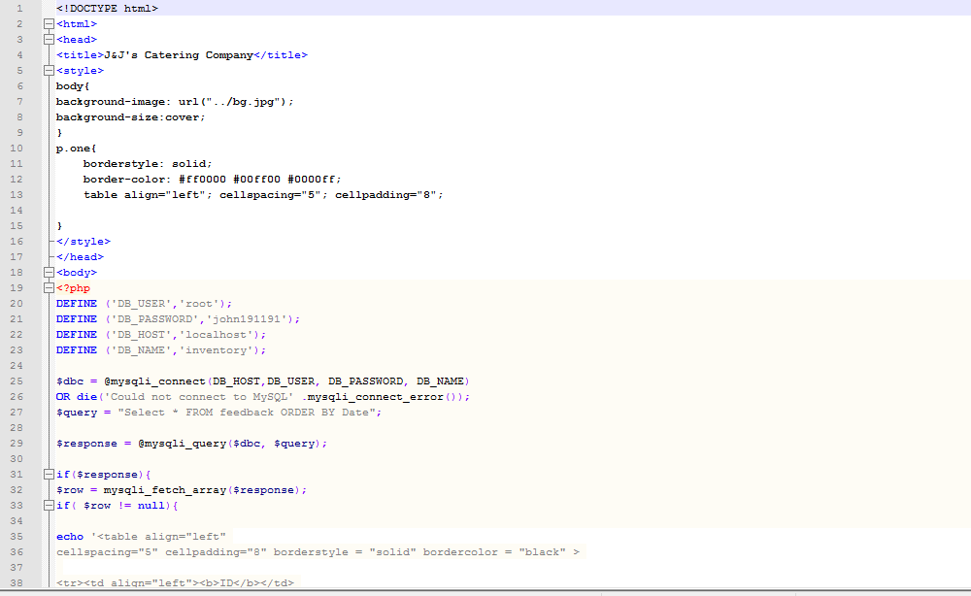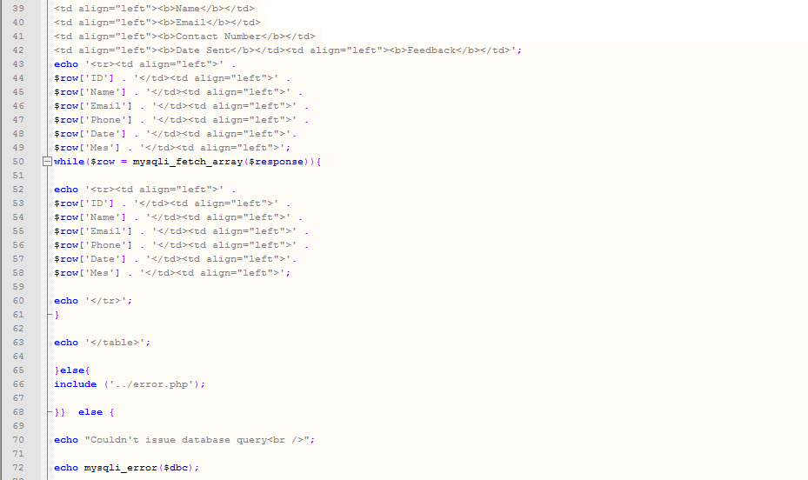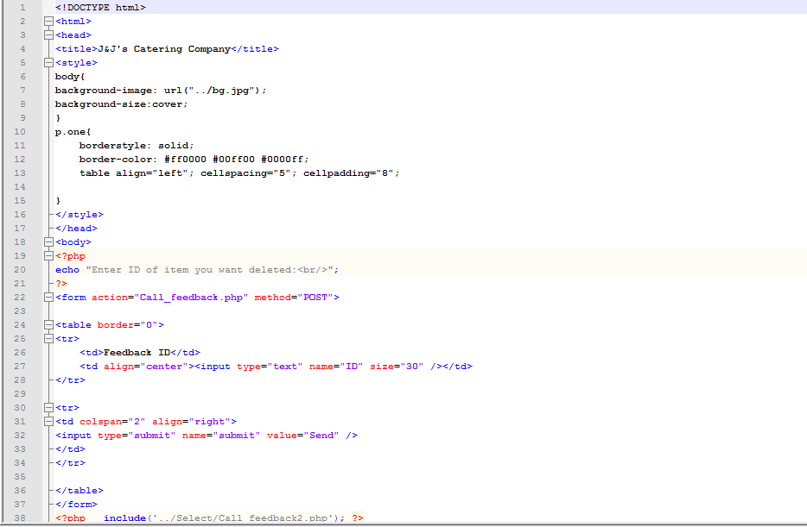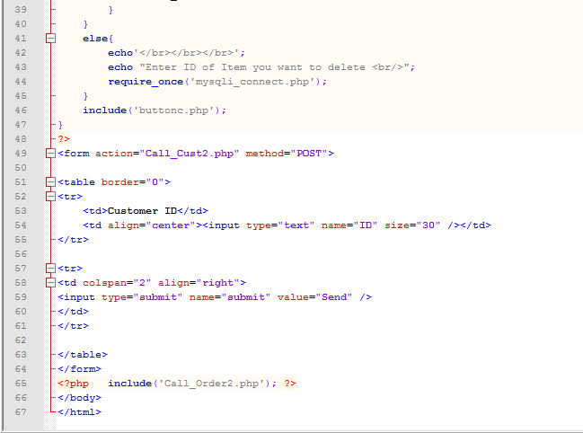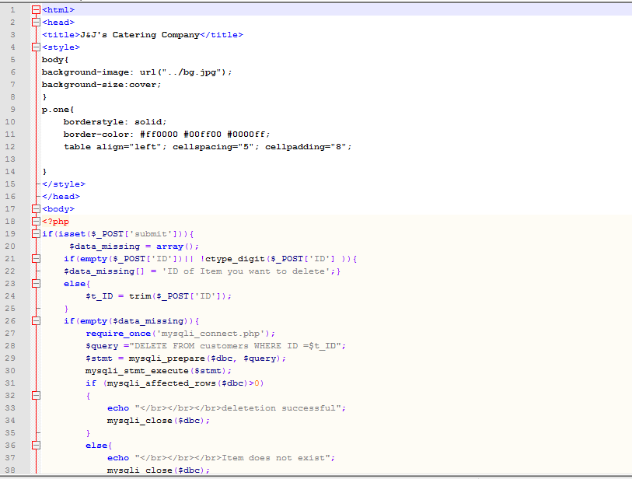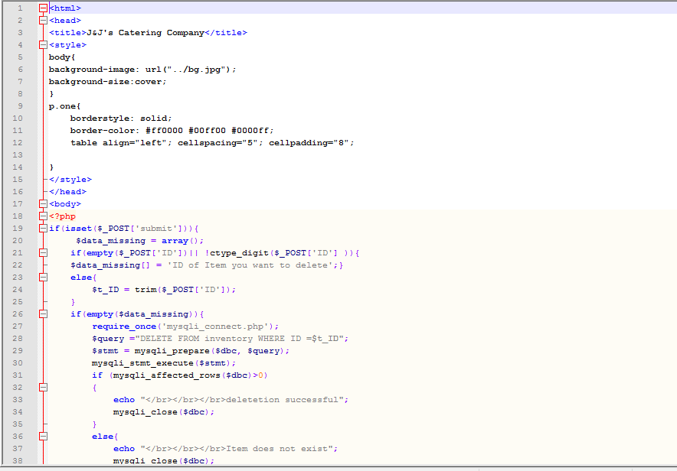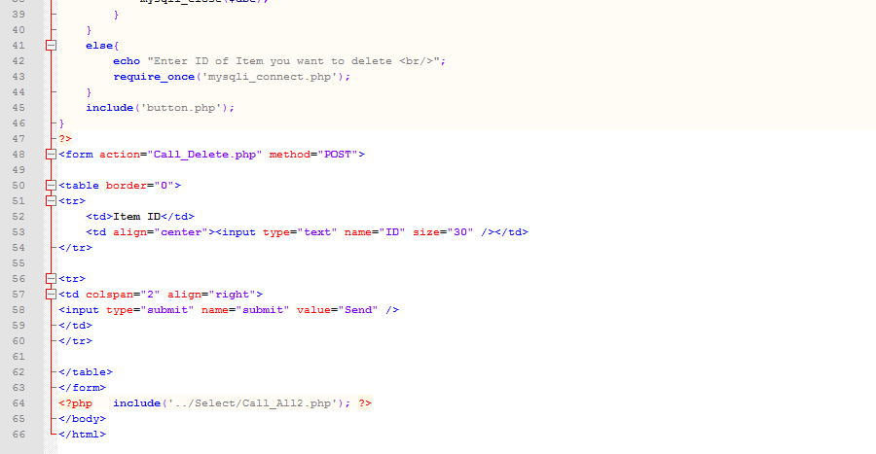

*Fig 11-E.61 Delete item*

*Fig 11-E.62 Delete feedback*

*Fig 11-E.63 Delete order*

*Fig 11-E.64 Delete item*

Creates Tables within the Database: 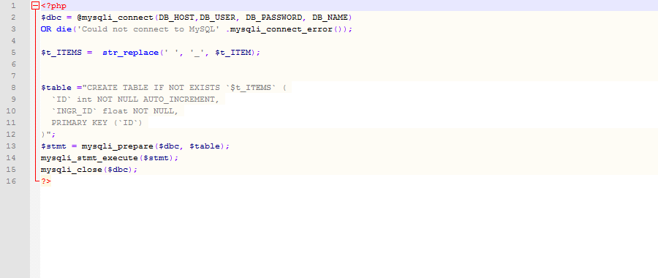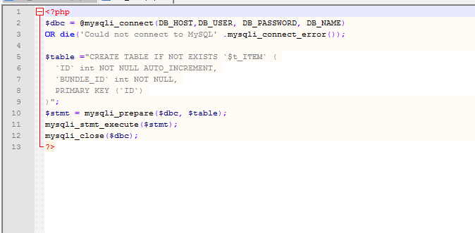

*Fig 11-E.65 Create tables in database*

1. **REFERENCES**

Pictures used:

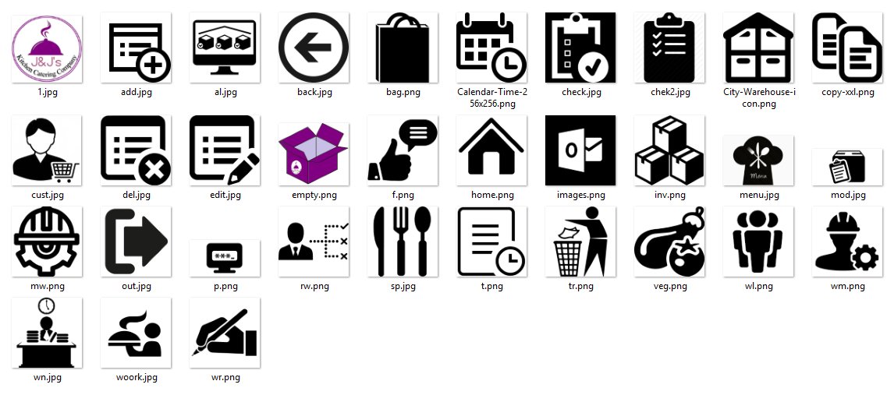

<https://www.scribd.com/doc/103442430/Related-Literature-and-Methodology-of-Inventory-System>

Fundamentals of Financial Management, 5th ed., (Hinsdale: Holt, Richard and Winston Sounders College Publishing, 2000), pp. 840-841.

Author/s: Eugene F. Brigman,

<https://www.ncbi.nlm.nih.gov/pmc/articles/PMC4100748/>

Systematic review automation technologies (Centre for Health Informatics, Australian Institute of Health Innovation, University of New South Wales, Sydney, Australia & Centre for Research on Evidence Based Practice, Bond University, Gold Coast, AustraliaCentre for Health Informatics, Australian Institute of Health Innovation, University of New South Wales, Sydney, Australia

2Centre for Research on Evidence Based Practice, Bond University, Gold Coast, Australia

Centre for Health Informatics, Australian Institute of Health Innovation, University of New South Wales, Sydney, Australia

2Centre for Research on Evidence Based Practice, Bond University, Gold Coast, Australia

Centre for Health Informatics, Australian Institute of Health Innovation, University of New South Wales, Sydney, Australia

2Centre for Research on Evidence Based Practice, Bond University, Gold Coast, Australia

Centre for Health Informatics, Australian Institute of Health Innovation, University of New South Wales, Sydney, Australia

2Centre for Research on Evidence Based Practice, Bond University, Gold Coast, Australia

)

Author/s: Guy Tsafnat; Paul Glasziou; Miew Keen Choong; Adam Dunn; Filippo Galgani; Enrico Coiera:

<http://www.tandfonline.com/doi/abs/10.1300/J502v01n01_04>

A Literature Review of Academic Library Web Page Studies

Author/s: Barbara A. Blummer